Sixteenth Sunday after Pentecost September 12, 2021

PRELUDE Chant de Paix, Op. 40, no. 3 Langlais (1907-1991)

WELCOME & ANNOUNCEMENTS

INTROIT Let all the World in Every Corner Sing Routley (1917-1982)

CALL TO WORSHIP
Leader: Wisdom cries out in the streets:
People: Listen to my word and live.
Leader: Jesus calls out to the church:
People: Take up the cross and follow me.
Leader: Let us Worship God.

MORNING PRAYER

*OPENING HYMN #722 Lord, Speak to Me That I May Speak Canonbury

PRAYER OF CONFESSION
Merciful God, we confess we have not followed your way. We protect what is dear to us, but neglect what is dear to you. We preserve our own way of life and profit at the expense of others. Forgive us, Lord, this and all our sin. Show us the error of our ways, and guide us back to your path of righteousness, justice, and peace; through Jesus Christ our Lord.

SILENT PRAYER

ASSURANCE OF PARDON

*GLORIA PATRI #581 Greatorex (1816-1853)

FIRST SCRIPTURE LESSON Psalm 19 p. 433

ANTHEM #693 The Gift of Love Hopson (b. 1933)

SECOND SCRIPTURE LESSON James 3: 1-12 p. 981

SERMON Declarations. Rev. Patrick S. Pettit

*AFFIRMATION OF FAITH The Apostles’ Creed Hymnal p. 35

PRAYERS OF THE PEOPLE & THE LORD’S PRAYER

*CLOSING HYMN #14 For the Beauty of the Earth Dix

*CHARGE & BENEDICTION

POSTLUDE Pastorale: IV BWV 590 Bach (1685-1750)

* Please stand if able.

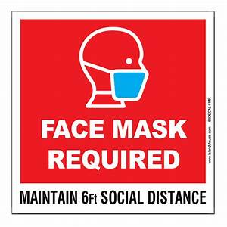

Audio aids are available for your convenience.
Please be aware that they do not function until after the service begins.

Prayers for Health and Other Concerns:

The Legacy: Eloise Morris, Mary June Cook

Shenandoah Nursing Home: Rubye Schwab

Summit Square: Lillian Hryshkanych

Home: Dick Huff, Nancy Garber, Mary Ultee, Edie Lawrence, Mary Ann Maupin

Friends and Family: Andy & Jean Robeson, (Cunninghams), Steve Stevens, Marianne Beck, Bill Bromley, Grace Measles (Jen Jones), Danny Smith (Nancy Hypes), Jennifer & Charlotte Sergeant (Kathy Brown), Emily Bardeen (Sandi Henderson), Kathy Doyle (Cindy & Rodger Doyle), Bill Metzel (Joyce Tipton), Tony Poplin, Jerry Hughes, Paul Watts (Colleen Cash), Shae Blackwell and Family (Preschool), Col. Stuart Roberts (Mark Henderson), Alissa Voils (Pam Leech), Phil Hashagen (Jean & Don), Erwin Berry (Joan), Claude Williamson

Military: Jeremiah Henderson, Carson Craig

Missionaries: Elmarie & Scott Parker, PC (USA) Regional Liaisons to Iraq, Syria & Lebanon

The rose on the pulpit this morning is to celebrate the arrival of Collin Patrick Skinner on Tuesday 9/7. Collin is the son of Kristin and Sean Skinner, grandson of Don and Jeanne Hashagen (their 8th grandchild), and great-nephew of Jean Hashagen (her 12th great-baby).

“Beyond the Architecture, the Story of Waynesboro City Churches and their People” is currently on view at the Waynesboro Heritage Museum, 420 W. Main St., in downtown Waynesboro.

Link for todays service : https://youtu.be/rCfrMSI-WXQ
FIRST PRESBYTERIAN CHURCH
WAYNESBORO, VIRGINIA

A community-minded congregation living out the love of Christ as we serve one another with humility, gentleness, and patience through God’s grace.

September 12, 2021 11:00 AM

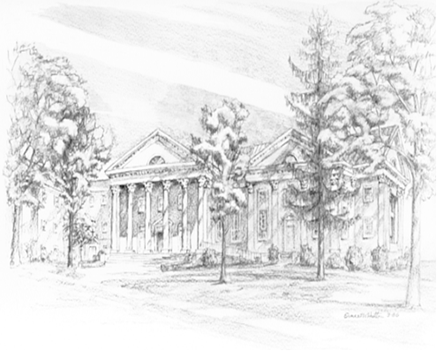

P.O. Box 877
249 South Wayne Avenue
Waynesboro, Virginia
(540) 949-8366
Church Website: www.firstpresway.org
Preschool Website: www.firstprespre.org
Email: church@firstpresway.com

