Seventeenth Sunday after Pentecost September 19, 2021

PRELUDE Pièce d'orgue BWV 572: Très vitement Bach (1685-1750)

WELCOME & ANNOUNCEMENTS

INTROIT Now Enter In Hebble (1934-2020)

CALL TO WORSHIP
Leader: Who will be first in the kingdom of God?
People: The one who is last and servant of all.
Leader: Who will be great in the realm of heaven?
People: The one who comes as a humble child.
Leader: Let us Worship God.

MORNING PRAYER

*OPENING HYMN #457 How Happy Are the Saints of God Wareham

PRAYER OF CONFESSION
Merciful God, we confess we have not followed your way. We sow the seeds of conflict, while you seek the harvest of peace. We argue about who is greatest while you welcome the last and least. Forgive us, Lord, this and all our sin. Draw near to us with the wisdom of your Word, and teach us how to serve you; through Jesus Christ our Lord. Amen

SILENT PRAYER

ASSURANCE OF PARDON

*GLORIA PATRI #581 Greatorex (1816-1853)

FIRST SCRIPTURE LESSON Psalm 1 p.424

ANTHEM The Beatitudes Russian Orthodox/arr. Proulx (1937-2010)
(Matthew 5: 3-12)

Remember Your servants, Lord, when You come in your kingly power.
Blessed are the poor in spirit, for theirs is the kingdom of heaven.
Blessed are those who mourn, for they shall be comforted.
Blessed are the meek, for they shall inherit the earth.
Blessed are those who hunger and thirst after righteousness, for they shall be satisfied.
Blessed are the merciful, for they shall obtain mercy.
Blessed are the pure in heart, for they shall see God.
Blessed are the peacemakers, for they will be called children of God.
Blessed are those who are persecuted for righteousness’ sake,
for theirs is the kingdom of heaven.
Blessed are you when the world reviles you and persecutes you
and utters all manner of evil against you falsely for my sake.
Rejoice and be exceedingly glad, for great is your reward in heaven.
Remember Your servants, Lord, when You come in your kingly power.

SECOND SCRIPTURE LESSON James 3:13, 4: 8 p.982

SERMON Doubled barreled preaching. Rev. Patrick S. Pettit

*AFFIRMATION OF FAITH The Apostles’ Creed Hymnal p. 35

MINUTE FOR MISSION

PRAYERS OF THE PEOPLE & THE LORD’S PRAYER

*CLOSING HYMN 250wer Promise

*CHARGE & BENEDICTION

POSTLUDE Toccata in F BuxWV 157 Buxtehude (1637-1707)

*PLEASE STAND IF ABLE

Prayers for Health and Other Concerns:

The Legacy: Eloise Morris, Mary June Cook

Shenandoah Nursing Home: Rubye Schwab

Summit Square: Lillian Hryshkanych

Home: Dick Huff, Nancy Garber, Mary Ultee, Edie Lawrence, Mary Ann Maupin

Friends and Family: Andy & Jean Robeson, (Cunninghams), Steve Stevens, Marianne Beck, Bill Bromley, Grace Measles (Jen Jones), Danny Smith (Nancy Hypes), Jennifer & Charlotte Sergeant (Kathy Brown), Emily Bardeen (Sandi Henderson), Kathy Doyle (Cindy & Rodger Doyle), Bill Metzel (Joyce Tipton), Tony Poplin, Jerry Hughes, Paul Watts (Colleen Cash), Shae Blackwell and Family (Preschool), Col. Stuart Roberts (Mark Henderson), Alissa Voils (Pam Leech), Phil Hashagen (Jean & Don), Erwin Berry (Joan), Claude Williamson

Military: Jeremiah Henderson, Carson Craig

Missionaries: Elmarie & Scott Parker, PC (USA) Regional Liaisons to Iraq, Syria & Lebanon

The rose on the pulpit this morning is to celebrate the arrival of Anna Braly Doyle, born August 27, daughter of Elizabeth and Simon, sister of Jonathan, and granddaughter of Richard and Jeanne Curry

“Beyond the Architecture, the Story of Waynesboro City Churches and their People” is currently on view at the Waynesboro Heritage Museum, 420 W. Main St., in downtown Waynesboro.

Link for todays service : https://youtu.be/4I8_s971stY

FIRST PRESBYTERIAN CHURCH
WAYNESBORO, VIRGINIA

A community-minded congregation living out the love of Christ as we serve one another with humility, gentleness, and patience through God’s grace.

September 19, 2021 11:00 AM

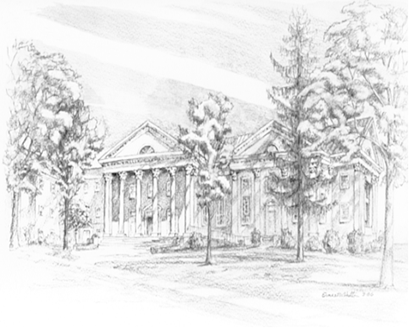

P.O. Box 877
249 South Wayne Avenue
Waynesboro, Virginia
(540) 949-8366
Church Website: www.firstpresway.org
Preschool Website: www.firstprespre.org
Email: church@firstpresway.com

