Eighteenth Sunday after Pentecost September 26, 2021

PRELUDE Préambule, Op. 31, no. 1 Vierne (1870-1937)

WELCOME & ANNOUNCEMENTS

INTROIT Let All the World in Every Corner Sing Routley (1917-1982)

CALL TO WORSHIP
Leader: Blessed be the Lord our God,
People: who has delivered us from evil.
Leader: Our help is in the name of the Lord,
People: maker of heaven and earth.
Leader: Let us Worship God.

MORNING PRAYER

*OPENING HYMN #330 Our Help Is in the Name of God Old 124th

PRAYER OF CONFESSION
Merciful God, we confess we have not followed your way. You rain down mercy upon us, yet we murmur in our discontent. You cast out the evil within us, yet we fling our curses at others. Forgive us, Lord, this and all our sin. Call us home from our wandering, deliver our souls from death, and cover us with your love; through Jesus Christ our Lord. Amen.

SILENT PRAYER

ASSURANCE OF PARDON

*GLORIA PATRI #581 Greatorex (1816-1853)

FIRST SCRIPTURE LESSON Psalm 124 p. 498

SPECIAL MUSIC Sonata in A-flat, H. 31: I CPE Bach (1714-1788)

SECOND SCRIPTURE LESSON James 5:13-20 p. 982

SERMON Are you looking in the right place? Rev. Patrick S. Pettit

*AFFIRMATION OF FAITH The Apostles’ Creed Hymnal p. 35

PRAYERS OF THE PEOPLE & THE LORD’S PRAYER

*CLOSING HYMN #667 When Morning Gilds the Skies Laudes Domini

*CHARGE & BENEDICTION

POSTLUDE Laudes Domini paraphrase

*PLEASE STAND IF ABLE

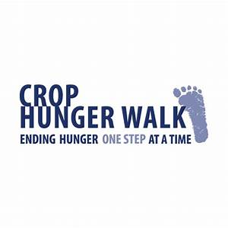

Ridgeview Park
2 p.m. today

Prayers for Health and Other Concerns:

The Legacy: Eloise Morris, Mary June Cook

Shenandoah Nursing Home: Rubye Schwab

Summit Square: Lillian Hryshkanych

Home: Dick Huff, Nancy Garber, Mary Ultee, Edie Lawrence, Mary Ann Maupin

Friends and Family: Andy & Jean Robeson, (Cunninghams), Steve Stevens, Marianne Beck, Bill Bromley, Grace Measles (Jen Jones), Danny Smith (Nancy Hypes), Jennifer & Charlotte Sergeant (Kathy Brown), Emily Bardeen (Sandi Henderson), Kathy Doyle (Cindy & Rodger Doyle), Bill Metzel (Joyce Tipton), Tony Poplin, Jerry Hughes, Paul Watts (Colleen Cash), Shae Blackwell and Family (Preschool), Col. Stuart Roberts (Mark Henderson), Alissa Voils (Pam Leech), Phil Hashagen (Jean & Don), Erwin Berry (Joan), Claude Williamson

Military: Jeremiah Henderson, Carson Craig

Missionaries: Elmarie & Scott Parker, PC (USA) Regional Liaisons to Iraq, Syria & Lebanon

“Beyond the Architecture, the Story of Waynesboro City Churches and their People” is currently on view at the Waynesboro Heritage Museum, 420 W. Main St., in downtown Waynesboro.

Link for todays service : https://youtu.be/8bidLvNnnRU

FIRST PRESBYTERIAN CHURCH
WAYNESBORO, VIRGINIA

A community-minded congregation living out the love of Christ as we serve one another with humility, gentleness, and patience through God’s grace.

September 26, 2021 11:00 AM

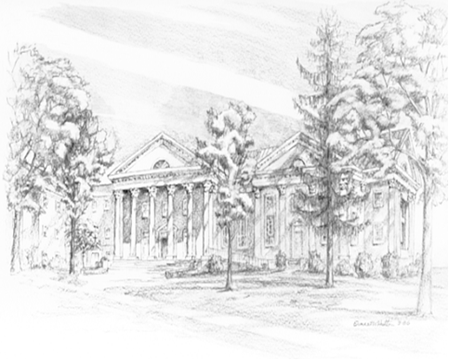

P.O. Box 877
249 South Wayne Avenue
Waynesboro, Virginia
(540) 949-8366
Church Website: www.firstpresway.org
Preschool Website: www.firstprespre.org
Email: church@firstpresway.com

