Fifteenth Sunday after Pentecost September 5, 2021

PRELUDE Prelude in E, BWV 566 Bach (1685-1750)

WELCOME & ANNOUNCEMENTS

INTROIT What Does the Lord Require Routley (1917-1982)

CALL TO WORSHIP
Leader: Wisdom cries out in the streets:
People: Listen to my word and live.
Leader: Jesus calls out to the church:
People: Take up the cross and follow me.
Leader: Let us Worship God.

MORNING PRAYER

*OPENING HYMN 351 All Who Love and Serve Your City Charlestown

PRAYER OF CONFESSION
Merciful God, we confess we have not followed your way. We protect what is dear to us and neglect what is dear to you. We preserve our own way of life and profit at the expense of others. Forgive us, Lord, this and all our sin. Show us the error of our ways, and guide us back to your paths of righteousness, justice, and peace; through Jesus Christ our Lord.

SILENT PRAYER

ASSURANCE OF PARDON

*GLORIA PATRI #581 Greatorex (1816-1853)

FIRST SCRIPTURE LESSON James 2:1-10 p. 981

ANTHEM 521 In Remembrance of Me Red (1936-2013)

SECOND SCRIPTURE LESSON James 2:11-17 p. 981

SERMON What we have...what we see...what we do. Rev. Patrick S. Pettit

*AFFIRMATION OF FAITH The Apostles’ Creed Hymnal p. 35

THE LORD’S SUPPER
Invitation
Great Thanksgiving
Communion of the People

*CLOSING HYMN 317 In Christ There Is No East or West McKee

*CHARGE & BENEDICTION

POSTLUDE Concerto in a: I BWV 593 Vivaldi (1678-1741)
Bach (1685-1750)

* Please stand if able.

Audio aids are available for your convenience.
Please be aware that they do not function until after the service begins.

Prayers for Health and Other Concerns:

The Legacy: Eloise Morris, Mary June Cook

Shenandoah Nursing Home: Rubye Schwab

Summit Square: Lillian Hryshkanych

Home: Dick Huff, Nancy Garber, Mary Ultee, Edie Lawrence, Mary Ann Maupin

Friends and Family: Andy & Jean Robeson, (Cunninghams), Steve Stevens, Marianne Beck, Bill Bromley, Grace Measles (Jen Jones), Danny Smith (Nancy Hypes), Jennifer & Charlotte Sergeant (Kathy Brown), Bill Metzel (Joyce Tipton), Tony Poplin, Jerry Hughes, Paul Watts (Colleen Cash), Shae Blackwell and Family (Preschool), Col. Stuart Roberts (Mark Henderson), Alissa Voils (Pam Leech), Phil Hashagen (Jean & Don), Erwin Berry (Joan), Claude Williamson, Marianna Callaway and Bay Kelley (Ruth Kelley)

Military: Jeremiah Henderson, Carson Craig

Missionaries: Elmarie & Scott Parker, PC (USA) Regional Liaisons to Iraq, Syria & Lebanon

“Beyond the Architecture, the Story of Waynesboro City Churches and their People” is currently on view at the Waynesboro Heritage Museum, 420 W. Main St., in downtown Waynesboro

Link for todays service : https://youtu.be/n4gH_YjX6AA

FIRST PRESBYTERIAN CHURCH
WAYNESBORO, VIRGINIA

A community-minded congregation living out the love of Christ as we serve one another with humility, gentleness, and patience through God’s grace.

September 5, 2021 11:00 AM

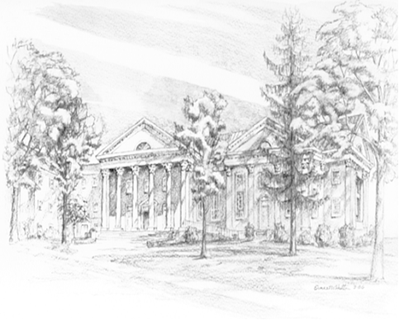

P.O. Box 877
249 South Wayne Avenue
Waynesboro, Virginia
(540) 949-8366
Church Website: www.firstpresway.org
Preschool Website: www.firstprespre.org
Email: church@firstpresway.com

