Twentieth Sunday after Pentecost October 10, 2021

PRELUDE Melodia, Op. 129, no. 4 Reger (1873-1916)

WELCOME & ANNOUNCEMENTS

INTROIT Deo Gracias Agincourt Hymn (c. 1415)

CALL TO WORSHIP
Leader: Who can claim to be good?
People: No one is good but God alone.
Leader: Then who can hope to be saved?
People: Nothing is impossible for God.
Leader: Let us Worship God.

MORNING PRAYER

*OPENING HYMN #424 Out of the Depths Aus tiefer Not

PRAYER OF CONFESSION
Eternal God, we confess our failure to seek your will. You have shown us what is good, but we remain enthralled by evil. You have offered us abundance, but we are satisfied to seek out mere wealth. Forgive us, Lord, this and all our sin. By the power of your Word, cut away all that is false and open our hearts to new life, through Jesus Christ our Lord. Amen.

SILENT PRAYER

ASSURANCE OF PARDON

*GLORIA PATRI #581 Greatorex (1816-1853)

FIRST SCRIPTURE LESSON Psalm 22:1-15

ANTHEM #415 Come, Ye Sinners, Poor and Needy Restoration

SECOND SCRIPTURE LESSON Hebrews 4:12-16

SERMON A living and active Word. Rev. Patrick S. Pettit

*AFFIRMATION OF FAITH The Apostles’ Creed Hymnal p. 35

PRAYERS OF THE PEOPLE & THE LORD’S PRAYER

*CLOSING HYMN #307 God of Grace, and God of Glory Cym Rhondda

*CHARGE & BENEDICTION

POSTLUDE Prelude in A, BWV 536 Bach (1685-1750)

*PLEASE STAND IF ABLE

Audio aids are available for your convenience.
Please be aware that they do not function until after the service begins.

Prayers for Health and Other Concerns:

The Legacy: Eloise Morris, Mary June Cook

Shenandoah Nursing Home: Rubye Schwab

Summit Square: Lillian Hryshkanych

Home: Dick Huff, Nancy Garber, Mary Ultee, Edie Lawrence, Mary Ann Maupin

Friends and Family: Andy & Jean Robeson, (Cunninghams), Steve Stevens, Marianne Beck, Bill Bromley, Grace Measles (Jen Jones), Danny Smith (Nancy Hypes), Jennifer & Charlotte Sergeant (Kathy Brown), Bill Metzel (Joyce Tipton), Tony Poplin, Jerry Hughes, Paul Watts (Colleen Cash), Shae Blackwell and Family (Preschool), Col. Stuart Roberts (Mark Henderson), Alissa Voils (Pam Leech), Phil Hashagen (Jean & Don), Erwin Berry (Joan), Claude Williamson, Marianna Callaway and Bay Kelley (Ruth Kelley)

Military: Jeremiah Henderson, Carson Craig

Missionaries: Elmarie & Scott Parker, PC (USA) Regional Liaisons to Iraq, Syria & Lebanon

“Beyond the Architecture, the Story of Waynesboro City Churches and their People” is currently on view at the Waynesboro Heritage Museum, 420 W. Main St., in downtown Waynesboro.

Link for todays service : https://youtu.be/rnsW2FR6T8U

FIRST PRESBYTERIAN CHURCH
WAYNESBORO, VIRGINIA

A community-minded congregation living out the love of Christ as we serve one another with humility, gentleness, and patience through God’s grace.

October 10, 2021 11:00 AM

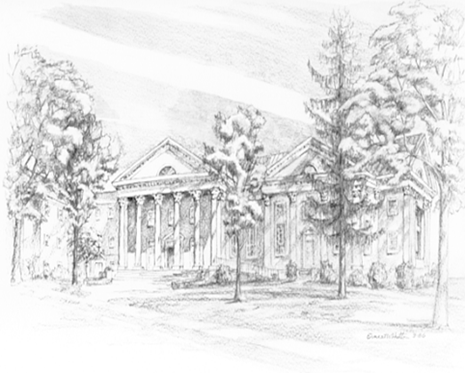

P.O. Box 877
249 South Wayne Avenue
Waynesboro, Virginia
(540) 949-8366
Church Website: www.firstpresway.org
Preschool Website: www.firstprespre.org
Email: church@firstpresway.com

