Twenty First Sunday after Pentecost October 17, 2021

PRELUDE Duo, Trio Clérambault (1676-1749)

WELCOME & ANNOUNCEMENTS

INTROIT Now Enter In Hebble (1934-2020)

CALL TO WORSHIP
Leader: The Lord alone is our refuge;
People: God is our dwelling place.
Leader: Call on the name of the Lord;
People: Our salvation comes from God.
Leader: Let us worship God.

MORNING PRAYER

*OPENING HYMN #4 Holy God, We Praise Your Name Grosser Gott Wir Loben Dich

PRAYER OF CONFESSION
Eternal God, we confess we have failed to seek your will. We try to master your creation but cannot grasp your great design. We want to share the throne of glory but cannot bear the cross of grief. Forgive us, Lord, this and all our sin. Save us from ourselves and give us the humility to trust in you alone, through Jesus Christ our Lord. Amen.

SILENT PRAYER

ASSURANCE OF PARDON

*GLORIA PATRI #581 Greatorex (1816-1853)

FIRST SCRIPTURE LESSON Psalm 104 p. 483

ANTHEM All Praise to Thee Tallis (c. 1505-1585)

All praise to thee, Our God and King, for all the blessings thou dost bring,
For loving care thou dost bestow on all thy creatures here below.
We thank thee, Lord, for thy dear Son, for all the goodness He hath done,
For all the sorrow He hath borne, for joy He brings to men forlorn.
Praise God, from whom all blessings flow; praise Him, all creatures here below;
Praise Him above, ye heavenly hosts; praise Father, Son and Holy Ghost.

SECOND SCRIPTURE LESSON Mark 10: 35-45 p. 823

SERMON A Savior that serves; or serving the Savior. Rev. Patrick S. Pettit

*AFFIRMATION OF FAITH The Apostles’ Creed Hymnal p. 35

PRAYERS OF THE PEOPLE & THE LORD’S PRAYER

*CLOSING HYMN #546 Lord, Dismiss Us with Your Blessing Sicilian Mariners

*CHARGE & BENEDICTION

POSTLUDE Prelude in F, BWV 928 Bach (1685-1750)

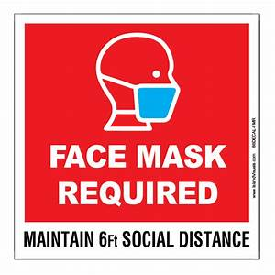
*PLEASE STAND IF ABLE

Audio aids are available for your convenience.
Please be aware that they do not function until after the service begins.

Prayers for Health and Other Concerns:

The Legacy: Eloise Morris, Mary June Cook

Shenandoah Nursing Home: Rubye Schwab

Summit Square: Lillian Hryshkanych

Home: Dick Huff, Nancy Garber, Mary Ultee, Edie Lawrence, Mary Ann Maupin

Friends and Family: Andy & Jean Robeson, (Cunninghams), Steve Stevens, Marianne Beck, Bill Bromley, Grace Measles (Jen Jones), Danny Smith (Nancy Hypes), Jennifer & Charlotte Sergeant (Kathy Brown), Bill Metzel (Joyce Tipton), Tony Poplin, Jerry Hughes, Paul Watts (Colleen Cash), Shae Blackwell and Family (Preschool), Col. Stuart Roberts (Mark Henderson), Alissa Voils (Pam Leech), Phil Hashagen (Jean & Don), Erwin Berry (Joan), Claude Williamson, Bay Kelley (Ruth Kelley)

Military: Jeremiah Henderson, Carson Craig

Missionaries: Elmarie & Scott Parker, PC (USA) Regional Liaisons to Iraq, Syria & Lebanon

“Beyond the Architecture, the Story of Waynesboro City Churches and their People” is currently on view at the Waynesboro Heritage Museum, 420 W. Main St., in downtown Waynesboro.

Link for todays service : https://youtu.be/nt8HRIyryo4

FIRST PRESBYTERIAN CHURCH
WAYNESBORO, VIRGINIA

A community-minded congregation living out the love of Christ as we serve one another with humility, gentleness, and patience through God’s grace.

October 17, 2021 11:00 AM

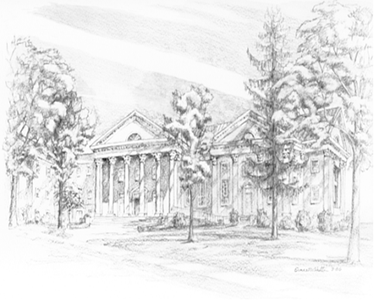

P.O. Box 877
249 South Wayne Avenue
Waynesboro, Virginia
(540) 949-8366
Church Website: www.firstpresway.org
Preschool Website: www.firstprespre.org
Email: church@firstpresway.com

