Twenty Second Sunday after Pentecost October 24, 2021

PRELUDE Two Trios, op. 49, nos. 2 and 10 Rheinberger (1839-1901)

WELCOME & ANNOUNCEMENTS

INTROIT Let all the World Routley (1917-1982)

CALL TO WORSHIP
Leader: Look to the Lord, who is faithful,
People: who gathers and guards the people.
Leader: Look to the Lord, who is merciful,
People: who redeems and restores our lives.
Leader: Let us Worship God.

MORNING PRAYER

*OPENING HYMN #366 Love Divine, all Love Excelling Hyfrydol
stanzas 1 and 3

PRAYER OF CONFESSION
Eternal God, we confess that we have failed to seek your way. When the poor cry out for help, we often pass them by. When the weak reveal their strength, we want to silence their voices. Forgive us, Lord, this and all our sin. Save a place for us at that great banquet of redemption, when all will be made whole; through Jesus Christ our Lord. Amen.

SILENT PRAYER

ASSURANCE OF PARDON

*GLORIA PATRI #581 Greatorex (1816-1853)

FIRST SCRIPTURE LESSON Psalm 34 :1-8 p. 441

ANTHEM Glory, Glory, Since I Laid My Burden Down Spiritual
Sung by Paul Jones

SECOND SCRIPTURE LESSON Mark 10: 46-52 p. 822

SERMON The limits of ministry Rev. Patrick S. Pettit

*AFFIRMATION OF FAITH The Apostles’ Creed Hymnal p. 35

PRAYERS OF THE PEOPLE & THE LORD’S PRAYER

*CLOSING HYMN #792 There is a Balm in Gilead Balm in Gilead

*CHARGE & BENEDICTION

POSTLUDE Concerto in G: Presto BWV 592 Ernst (1696-1715)
Bach (1685-1750)

*PLEASE STAND IF ABLE

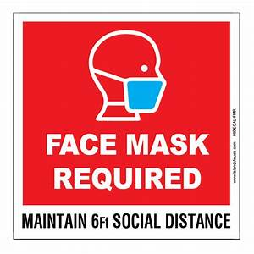

Audio aids are available for your convenience.
Please be aware that they do not function until after the service begins.

Prayers for Health and Other Concerns:

The Legacy: Eloise Morris, Mary June Cook

Shenandoah Nursing Home: Rubye Schwab

Summit Square: Lillian Hryshkanych

Home: Dick Huff, Nancy Garber, Mary Ultee, Edie Lawrence, Mary Ann Maupin

Friends and Family: Andy & Jean Robeson, (Cunninghams), Steve Stevens, Marianne Beck, Bill Bromley, Grace Measles (Jen Jones), Danny Smith (Nancy Hypes), Jennifer & Charlotte Sergeant (Kathy Brown), Bill Metzel (Joyce Tipton), Tony Poplin, Jerry Hughes, Paul Watts (Colleen Cash), Shae Blackwell and Family (Preschool), Col. Stuart Roberts (Mark Henderson), Alissa Voils (Pam Leech), Phil Hashagen (Jean & Don), Erwin Berry (Joan), Claude Williamson, Bay Kelley (Ruth Kelley), Leon Harouff

Military: Jeremiah Henderson, Carson Craig

Missionaries: Elmarie & Scott Parker, PC (USA) Regional Liaisons to Iraq, Syria & Lebanon

Link for todays service : https://youtu.be/w2-8M2J_dY4

News has been received that Leon Harouff is now residing in a memory care facility under hospice care.

FIRST PRESBYTERIAN CHURCH
WAYNESBORO, VIRGINIA

A community-minded congregation living out the love of Christ as we serve one another with humility, gentleness, and patience through God’s grace.

October 24, 2021 11:00 AM

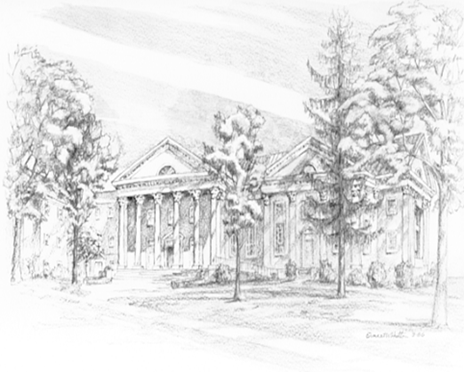

P.O. Box 877
249 South Wayne Avenue
Waynesboro, Virginia
(540) 949-8366
Church Website: www.firstpresway.org
Preschool Website: www.firstprespre.org
Email: church@firstpresway.com

