Nineteenth Sunday after Pentecost October 3, 2021

PRELUDE Adorn yourself, O dear soul, op. 122, no. 2 Brahms (1833-1897)

WELCOME & ANNOUNCEMENTS

INTROIT Let Us Break Bread Together Spiritual

CALL TO WORSHIP
Leader: Come to the feast of the people of God!
People: The hungry will find the bread of life.
Leader: Thirsty will drink from the fountain of grace.
People: The lost shall find safety.
Leader: The lonely shall find friends.
People: The broken shall find healing.
Leader: The dying shall find eternal life.
All: Let us worship God!

MORNING PRAYER

*OPENING HYMN #498 Loaves Were Broken, Words Were Spoken Beach Spring

PRAYER OF CONFESSION
God of Bread and Wine, we confess we do not eat well. Too often, our meals are on the move, or we distracted by the media. We consume too much, and what we consume does not nourish. Forgive us, Lord, this and all our sin. Bring us now to your table, where way we take the bread of life and the cup of salvation and be truly satisfied.

SILENT PRAYER

ASSURANCE OF PARDON
Leader : Persistently, patiently, lovingly, God pours out grace and joy into our lives, healing our brokenness, forgiving our sin.
Many: Loved, we are sent to love; forgiven, we are freed to forgive; graced, we can offer our gifts to everyone we meet. Thanks be to God. Amen.

*GLORIA PATRI #581 Greatorex (1816-1853)

FIRST SCRIPTURE LESSON Psalm 90: 12-17

SPECIAL MUSIC Shall We Gather At the River arr. Voltz (b. 1957)
Cathy Cunningham, harp

SECOND SCRIPTURE LESSON Mark 10: 17-31

SERMON Nothing to lose. Rev. Patrick S. Pettit

*AFFIRMATION OF FAITH The Apostles’ Creed Hymnal p. 35

THE LORD’S SUPPER
Invitation
Great Thanksgiving
Communion of the People

*CLOSING HYMN #377 I Want to Walk as a Child of the Light Houston

*CHARGE & BENEDICTION

POSTLUDE Draw Us in the Spirit’s Tether Friedell (1905-1958)

* Please stand if able.

Audio aids are available for your convenience.
Please be aware that they do not function until after the service begins.

Prayers for Health and Other Concerns:

The Legacy: Eloise Morris, Mary June Cook

Shenandoah Nursing Home: Rubye Schwab

Summit Square: Lillian Hryshkanych

Home: Dick Huff, Nancy Garber, Mary Ultee, Edie Lawrence, Mary Ann Maupin

Friends and Family: Andy & Jean Robeson, (Cunninghams), Steve Stevens, Marianne Beck, Bill Bromley, Grace Measles (Jen Jones), Danny Smith (Nancy Hypes), Jennifer & Charlotte Sergeant (Kathy Brown), Bill Metzel (Joyce Tipton), Tony Poplin, Jerry Hughes, Paul Watts (Colleen Cash), Shae Blackwell and Family (Preschool), Col. Stuart Roberts (Mark Henderson), Alissa Voils (Pam Leech), Phil Hashagen (Jean & Don), Erwin Berry (Joan), Claude Williamson, Marianna Callaway and Bay Kelley (Ruth Kelley)

Military: Jeremiah Henderson, Carson Craig

Missionaries: Elmarie & Scott Parker, PC (USA) Regional Liaisons to Iraq, Syria & Lebanon

Link for todays service : https://youtu.be/rdXqbOxKAqc

FIRST PRESBYTERIAN CHURCH
WAYNESBORO, VIRGINIA

A community-minded congregation living out the love of Christ as we serve one another with humility, gentleness, and patience through God’s grace.

October 3, 2021 11:00 AM
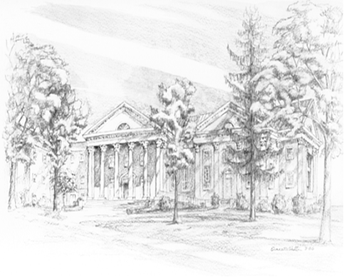

P.O. Box 877
249 South Wayne Avenue
Waynesboro, Virginia
(540) 949-8366
Church Website: www.firstpresway.org
Preschool Website: www.firstprespre.org
Email: church@firstpresway.com

