Twenty Third Sunday after Pentecost October 31, 2021

PRELUDE Prelude in F, BuxWV 145 Buxtehude 1637-1707

WELCOME & ANNOUNCEMENTS

INTROIT Now Enter In Hebble (1934-2020)

MINUTE FOR MISSION

CALL TO WORSHIP
Leader: See, the Lord our God is with us.
People: God is making all things new.
Leader: Jesus is the Alpha and Omega.
People: Alleluia! Amen.
Leader: Let us Worship God.

MORNING PRAYER

*OPENING HYMN #326 For All the Saints Sine Nomine

PRAYER OF CONFESSION
Eternal God, we confess we have failed to follow your Call. You have come to live among us, yet we do not welcome you. You call us to rise up in Christ, yet we remain in the dust of death. Forgive us, Lord, this and all our sin. Like our brother Lazarus, unbind us and let us go, that we may walk in newness of life, through Jesus Christ our Lord. Amen.

SILENT PRAYER

ASSURANCE OF PARDON

*GLORIA PATRI #581 Greatorex (1816-1853)

FIRST SCRIPTURE LESSON John 11:1-11 p. 873

SPECIAL MUSIC Le Tombeau de Couperin: Prelude Ravel (1875-1937)

SECOND SCRIPTURE LESSON John 11: 12-45 p. 873

SERMON Roll away the stone. Rev. Patrick S. Pettit

THE NECROLOGY
Recognizing those who have entered the church triumphant 2020-2021

Glennis Kite Bear May 3, 2021

Welby Charles Poland June 17, 2021

*AFFIRMATION OF FAITH The Apostles’ Creed Hymnal p. 35

PRAYERS OF THE PEOPLE & THE LORD’S PRAYER

*CLOSING HYMN #730 I Sing a Song of the Saints of God Grand Isle

*CHARGE & BENEDICTION

POSTLUDE Postlude in F, BuxWV 145 Buxtehude

*PLEASE STAND IF ABLE

Audio aids are available for your convenience.
Please be aware that they do not function until after the service begins.

Prayers for Health and Other Concerns:

The Legacy: Eloise Morris, Mary June Cook

Shenandoah Nursing Home: Rubye Schwab

Summit Square: Lillian Hryshkanych

Home: Dick Huff, Nancy Garber, Mary Ultee, Edie Lawrence, Mary Ann Maupin

Friends and Family: Andy & Jean Robeson, (Cunninghams), Steve Stevens, Marianne Beck, Bill Bromley, Grace Measles (Jen Jones), Danny Smith (Nancy Hypes), Jennifer & Charlotte Sergeant (Kathy Brown), Bill Metzel (Joyce Tipton), Tony Poplin, Jerry Hughes, Paul Watts (Colleen Cash), Shae Blackwell and Family (Preschool), Col. Stuart Roberts (Mark Henderson), Alissa Voils (Pam Leech), Phil Hashagen (Jean & Don), Erwin Berry (Joan), Claude Williamson, Bay Kelley (Ruth Kelley), Leon Harouff, Camila Pleasants (Jo Pannill)

Military: Jeremiah Henderson, Carson Craig

Missionaries: Elmarie & Scott Parker, PC (USA) Regional Liaisons to Iraq, Syria & Lebanon

Link for todays service : https://youtu.be/dhqbvc2yPVw

Meetings to Talk about our Future (lunch provided):
November 14 – Finances – challenges and opportunities
November 21 – Direction of future mission and ministry

If you care about FPC, plan to attend both Sundays.

FIRST PRESBYTERIAN CHURCH
WAYNESBORO, VIRGINIA

A community-minded congregation living out the love of Christ as we serve one another with humility, gentleness, and patience through God’s grace.

October 31, 2021 11:00 AM

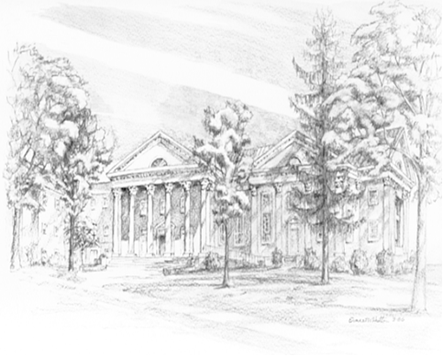

P.O. Box 877
249 South Wayne Avenue
Waynesboro, Virginia
(540) 949-8366
Church Website: www.firstpresway.org
Preschool Website: www.firstprespre.org
Email: church@firstpresway.com

