Twenty Fifth Sunday after Pentecost November 14, 2021

PRELUDE Prelude, Op. 50, no. 5 Foote (1853-1937)

WELCOME & ANNOUNCEMENTS

INTROIT God of the Ages Warren (1828-1902)

CALL TO WORSHIP
Leader: God is faithful: Christ is coming;
People: to raise the poor from the dust
Leader: God is faithful: Christ is coming;
People: to judge and rule the earth.
Leader: Let us Worship God.

MORNING PRAYER

*OPENING HYMN 8 Eternal Father, Strong to Save Melita

PRAYER OF CONFESSION
Eternal God, we confess our sin before You. You warn us of what is to come, but we ignore the signs of the times. You promise us a new creation, but we cling to the ruins of this world. Forgive us, Lord, this and all our sin. Wash away our stain and keep us faithful in love and in deed, while we await your coming in glory, through Jesus Christ our Lord. Amen.

SILENT PRAYER

ASSURANCE OF PARDON

*GLORIA PATRI 581 Greatorex (1816-1853)

FIRST SCRIPTURE LESSON Psalm 16 p. 430

ANTHEM O Beautiful for Spacious Skies Materna

O beautiful for spacious skies, for amber waves of grain,
For purple mountains majesty above the fruited plain!
America! America! God shed His grace on thee,
And crown thy good with brotherhood from sea to shining sea!

SECOND SCRIPTURE LESSON Mark 13:1-8 p. 825

SERMON A long labor. Rev. Patrick S. Pettit

*AFFIRMATION OF FAITH The Apostles’ Creed Hymnal p. 35

PRAYERS OF THE PEOPLE & THE LORD’S PRAYER

*CLOSING HYMN 687 O God Our Help in Ages Past St. Anne

*CHARGE & BENEDICTION

POSTLUDE Postlude in C Foote

*PLEASE STAND IF ABLE

Audio aids are available for your convenience.
Please be aware that they do not function until after the service begins.

Prayers for Health and Other Concerns:

The Legacy: Mary June Cook

Shenandoah Nursing Home: Rubye Schwab

Summit Square: Lillian Hryshkanych

Home: Dick Huff, Nancy Garber, Mary Ultee, Edie Lawrence, Mary Ann Maupin

Friends and Family: Andy & Jean Robeson, (Cunninghams), Steve Stevens, Marianne Beck, Bill Bromley, Grace Measles (Jen Jones), Danny Smith (Nancy Hypes), Jennifer & Charlotte Sergeant (Kathy Brown), Bill Metzel (Joyce Tipton), Tony Poplin, Jerry Hughes, Paul Watts, (Colleen Cash), Shae Blackwell and Family (Preschool), Col. Stuart Roberts (Mark Henderson), Alissa Voils (Pam Leech), Phil Hashagen (Jean & Don), Erwin Berry (Joan), Claude Williamson, Bay Kelley (Ruth Kelley), Camila Pleasants (Jo Pannill)

Military: Jeremiah Henderson, Carson Craig

Missionaries: Elmarie & Scott Parker, PC (USA) Regional Liaisons to Iraq, Syria & Lebanon

Link for todays service : https://youtu.be/NF43jQJb_eA

Meetings to Talk about our Future (lunch provided):
Today – Finances – challenges and opportunities
November 21 – Direction of future mission and ministry

If you care about FPC, plan to attend both Sundays.

FIRST PRESBYTERIAN CHURCH
WAYNESBORO, VIRGINIA

A community-minded congregation living out the love of Christ as we serve one another with humility, gentleness, and patience through God’s grace.

November 14, 2021 11:00 AM

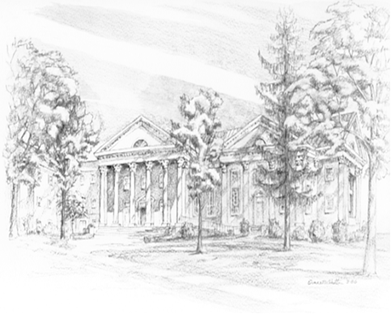

P.O. Box 877
249 South Wayne Avenue
Waynesboro, Virginia
(540) 949-8366
Church Website: www.firstpresway.org
Preschool Website: www.firstprespre.org
Email: church@firstpresway.com

