Christ the King November 21, 2021

PRELUDE The King Sitteth At His Table Op. 18, no. 1 Dupré (1886-1971)

WELCOME & ANNOUNCEMENTS

INTROIT Christ Whose Glory Fills the Skies Ratisbon

CALL TO WORSHIP
Leader: Grace and peace from the Lord God,
People: who was and is and is to come.
Leader: Grace and peace in Jesus Christ;
People: The Alpha and the Omega.
Leader: Let us Worship God.

MORNING PRAYER

*OPENING HYMN 268 Crown Him With Many Crowns Diademata

PRAYER OF CONFESSION
Almighty God, King of Creation, we confess our failures before You. You come to us in glory, yet we hide our faces in fear. You speak to us in truth, but we close our ears and hearts to your word. Forgive us, Lord, this and all our sin. Release us from sin's bonds; restore our lives, and rule in our hearts, this day and always; through Jesus Christ our Lord.

SILENT PRAYER

ASSURANCE OF PARDON

*GLORIA PATRI 581 Greatorex (1816-1853)

FIRST SCRIPTURE LESSON Psalm 93 p. 478

ANTHEM For the Fruits of This Creation Jackson (b.1917)

For the fruits of this creation, thanks be to God;
For good gifts to every nation, thanks be to God;
For the ploughing, sowing, reaping, silent growth while we are sleeping,
Future needs in earth's safe-keeping, thanks be to God.

In the just reward of labor, God's will is done;
In the help we give our neighbor, God's will is done;
In our world-wide task of caring for the hungry and despairing,
In the harvests we are sharing, God's will is done.

For the harvests of the Spirit, thanks be to God;
For the good we all inherit, thanks be to God;
For the wonders that astound us, for the truths that still confound us,
Most of all, that love has found us, thanks be to God!

SECOND SCRIPTURE LESSON Revelation 1: 4-8 p. 994

SERMON A little bit of the big picture. Rev. Patrick S. Pettit

*AFFIRMATION OF FAITH The Apostles’ Creed Hymnal p. 35

PRAYERS OF THE PEOPLE & THE LORD’S PRAYER

*CLOSING HYMN 643 Now Thank We All Our God Nun danket alle Gott

*CHARGE & BENEDICTION

POSTLUDE Marche triomphale: Nun danket alle Gott Karg-Elert (1877-1933)

*PLEASE STAND IF ABLE

Audio aids are available for your convenience.
Please be aware that they do not function until after the service begins.

Prayers for Health and Other Concerns:

The Legacy: Mary June Cook

Shenandoah Nursing Home: Rubye Schwab

Summit Square: Lillian Hryshkanych

Home: Dick Huff, Nancy Garber, Mary Ultee, Edie Lawrence, Mary Ann Maupin

Friends and Family: Andy & Jean Robeson, (Cunninghams), Steve Stevens, Marianne Beck, Bill Bromley, Grace Measles (Jen Jones), Danny Smith (Nancy Hypes), Jennifer & Charlotte Sergeant (Kathy Brown), Bill Metzel (Joyce Tipton), Tony Poplin, Jerry Hughes, Paul Watts, (Colleen Cash), Shae Blackwell and Family (Preschool), Col. Stuart Roberts (Mark Henderson), Alissa Voils (Pam Leech), Phil Hashagen (Jean & Don), Erwin Berry (Joan), Camila Pleasants (Jo Pannill), Mary Gillenwater

Military: Jeremiah Henderson, Carson Craig

Missionaries: Elmarie & Scott Parker, PC (USA) Regional Liaisons to Iraq, Syria & Lebanon

Link for todays service : https://youtu.be/J413ngpiybY

Meetings to Talk about our Future (lunch provided):

Today – Direction of future mission and ministry

FIRST PRESBYTERIAN CHURCH
WAYNESBORO, VIRGINIA

A community-minded congregation living out the love of Christ as we serve one another with humility, gentleness, and patience through God’s grace.

November 21, 2021 11:00 AM

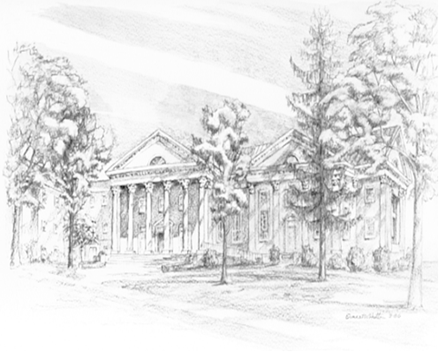

P.O. Box 877
249 South Wayne Avenue
Waynesboro, Virginia
(540) 949-8366
Church Website: www.firstpresway.org
Preschool Website: www.firstprespre.org
Email: church@firstpresway.com

