24th Sunday After Pentecost November 7, 2021

PRELUDE Meditation, Op. 31, no. 5 Vierne (1870-1937)

WELCOME & ANNOUNCEMENTS

INTROIT O For A Thousand Tongues to Sing arr. Dr. David Berry

CALL TO WORSHIP
Leader: All that we have is a gift from God;
People: by the grace of God we live.
Leader: As Jesus gave his life for us,
People: let us offer our lives to the Lord.
Leader: Let us Worship God.

MORNING PRAYER

*OPENING HYMN 42 Your Faithfulness, O Lord, Is Sure Winchester New

PRAYER OF CONFESSION
Eternal God, we confess we have failed to seek your will. We take for granted power and privilege while many are struggling to survive. We boast of our great contributions while some who have little give all. Forgive us, Lord, this and all our sin. Strip us of all pride and pretense and clothe us in your mercy alone, ready to meet you in your glory. Amen.

SILENT PRAYER

ASSURANCE OF PARDON

*GLORIA PATRI #581 Greatorex (1816-1853)

FIRST SCRIPTURE LESSON Psalm 145: 1-5, 17-38 p.506

Special Music Joshua Fit the Battle of Jericho arr. Berry

SECOND SCRIPTURE LESSON Luke 20: 27-38 p. 855

SERMON A small heaven. Rev. Patrick S. Pettit

*AFFIRMATION OF FAITH The Apostles’ Creed Hymnal p. 35

THE LORD’S SUPPER
Invitation
Great Thanksgiving
Communion of the People

*CLOSING HYMN 645 Sing Praise to God Who Reigns Above Mit freuden Zart

*CHARGE & BENEDICTION

POSTLUDE Sonata in B-flat, op. 65, no. 4: I Mendelssohn (1809-1847)

* Please stand if able.

This morning, we welcome Dr. David Berry to FPC. Dr Berry is Associate Professor of Piano at Eastern Mennonite University, chair of the Department of Music and was recently appointed Artistic Director of the Shenandoah Valley Bach Festival. We are grateful to Dr. Berry for sharing his talents with us this morning!

Audio aids are available for your convenience.
Please be aware that they do not function until after the service begins.

Prayers for Health and Other Concerns:

The Legacy: Eloise Morris, Mary June Cook

Shenandoah Nursing Home: Rubye Schwab

Summit Square: Lillian Hryshkanych

Home: Dick Huff, Nancy Garber, Mary Ultee, Edie Lawrence, Mary Ann Maupin

Friends and Family: Andy & Jean Robeson, (Cunninghams), Steve Stevens, Marianne Beck, Bill Bromley, Grace Measles (Jen Jones), Danny Smith (Nancy Hypes), Jennifer & Charlotte Sergeant (Kathy Brown), Bill Metzel (Joyce Tipton), Tony Poplin, Jerry Hughes, Paul Watts (Colleen Cash), Shae Blackwell and Family (Preschool), Col. Stuart Roberts (Mark Henderson), Alissa Voils (Pam Leech), Phil Hashagen (Jean & Don), Erwin Berry (Joan), Claude Williamson, Bay Kelley (Ruth Kelley), Camila Pleasants (Jo Pannill)

Military: Jeremiah Henderson, Carson Craig

Missionaries: Elmarie & Scott Parker, PC (USA) Regional Liaisons to Iraq, Syria & Lebanon

Link for todays service : https://youtu.be/knuNEa9FSBc

Flowers today are given from the family of Leon Harouff.

FIRST PRESBYTERIAN CHURCH
WAYNESBORO, VIRGINIA

A community-minded congregation living out the love of Christ as we serve one another with humility, gentleness, and patience through God’s grace.

November 7, 2021 11:00 AM
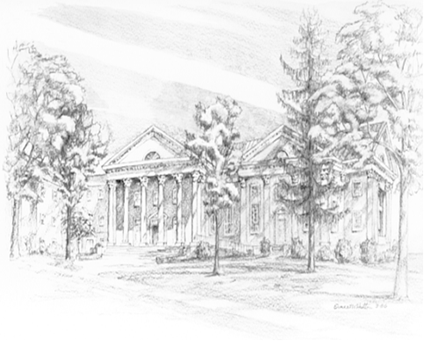

P.O. Box 877
249 South Wayne Avenue
Waynesboro, Virginia
(540) 949-8366
Church Website: www.firstpresway.org
Preschool Website: www.firstprespre.org
Email: church@firstpresway.com

