Second Sunday of Christmas January 2, 2022

PRELUDE Divine Spirits Boëly (1785-1858)
WELCOME & ANNOUNCEMENTS
INTROIT It Came Upon a Midnight Clear Carol

CALL TO WORSHIP
Leader: Praise the Lord from the heavens; praise God in the heights!
People: Praise the Lord, all angels; praise God, all the host!
Leader: Praise God, sun and moon; praise the Lord, all you shining stars!
People: Praise God, you highest heavens; praise the Lord!
Leader: Kings of the earth and all peoples, princes and all rulers of the earth! Young men and women, old and young together:
People: Praise the name of the Lord!
Leader: Let us worship God!
MORNING PRAYER
*OPENING HYMN 119 Hark, The Herald Angels Sing Mendelssohn
CALL TO CONFESSION

PRAYER OF CONFESSION

God of eternity, the holidays pass in a frenzied rush, distracting us from the message of salvation in Christ. As we take stock of the year now gone, forgive us for losing sight of Your will and Your comfort. As we look to the new year, restore our vision, and enhance our strength, that we may truly see the gift of salvation born among us, and tell the world of Your good news. Through Christ we pray, Amen.

SILENT PRAYER

ASSURANCE OF PARDON

*GLORIA PATRI #581 GREATOREX

FIRST SCRIPTURE LESSON Psalm 8
ANTHEM He’s Sweet I Know A. Jackson
sung by Paul Jones
SECOND SCRIPTURE LESSON Revelation 21: 1-6
THE SERMON A new beginning. Rev. Pettit

*AFFIRMATION OF FAITH The Apostles’ Creed Hymnal p. 35
THE LORD’S SUPPER
Invitation
Great Thanksgiving
Communion of the People

*CLOSING HYMN 113 Angels We Have Heard on High Gloria

*CHARGE & BENEDICTION
POSTLUDE Noël Suisse d’Aquin (1694-1772)

*PLEASE STAND IF ABLE.

Audio aids are available for your convenience.
Please be aware that they do not function until after the service begins.

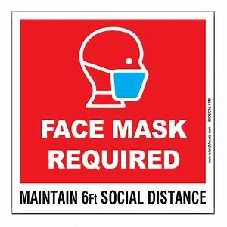

FIRST PRESBYTERIAN CHURCH
WAYNESBORO, VIRGINIA

A community-minded congregation living out the love of Christ as we serve one another with humility, gentleness, and patience through God’s grace.

January 2, 2022 11:00 AM

The Legacy: Mary June Cook

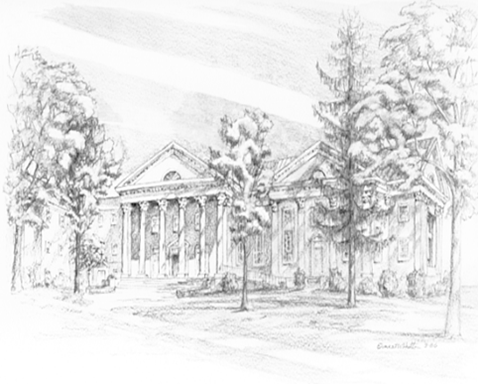
Shenandoah Nursing Home: Rubye Schwab Summit Square: Lillian Hryshkanych
Home: Dick Huff, Nancy Garber, Mary Ultee, Edie Lawrence, Mary Ann Maupin

Friends and Family: Marianne Beck, Erwin Berry (Joan), Shae Blackwell and Family (Preschool), Bill Bromley, Colleen Cash, Mary Gillenwater, Phil Hashagen (Jean & Don), Jerry Hughes, Grace Measles (Jen Jones), Bill Metzel (Joyce Tipton), Tony Poplin, Col.
Stuart Roberts (Mark Henderson), Andy & Jean Robeson, (Cunninghams), Jennifer & Charlotte Sergeant (Kathy Brown), Danny Smith (Nancy Hypes), Steve Stevens, Alissa Voils (Pam Leech), Paul Watts, (Colleen Cash).

Military: Carson Craig, Jeremiah Henderson.

Missionaries: Elmarie & Scott Parker, PC (USA) Regional Liaisons to Iraq, Syria & Lebanon

Link for todays service: https://youtu.be/bl_1tfaSoH0

P.O. Box 877
249 South Wayne Avenue
Waynesboro, Virginia
(540) 949-8366
Church Website: www.firstpresway.org
Preschool Website: www.firstprespre.org
Email: church@firstpresway.com

X

