Epiphany 3 January 23, 2022

PRELUDE Wie schön leuchtet der Morgenstern I BuxWV 223 Buxtehude (1637-1707)
WELCOME & ANNOUNCEMENTS
INTROIT How Brightly Shines the Morningstar Wie schön leuchte

CALL TO WORSHIP
Leader: In you, O Lord, we take refuge.
People: Let us never be put to shame.
Leader: In your righteousness deliver us.
People: For you are our rock and our fortress.
Leader: Let us worship God.

MORNING PRAYER
*OPENING HYMN 61 Your Law, O Lord, is Perfect Christus, der is mein Leben

CALL TO CONFESSION

PRAYER OF CONFESSION
O God of love and forgiveness, we admit that we are unwilling to be challenged and
changed by our study. We hear the words of Jesus and we ignore the way those words are
to lead us to change. Our thoughts and prayers are easily diverted from the essential to the
trivial matters. Forgive us, Lord, this and all our sin. Lead us by the Spirit to focus upon
your Word in Christ and see our faith mature.

SILENT PRAYER

ASSURANCE OF PARDON

GLORIA PATRI 581 Greaterex

FIRST SCRIPTURE READING Psalm 19

ANTHEM We Are One in the Spirit Scholtes (1938-2009)
Sung by Paul Jones
(The text to this week’s anthem can be found in hymn 300.)

SECOND SCRIPTURE READING Luke 4:14-21
SERMON
AFFIRMATION OF FAITH. The Apostles' Creed. Hymnal, p. 35
PRAYERS OF THE PEOPLE & THE LORD’S PRAYER

CLOSING HYMN In Christ There Is No East Or West McKee

CHARGE and BENEDICTION
Benediction

POSTLUDE Wie schön leuchtet der Morgenstern II, BuxWV 223 Buxtehude

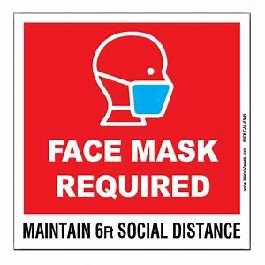

are available for your convenience.
Please be aware that they do not function until after the service begins.

FIRST PRESBYTERIAN CHURCH
WAYNESBORO, VIRGINIA

A community-minded congregation living out the love of Christ as we serve one another with humility, gentleness, and patience through God’s grace.

January 23, 2022 11:00 AM

The Legacy: Mary June Cook
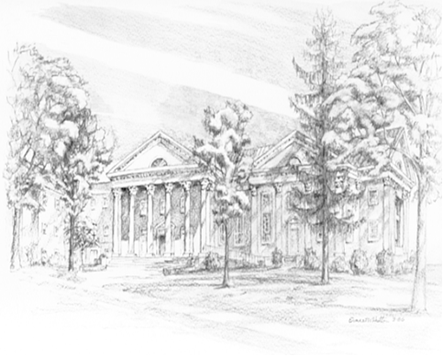
Shenandoah Nursing Home: Rubye Schwab Summit Square: Lillian Hryshkanych
Home: Dick Huff, Nancy Garber, Mary Ultee, Edie Lawrence, Mary Ann Maupin

Friends and Family: Marianne Beck, Erwin Berry (Joan), Shae Blackwell and Family (Preschool), Bill Bromley, Colleen Cash, Mary Gillenwater, Lorene Henderson, Grace Measles (Jen Jones), Bill Metzel (Joyce Tipton), Col. Stuart Roberts (Mark Henderson), Andy & Jean Robeson, (Cunninghams), Jennifer & Charlotte Sergeant (Kathy Brown), Danny Smith (Nancy Hypes), Steve Stevens, Alissa Voils (Pam Leech), Paul Watts, (Colleen Cash).

Military: Carson Craig, Jeremiah Henderson.

Missionaries: Elmarie & Scott Parker, PC (USA) Regional Liaisons to Iraq, Syria & Lebanon

Link for today's service: https://youtu.be/gvUGN5zDz8w
P.O. Box 877
249 South Wayne Avenue
Waynesboro, Virginia
(540) 949-8366
Church Website: www.firstpresway.org
Preschool Website: www.firstprespre.org
Email: church@firstpresway.com

