Sunday of the Baptism of the Lord, redux January 16, 2022

PRELUDE Wie schön leuchtet der Morgenstern I BuxWV 223
Buxtehude (1637-1707)
WELCOME & ANNOUNCEMENTS
INTROIT How Brightly Shines the Morningstar Wie schön leuchte

CALL TO WORSHIP Mark Henderson
Leader: In the beginning was the Word;
People: And the Word was with God, and the Word was God.
Leader: The Word became flesh and lived among us;
People: And we have seen his glory.
Leader: Let us worship God.
MORNING PRAYER
*OPENING HYMN 156 Sing of God Made Manifest SALZBURG
CALL TO CONFESSION

PRAYER OF CONFESSION

In the waters of baptism, O God, you have cleansed us and claimed us. But too often we resist your grace and deny your Holy name. We follow our own paths, and they lead us far from You. Forgive us, Lord, this and all our sin. Help us to live into our baptisms, trusting that You have marked as Your own, loving us without limit. Wash us with Your love again, so that with clean hearts we may go in the way of Jesus Christ.

SILENT PRAYER

ASSURANCE OF PARDON

*GLORIA PATRI #581 GREATOREX

FIRST SCRIPTURE LESSON Isaiah 60: 1-6
ANTHEM What Star is This PUER NOBIS
The text to this week’s anthem can be found in hymn 152.
SECOND SCRIPTURE LESSON Matthew 2:1-12
THE SERMON A political act. Rev. Pettit

*AFFIRMATION OF FAITH The Apostles’ Creed Hymnal p. 35
PASTORAL PRAYER
*CLOSING HYMN 151 We Three Kings Kings of Orient
Please sing the refrain only after verses 1, 4 and 5.

*CHARGE & BENEDICTION
POSTLUDE Wie schön leuchtet der Morgenstern II BuxWV 223 Buxtehude

*PLEASE STAND IF ABLE.

Audio aids are available for your convenience.
Please be aware that they do not function until after the service begins.

FIRST PRESBYTERIAN CHURCH
WAYNESBORO, VIRGINIA

A community-minded congregation living out the love of Christ as we serve one another with humility, gentleness, and patience through God’s grace.

January 9, 2022 11:00 AM

The Legacy: Mary June Cook

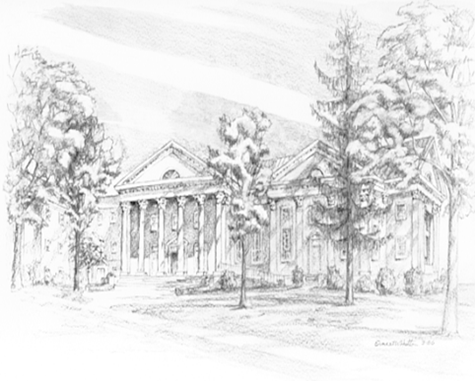
Shenandoah Nursing Home: Rubye Schwab Summit Square: Lillian Hryshkanych
Home: Dick Huff, Nancy Garber, Mary Ultee, Edie Lawrence, Mary Ann Maupin

Friends and Family: Marianne Beck, Erwin Berry (Joan), Shae Blackwell and Family (Preschool), Bill Bromley, Colleen Cash, Mary Gillenwater, Lorene Henderson, Jerry Hughes, Grace Measles (Jen Jones), Bill Metzel (Joyce Tipton), Col. Stuart Roberts (Mark Henderson), Andy & Jean Robeson, (Cunninghams), Jennifer & Charlotte Sergeant (Kathy Brown), Danny Smith (Nancy Hypes), Steve Stevens, Alissa Voils (Pam Leech), Paul Watts, (Colleen Cash).

Military: Carson Craig, Jeremiah Henderson.

Missionaries: Elmarie & Scott Parker, PC (USA) Regional Liaisons to Iraq, Syria & Lebanon

Link for today's service: https://youtu.be/gvUGN5zDz8w

P.O. Box 877
249 South Wayne Avenue
Waynesboro, Virginia
(540) 949-8366
Church Website: www.firstpresway.org
Preschool Website: www.firstprespre.org
Email: church@firstpresway.com

