Epiphany 7 February 20, 2022

PRELUDE Prelude and Fugue in C BuxWV 137 Buxtehude (1637-1707)

WELCOME & ANNOUNCEMENTS

INTROIT Now Enter In Hebble (1934-2020)

CALL TO WORSHIP Bill Pannill

Leader: Take delight in the Lord, who satisfies the desires of your heart.
People: Commit your way to the Lord and trust in God’s actions.
Leader: Be still before the Lord and wait patiently for God.
People: The Lord is our salvation and our refuge in times of trouble.
Leader: Let us worship God.

MORNING PRAYER

*OPENING HYMN 756 O God of Every Nation Llangloffan
CALL TO CONFESSION

PRAYER OF CONFESSION
Merciful God, we confess that we have not followed your ways or trusted your promises. We love only those who love us; we show kindness only to those who are kind to us; we give only when we expect to receive. Forgive us, Lord, this and all our sin. Fill our hearts with your selfless love, and change our lives by your matchless grace; through Christ our Savior.

SILENT PRAYER

ASSURANCE OF PARDON

GLORIA PATRI 581 Greaterex

FIRST SCRIPTURE READING Psalm 37:1-11, 39-40 p. 443

ANTHEM For the Healing of the Nations Wade (1711-1786)
(Text can be found in hymn 346)

SECOND SCRIPTURE READING Luke 6:27-38 p. 838

SERMON Giving as good as you get. Rev. Patrick S. Pettit

AFFIRMATION OF FAITH The Apostles' Creed Hymnal p. 35

PRAYERS OF THE PEOPLE & THE LORD’S PRAYER

*CLOSING HYMN 819 Be Still, My Soul Finlandia

CHARGE and BENEDICTION

POSTLUDE Chaconne BuxWV 137 Buxtehude

Hearing devices are available for your convenience.
Please be aware that they do not function until after the service begins.

The Legacy: Mary June Cook

Shenandoah Nursing Home: Rubye Schwab

Summit Square: Lillian Hryshkanych

Kings Daughters Nursing & Rehab: Richard Curry

Home: Dick Huff, Nancy Garber, Mary Ultee, Edie Lawrence, Mary Ann Maupin

Friends and Family: Marianne Beck, Erwin Berry (Joan), Shae Blackwell and Family (Preschool), Bill Bromley, Mary Gillenwater, Lorene Henderson, Grace Measles (Jen Jones), Bill Metzel (Joyce Tipton), Col. Stuart Roberts (Mark Henderson), Andy & Jean Robeson (Cunninghams), Jennifer & Charlotte Sergeant (Kathy Brown), Danny Smith (Nancy Hypes), Steve Stevens, Alissa Voils (Pam Leech), Paul Watts (Colleen Cash).

Military: Carson Craig, Jeremiah Henderson.

Missionaries: Elmarie & Scott Parker, PC (USA) Regional Liaisons to Iraq, Syria & Lebanon

A Congregational Meeting has been called immediately after worship today to share information with the congregation and hear their thoughts.

Our Christian Sympathies to Anne Wood and family on the death of her son Jeff.
Also to Mike Griffith and family on the death of his Mother in law

Todays link is : https://youtu.be/xoeNMGl-Ogo

FIRST PRESBYTERIAN CHURCH
WAYNESBORO, VIRGINIA

A community-minded congregation living out the love of Christ as we serve one another with humility, gentleness, and patience through God’s grace.

February 20, 2022 11:00 AM

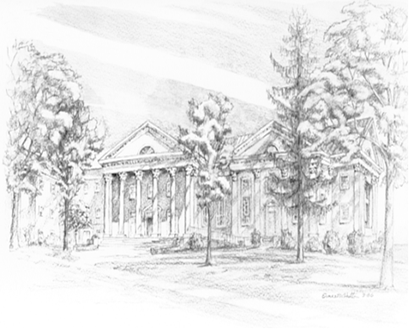

P.O. Box 877
249 South Wayne Avenue
Waynesboro, Virginia
(540) 949-8366
Church Website: www.firstpresway.org
Preschool Website: www.firstprespre.org
Email: church@firstpresway.com

P.O. Box 877
249 South Wayne Avenue
Waynesboro, Virginia
(540) 949-8366
Church Website: www.firstpresway.org
Preschool Website: www.firstprespre.org
Email: church@firstpresway.com

