Transfiguration of the Lord February 27, 2022

PRELUDE How Fair and How Pleasant art Thou, Op. 18, no. 5 Dupré (1886-1971)

WELCOME & ANNOUNCEMENTS

INTROIT Let All The World in Every Corner Sing Routley (1917-1982)

CALL TO WORSHIP Jen Jones
Leader: We see the light of God:
People: On lofty mountain and fertile valley.
Leader: We witness the light of Christ:
People: In his splendor on the mountain and his glorious resurrection.
Leader: We know the light of the Spirit:
People: Eyes and ears open; tongues free to speak.
Leader: Let us worship God.

MORNING PRAYER

*OPENING HYMN 156 Sing of God Made Manifest Salzburg

CALL TO CONFESSION

PRAYER OF CONFESSION
Gracious God, In Jesus, you have shown us a more excellent way, a way of love that is greater than all other. We confess that we have neglected Your love. We ignore it or tie it up with conditions. We make it conform to our terms, unwilling to accept it is boundless. Forgive us, Lord, this and all our sin. Open us to love’s possibilities, and expand our view of what love can accomplish, even in us; in the name of Jesus Christ, we pray.

SILENT PRAYER

ASSURANCE OF PARDON

*GLORIA PATRI 581 Greaterex

FIRST SCRIPTURE READING Psalm 99 p. 480

ANTHEM O Wondrous Sight, O Vision Fair Deo Gracias
(Text can be found in hymn 189)

SECOND SCRIPTURE READING Luke 9:28-36 p. 843

SERMON Better Vision. Rev. Patrick S. Pettit

* AFFIRMATION OF FAITH The Apostles' Creed Hymnal p. 35

PRAYERS OF THE PEOPLE & THE LORD’S PRAYER

*CLOSING HYMN 193 Jesus, Take Us to the Mountain Unser Herrscher
(stanzas 1, 2 and 3)

*CHARGE and BENEDICTION

POSTLUDE Concerto in a: Allegro RV 522/BWV 593 Vivaldi (1678-1741)
Bach (1685-1750)

Hearing devices are available for your convenience.
Please be aware that they do not function until after the service begins.

The Legacy: Mary June Cook

Shenandoah Nursing Home: Rubye Schwab

Summit Square: Lillian Hryshkanych

Kings Daughters Nursing & Rehab: Richard Curry

Home: Dick Huff, Nancy Garber, Mary Ultee, Edie Lawrence, Mary Ann Maupin

Friends and Family: Marianne Beck, Erwin Berry (Joan), Shae Blackwell and Family (Preschool), Bill Bromley, Mary Gillenwater, Lorene Henderson, Grace Measles (Jen Jones), Bill Metzel (Joyce Tipton), Col. Stuart Roberts (Mark Henderson), Andy Robeson (Cunninghams), Jennifer & Charlotte Sergeant (Kathy Brown), Danny Smith (Nancy Hypes), Steve Stevens, Alissa Voils (Pam Leech), Paul Watts, Jerry Hughes (Colleen Cash).

Military: Carson Craig, Jeremiah Henderson.

Missionaries: Elmarie & Scott Parker, PC (USA) Regional Liaisons to Iraq, Syria & Lebanon

Today’s link is : https://youtu.be/Vc3fIjr2zAc

FIRST PRESBYTERIAN CHURCH
WAYNESBORO, VIRGINIA

A community-minded congregation living out the love of Christ as we serve one another with humility, gentleness, and patience through God’s grace.

February 27, 2022 11:00 AM

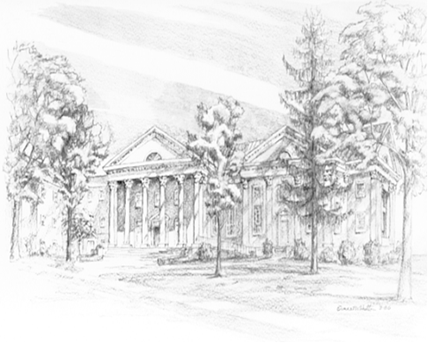

P.O. Box 877
249 South Wayne Avenue
Waynesboro, Virginia
(540) 949-8366
Church Website: www.firstpresway.org
Preschool Website: www.firstprespre.org
Email: church@firstpresway.com

P.O. Box 877
249 South Wayne Avenue
Waynesboro, Virginia
(540) 949-8366
Church Website: www.firstpresway.org
Preschool Website: www.firstprespre.org
Email: church@firstpresway.com

