Epiphany 6 February 6, 2022

PRELUDE Caprice Muffat (1690-1770)

WELCOME & ANNOUNCEMENTS

INTROIT Now Enter In Hebble (1934-2020)

CALL TO WORSHIP Cynthia Hoover
Leader: In his sanctuary, God calls us.
People: In the midst of life, God calls us.
Leader: Let us respond with hearts full!
People Let us sing God’s praise!
Leader: Let us worship God.

MORNING PRAYER

*OPENING HYMN 509 All Who Hunger, Gather Gladly Holy Manna

CALL TO CONFESSION

PRAYER OF CONFESSION
O God, though we walk in the midst of trouble, you preserve and deliver us.
We wander from your way and yet you still call us. Our lips are not clean and
our hearts are not pure; we fail to comprehend your ways. Forgive us, Lord, this and
all our sin. Enrich our spirits by your grace and glory, that we might be healed and set free;
in Jesus’ name, we pray.

SILENT PRAYER

ASSURANCE OF PARDON

*GLORIA PATRI #581 Gretorex

FIRST SCRIPTURE LESSON Psalm 138
ANTHEM The Summons Scottish folk tune/arr Bell (b. 1949)
(Text can be found in hymn 726)

SECOND SCRIPTURE LESSON Luke 5: 1-11
THE SERMON Fishing. Rev. Patrick Pettit

*AFFIRMATION OF FAITH The Apostles’ Creed Hymnal p. 35

THE LORD’S SUPPER
Invitation
Great Thanksgiving
Communion of the People

PASTORAL PRAYER

*CLOSING HYMN 624 To God be the Glory To God be the Glory

*CHARGE & BENEDICTION

POSTLUDE Toccata in E, BWV 566 Bach (1685-1750)
*PLEASE STAND IF ABLE.

Audio aids are available for your convenience.
Please be aware that they do not function until after the service begins.

FIRST PRESBYTERIAN CHURCH
WAYNESBORO, VIRGINIA

A community-minded congregation living out the love of Christ as we serve one another with humility, gentleness, and patience through God’s grace.

February 6, 2022 11:00 AM

The Legacy: Mary June Cook
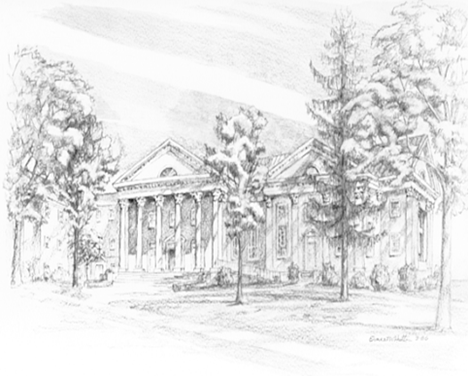
Shenandoah Nursing Home: Rubye Schwab

Summit Square: Lillian Hryshkanych

Kings Daughters Nursing & Rehab: Richard Curry

Home: Dick Huff, Nancy Garber, Mary Ultee, Edie Lawrence, Mary Ann Maupin

Friends and Family: Erwin Berry (Joan), Shae Blackwell and Family (Preschool),
Bill Bromley, Mary Gillenwater, Lorene Henderson, Bill Metzel (Joyce Tipton),
Col. Stuart Roberts (Mark Henderson), Andy & Jean Robeson (Cunninghams),
Jennifer & Charlotte Sergeant (Kathy Brown), Danny Smith (Nancy Hypes),
Alissa Voils (Pam Leech), Paul Watts (Colleen Cash).

Military: Carson Craig, Jeremiah Henderson.

Missionaries: Elmarie & Scott Parker, PC (USA) Regional Liaisons to Iraq, Syria & Lebanon

Link for today's service: https://youtu.be/RQLtf4OEf4o

ALERT! ALERT! ALERT!
P.O. Box 877
249 South Wayne Avenue
Waynesboro, Virginia
(540) 949-8366
Church Website: www.firstpresway.org
Preschool Website: www.firstprespre.org
Email: church@firstpresway.com

Please let someone in the Church Office know
if you are sick, in the hospital, or need a visit. We’re not nearly as smart as you
might think we are! It’s disheartening for us to find that someone who needed
a hospital visit has already returned home. Your staff, deacons and elders want to
“be there” for their church family, but we need to know what’s going on.
You can always leave a message (949-8366) or call a person with whom you have a special bond.

