Epiphany 6 February 7, 2022

PRELUDE
WELCOME & ANNOUNCEMENTS
INTROIT

CALL TO WORSHIP

MORNING PRAYER
*OPENING HYMN

CALL TO CONFESSION

PRAYER OF CONFESSION
SILENT PRAYER

ASSURANCE OF PARDON

GLORIA PATRI 581 Greaterex

FIRST SCRIPTURE READING

ANTHEM

SECOND SCRIPTURE READING

SERMON Rev. Patrick S. Pettit

AFFIRMATION OF FAITH. The Apostles' Creed. Hymnal, p. 35

PRAYERS OF THE PEOPLE & THE LORD’S PRAYER

*CLOSING HYMN

CHARGE and BENEDICTION

POSTLUDE

Hearing devices are available for your convenience.
Please be aware that they do not function until after the service begins.

The Legacy: Mary June Cook

Shenandoah Nursing Home: Rubye Schwab

Summit Square: Lillian Hryshkanych

Kings Daughter Nursing & Rehab: Richard Curry

Home: Dick Huff, Nancy Garber, Mary Ultee, Edie Lawrence, Mary Ann Maupin

Friends and Family: Marianne Beck, Erwin Berry (Joan), Shae Blackwell and Family (Preschool), Bill Bromley, Mary Gillenwater, Lorene Henderson, Grace Measles (Jen Jones), Bill Metzel (Joyce Tipton), Col. Stuart Roberts (Mark Henderson), Andy & Jean Robeson (Cunninghams), Jennifer & Charlotte Sergeant (Kathy Brown), Danny Smith (Nancy Hypes), Steve Stevens, Alissa Voils (Pam Leech), Paul Watts (Colleen Cash).

Military: Carson Craig, Jeremiah Henderson.

Missionaries: Elmarie & Scott Parker, PC (USA) Regional Liaisons to Iraq, Syria & Lebanon

Our Christian Sympathies to Anne Wood and family, at the death of her son Jeff.

Link for today's service:

FIRST PRESBYTERIAN CHURCH
WAYNESBORO, VIRGINIA

A community-minded congregation living out the love of Christ as we serve one another with humility, gentleness, and patience through God’s grace.

February 13, 2022 11:00 AM

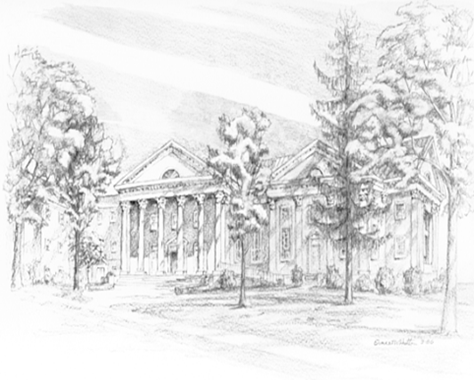

P.O. Box 877
249 South Wayne Avenue
Waynesboro, Virginia
(540) 949-8366
Church Website: www.firstpresway.org
Preschool Website: www.firstprespre.org
Email: church@firstpresway.com

P.O. Box 877
249 South Wayne Avenue
Waynesboro, Virginia
(540) 949-8366
Church Website: www.firstpresway.org
Preschool Website: www.firstprespre.org
Email: church@firstpresway.com

