First Sunday of Lent March 6, 2022

PRELUDE Plein Jeu, Duo, Trio Clérambault (1676-1749)

WELCOME & ANNOUNCEMENTS

INTROIT 576 Lord, Have Mercy Singapura
(Sung twice by the congregation)

CALL TO WORSHIP
Leader: We who dwell in the shelter of the Most High, and abide under the shadow
of the Almighty:
People: We shall say to the Lord: Our refuge and our stronghold, our God in
whom we put our trust.
Leader: We call on the Lord, confident he will answer. Let us worship God.

MORNING PRAYER

*OPENING HYMN 43 You Who Dwell in the Shelter of the Lord On Eagle’s Wings

CALL TO CONFESSION

PRAYER OF CONFESSION
Almighty God, our refuge, and our fortress; we confess we are often tempted
to seek bread that does not satisfy. We forget what you have done for us, and
chase after other gods, even when we know they are false. Time after time, we
complain after our lot and put you to the test. Forgive us, Lord, this and all our sin.
Empower us to remember your salvation and to live into the promise in our risen
Savior, Jesus Christ, whom we confess as Lord. Amen.

SILENT PRAYER

ASSURANCE OF PARDON

*GLORIA PATRI #581 Gretorex

FIRST SCRIPTURE LESSON Psalm 91 p. 477

ANTHEM Sonata in D, Hob. XVI/37: Largo e sostenuto Haydn (1732-1809) Charles Simpkins, piano

SECOND SCRIPTURE LESSON Deuteronomy 26:1-11 p. 158
THE SERMON Can you spare some change? Rev. Patrick Pettit

*AFFIRMATION OF FAITH The Apostles’ Creed Hymnal p. 35

THE LORD’S SUPPER
Invitation
Great Thanksgiving
Communion of the People

PASTORAL PRAYER

*CLOSING HYMN 167 Forty Days and Forty Nights Aus Der Tiefe Rufe Ich

*CHARGE & BENEDICTION

POSTLUDE Basse de Trompette, Grand Jeu Clérambault
*PLEASE STAND IF ABLE.

Audio aids are available for your convenience.
Please be aware that they do not function until after the service begins.

P.O. Box 877
249 South Wayne Avenue
Waynesboro, Virginia
(540) 949-8366
Church Website: www.firstpresway.org
Preschool Website: www.firstprespre.org
Email: church@firstpresway.com

The Legacy: Mary June Cook

Shenandoah Nursing Home: Rubye Schwab

Summit Square: Lillian Hryshkanych

Home: Dick Huff, Nancy Garber, Mary Ultee, Edie Lawrence, Mary Ann Maupin, Richard Curry

Friends and Family: Erwin Berry (Joan), Shae Blackwell and Family (Preschool),
Bill Bromley, Mary Gillenwater, Lorene Henderson, Bill Metzel (Joyce Tipton),
Col. Stuart Roberts (Mark Henderson), Andy Robeson (Cunningham’s),
Jennifer & Charlotte Sergeant (Kathy Brown), Danny Smith (Nancy Hypes),
Alissa Voils (Pam Leech), Paul Watts, Jerry Hughes (Colleen Cash).

Military: Carson Craig, Jeremiah Henderson.

Missionaries: Elmarie & Scott Parker, PC (USA) Regional Liaisons to Iraq, Syria & Lebanon

Link for today's service: https://youtu.be/j7IAzGvuGMo

FIRST PRESBYTERIAN CHURCH
WAYNESBORO, VIRGINIA

A community-minded congregation living out the love of Christ as we serve one another with humility, gentleness, and patience through God’s grace.

March 6, 2022 11:00 AM

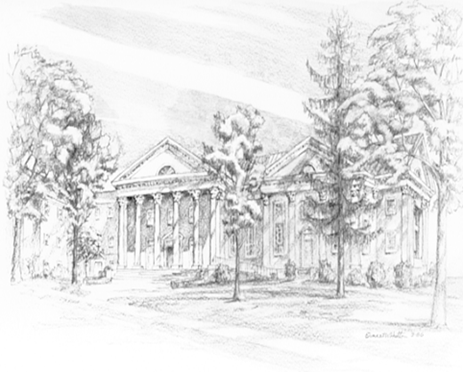

249 South Wayne Avenue
Waynesboro, Virginia
(540) 949-8366
Church Website: www.firstpresway.org
Preschool Website: www.firstprespre.org
Email: church@firstpresway.com

