Second Sunday in Lent March 13, 2022

PRELUDE Variations Sweelinck (1562-1621)

WELCOME & ANNOUNCEMENTS

INTROIT 576 Lord, Have Mercy Singapura
(sung twice by the congregation)

CALL TO WORSHIP Joan Berry
Leader: Wait for the Lord.
People: We gather in response to God’s promise.
Leader: Be strong, take heart, and wait for the Lord.
People: We gather in hope and expectation
Leader: Let us worship God.

MORNING PRAYER

*OPENING HYMN 816 If Thou But Trust in God to Guide Thee Wer nur den lieben Gott

CALL TO CONFESSION

PRAYER OF CONFESSION
O Lord, you are the shield and stronghold of our lives, but we confess our neglect of your gracious covenant. Though you have granted us citizenship in heaven, we concern ourselves with earthly things; though your Son has borne the cross for our redemption, we remain preoccupied with matters of the flesh. Forgive us, Lord, this and all our sin. Transform us by your glory and the power into the citizens of heaven you intend us to be; in the name of Christ Jesus. Amen.

SILENT PRAYER

ASSURANCE OF PARDON

*GLORIA PATRI 581 Greaterex

FIRST SCRIPTURE READING Psalm 27 p. 437

ANTHEM The Lord Is My Light Allisten (1848-1912)
Jean Hashagen, soloist
Text from Psalm 27

The Lord is my light and my salvation, whom, then, shall I fear?
The Lord is the strength of my life, of whom , then, shall I be afraid?
Though an host of men were laid against me, yet shall not my heart be afraid:
And tho there 'rose up war against me, yet I will put my trust in Him
For, in the time of trouble, He shall hide me in His tabernacle,
Yea, in the secret places of His dwelling shall He hide me, and upon a rock of stone.

SECOND SCRIPTURE READING Philippians 3:17-4:1 p. 955

SERMON A civics lessons. Rev. Patrick S. Pettit

*AFFIRMATION OF FAITH The Apostles' Creed Hymnal p. 35

PRAYERS OF THE PEOPLE & THE LORD’S PRAYER

*CLOSING HYMN 12 Immortal, Invisible, God Only Wise St. Denio

*CHARGE and BENEDICTION

POSTLUDE Fantasie in c, BWV 562 Bach (1685-1750)

Hearing devices are available for your convenience.
Please be aware that they do not function until after the service begins.

The Legacy: Mary June Cook

Shenandoah Nursing Home: Rubye Schwab

Summit Square: Lillian Hryshkanych

Home: Dick Huff, Nancy Garber, Mary Ultee, Edie Lawrence, Mary Ann Maupin

Friends and Family: Marianne Beck, Erwin Berry (Joan), Shae Blackwell and Family (Preschool), Bill Bromley, Mary Gillenwater, Grace Measles (Jen Jones), Bill Metzel (Joyce Tipton), Col. Stuart Roberts (Mark Henderson), Andy Robeson (Cunninghams), Jennifer & Charlotte Sergeant (Kathy Brown), Danny Smith (Nancy Hypes), Steve Stevens, Alissa Voils (Pam Leech), Paul Watts, Jerry Hughes (Colleen Cash).

Military: Carson Craig, Jeremiah Henderson.

Missionaries: Elmarie & Scott Parker, PC (USA) Regional Liaisons to Iraq, Syria & Lebanon

Today’s link is : https://youtu.be/KsFXOzIEpf0

Easter Lily orders are due $12.00

BOOK STUDY LENT 2022
Lunch provided
Wednesdays at Noon in the Barksdale Room
March 16, 23, 30 and April 6

FIRST PRESBYTERIAN CHURCH
WAYNESBORO, VIRGINIA

A community-minded congregation living out the love of Christ as we serve one another with humility, gentleness, and patience through God’s grace.

March 13, 2022 11:00 AM

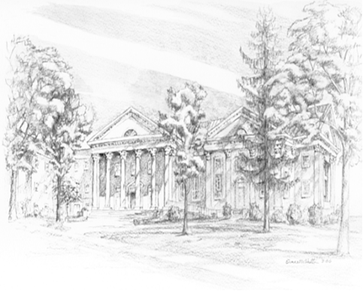

P.O. Box 877
249 South Wayne Avenue
Waynesboro, Virginia
(540) 949-8366
Church Website: www.firstpresway.org
Preschool Website: www.firstprespre.org
Email: church@firstpresway.com

P.O. Box 877
249 South Wayne Avenue
Waynesboro, Virginia
(540) 949-8366
Church Website: www.firstpresway.org
Preschool Website: www.firstprespre.org
Email: church@firstpresway.com

