Third Sunday in Lent March 20, 2022

PRELUDE Etude in d Scarlatti (1685-1757)

WELCOME & ANNOUNCEMENTS

INTROIT 576 Lord, Have Mercy Singapura
(sung twice by the congregation)

CALL TO WORSHIP Linda Sandquist
Leader: Come, all you who are thirsty!
People: We come to the waters.
Leader: Listen to what is good;
People: Our souls will delight in the richest of fare.
Leader: Give ear and come to the Lord.
People: We listen, that our souls may live.
Leader: Let us worship God.

MORNING PRAYER

*OPENING HYMN 442 Just As I Am Woodworth

CALL TO CONFESSION

PRAYER OF CONFESSION
O Lord, you are faithful, providing a way out when we are tested, and setting a limit to what we must endure. We confess that we often fail to choose your way of life, squandering our substance on that which does not satisfy. Forgive us, O Lord, this and all our sin. Grant us mercy and pardon, in the name of Jesus Christ, that we find delight and peace in your presence once again.

SILENT PRAYER

ASSURANCE OF PARDON

*GLORIA PATRI 581 Greaterex

FIRST SCRIPTURE READING Psalm 63, p. 458

ANTHEM Out of the Depths Aus tiefer Not
(text can be found in hymn 424)

SECOND SCRIPTURE READING Luke 13:1-9, p.848

SERMON The “wait and see” Rev. Patrick S. Pettit

*AFFIRMATION OF FAITH The Apostles' Creed Hymnal p. 35

PRAYERS OF THE PEOPLE & THE LORD’S PRAYER

*CLOSING HYMN 182 I Heard the Voice of Jesus Say Kingsfold

*CHARGE and BENEDICTION

POSTLUDE Fugue Mattheson (1681-1764)

Hearing devices are available for your convenience.
Please be aware that they do not function until after the service begins.

The Legacy: Mary June Cook

Shenandoah Nursing Home: Rubye Schwab

Summit Square: Lillian Hryshkanych

Home: Dick Huff, Nancy Garber, Mary Ultee, Edie Lawrence, Mary Ann Maupin

Friends and Family: Marianne Beck, Erwin Berry (Joan), Shae Blackwell and Family (Preschool), Bill Bromley, Grace Measles (Jen Jones), Bill Metzel (Joyce Tipton), Col. Stuart Roberts (Mark Henderson), Andy Robeson (Cunninghams), Jennifer & Charlotte Sergeant (Kathy Brown), Danny Smith (Nancy Hypes), Steve Stevens, Alissa Voils (Pam Leech), Paul Watts, (Colleen Cash).

Military: Carson Craig, Jeremiah Henderson.

Missionaries: Elmarie & Scott Parker, PC (USA) Regional Liaisons to Iraq, Syria & Lebanon

Today’s link is : https://youtu.be/GKsl58muc74

Easter Lily orders are due $12.00

BOOK STUDY LENT 2022
Lunch provided
Wednesdays at Noon in the Barksdale Room
March 23, 30 and April 6

FIRST PRESBYTERIAN CHURCH
WAYNESBORO, VIRGINIA

A community-minded congregation living out the love of Christ as we serve one another with humility, gentleness, and patience through God’s grace.

March 20, 2022 11:00 AM

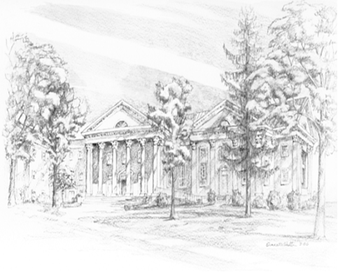

P.O. Box 877
249 South Wayne Avenue
Waynesboro, Virginia
(540) 949-8366
Church Website: www.firstpresway.org
Preschool Website: www.firstprespre.org
Email: church@firstpresway.com

P.O. Box 877
249 South Wayne Avenue
Waynesboro, Virginia
(540) 949-8366
Church Website: www.firstpresway.org
Preschool Website: www.firstprespre.org
Email: church@firstpresway.com

