THE COLUMNS

March 2021, Volume 60, Issue 3
First Presbyterian Church, Waynesboro, VA

First Presbyterian Church of Waynesboro is a community-minded congregation living out the love of Christ as we serve one another with humility, gentleness, and patience through God’s grace.

Sunday Morning Worship Schedule Church Office Hours
11:00 AM—Worship Service; Sanctuary Monday – Wednesday - 8:00 – 2:30
Simulcast at firstpreswayway.com Thursday – 8:00 – 4:30
Friday – Closed
Pastor: Monday - Thursday 10 - 2:30

March Music Notes

If you would like to purchase an Easter Lily in honor or memory of someone, please contact the Church by Monday March 28. Lilies are $12.00 each.

April 17,2022

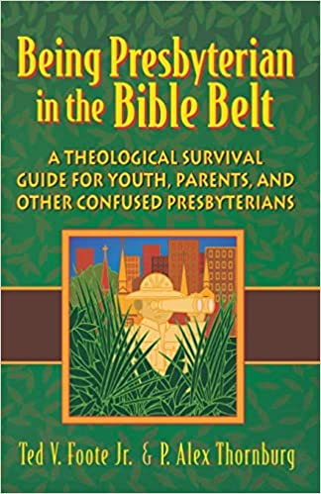
BOOK STUDY LENT 2022
Lunch provided
Wednesdays at Noon in the Barksdale Room
March 9,16,23,30 April 6

Rev. Patrick Pettit will be leading a study on the book,
“ Being Presbyterian in the Bible Belt. “

Please register at:
ccash@firstpresway.com
or call 540-949-8366
to receive a copy of the book.

If you would like to help with lunch,
Please call Joan at 252-508-2101
Or call the office at 540-949-8366

March 2, 2022 Noon

April 14, 2022 Noon

Simple Meal

1 - Sandy Bellamy 8 - Holly Bennett

9 - Steve Doherty 14 - Olive Prettyman

19 - Art Johnson 20 - Pam Hammock

21 - Dick Huff 22 - Buck Hartley

25 - Linda Sandquist

Daylight Savings Time Starts March 13

Calendar

Mailing Address
P. O. Box 877
Waynesboro, VA 22980
Phone
540.949.8366
Fax
540.949.5750
E-mail
church@firstpresway.com
Website
www.firstpresway.org

Church Office Hours
Monday-Wednesday
8 a.m. – 2:30 p.m.
Thursday
8 a.m. – 4:30 p.m.

Interim Pastor
Rev. Patrick S. Pettit
pspettit@gmail.com

Administrative Assistant
Mrs. Colleen Cash
ccash@firstpresway.com

Preschool Director
Nate Rudin
preschool@firstpresway.com

Director of Music
Mr. Roger Daggy
rogerdaggy@gmail.com

Music Associate
Mrs. Kimberlea Daggy
kimberleadaggy@gmail.com

Audio/Visual Technician
Mr. Craig Cavanaugh

Maintenance Technician
Mr. Michael Griffith

Custodian
Mrs. Caroleia Strandburg

Wednesday, March 2
12:00 PM Ash Wednesday Service
Thursday, March 3
6 - 8 PM Food Bank
7- 9:30 PM Symphony Practice
Sunday, March 6
11:00 AM Worship Service—Sanctuary
Tuesday, March 8
Session Meeting Room
Wednesday, March 9
12:00 PM Lenten Book Study-Barksdale Room
Thursday, March 10
2 - 4 PM Food Bank
7 – 9:30 PM Symphony Practice
Friday, March 11
7 – 9:30 PM Symphony Practice
Sunday, March 13
11:00 AM Worship Service—Sanctuary
Wednesday, March 16
12:00PM Lenten Book Study Barksdale Room
Thursday, March 17
2-4 PM Food Bank
Sunday, March 20
11:00 AM Traditional Worship Service—Sanctuary
Wednesday, March 23
12:00PM Lenten Book Study Barksdale Room
Thursday, March 24
6 – 8 PM Food Bank
Sunday, March 27
11:00AM Worship Service Sanctuary
Wednesday, March 30
12:00PM Lenten Book Study Barksdale Room

