Palm Sunday April 10, 2022

PRELUDE Prelude in C, BWV 547 Bach (1685-1750)
WELCOME & ANNOUNCEMENTS

INTROIT Hosanna Mathias (1934-1992)

Holy, holy, holy Lord, God of power and might,
heaven and earth are full of Your glory.
Hosanna in the highest!
Blessed is he that comes in the name of the Lord.
Hosanna in the highest!

THE PROCLAMATION OF THE PALMS Luke 19 :28-40 p.854

CALL TO WORSHIP Danny Leech
Leader: The stone that the builders rejected has become the chief cornerstone.
People: This is the Lord’s doing; it is marvelous in our eyes.
Leader: Blessed is he who comes in the name of the Lord!
People: Hosanna in the highest!
Leader: Let us worship God.

MORNING PRAYER

*OPENING HYMN 197 Hosanna, Loud Hosanna Ellacombe

CALL TO CONFESSION

PRAYER OF CONFESSION

Triumphant God, like the crowds of the ages, we shout your praises; but we confess our lives seldom reflect your will. We sing easily of your greatness but living faithfully is often beyond us. We hear of your salvation, yet sin is still close and real, daily leading us away from you. Forgive us, Lord, this and all our sin. Ride into our hearts with healing grace and save us. Amen.

SILENT PRAYER

ASSURANCE OF PARDON

*GLORIA PATRI 581 Greaterex

FIRST SCRIPTURE READING Psalm 118: 19-29 p. 492

ANTHEM Hosanna Gregor (1723-1801)

Hosanna! Blessed is he that comes in the name of the Lord! Hosanna in the highest!

SECOND SCRIPTURE READING Luke 19: 39-48 p.854

SERMON The world turns. Rev. Patrick S. Pettit

*AFFIRMATION OF FAITH The Apostles' Creed Hymnal p. 35

PRAYERS OF THE PEOPLE & THE LORD’S PRAYER

*CLOSING HYMN 198 Ride On! Ride On in Majesty! St. Drostane

*CHARGE and BENEDICTION

POSTLUDE Fanfare Soler (1729-1773)

Hearing devices are available for your convenience.
Please be aware that they do not function until after the service begins.

The Legacy: Mary June Cook

Shenandoah Nursing Home: Rubye Schwab

Summit Square: Lillian Hryshkanych

Home: Dick Huff, Nancy Garber, Mary Ultee, Edie Lawrence, Mary Ann Maupin

Friends and Family: Erwin Berry (Joan), Shae Blackwell and Family (Preschool), Bill Bromley, Tom Brown, Jerry Hughes, Sally McNeel, Bill Metzel (Joyce Tipton), George Morris Jr., Col. Stuart Roberts (Mark Henderson), Andy Robeson (Cunninghams), Jennifer & Charlotte Sergeant (Kathy Brown), Danny Smith (Nancy Hypes), Alissa Voils (Pam Leech), Ida Waddy, Paul Watts (Colleen Cash).

Military: Carson Craig, Jeremiah Henderson.

Missionaries: Elmarie & Scott Parker, PC (USA) Regional Liaisons to Iraq, Syria & Lebanon

Today’s link is : https://youtu.be/SV7MXEU0GIc

Easter Lily orders are due $12.00

Maundy Thursday Service April 14 at noon with light lunch

BOOK STUDY LENT 2022

Discussions will continue Wednesday at noon in the Barksdale Room
After Easter
Being Presbyterian in the Bible Belt
You are welcome to bring your lunch

FIRST PRESBYTERIAN CHURCH
WAYNESBORO, VIRGINIA

A community-minded congregation living out the love of Christ as we serve one another with humility, gentleness, and patience through God’s grace.

April 10, 2022 11:00 AM

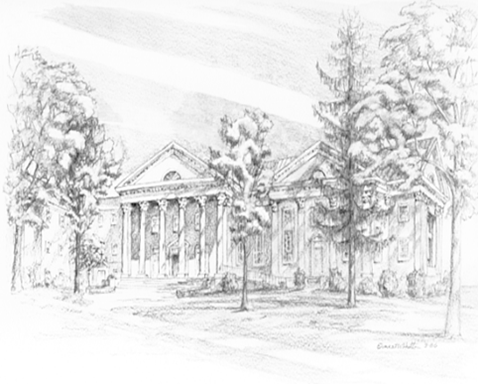

P.O. Box 877
249 South Wayne Avenue
Waynesboro, Virginia
(540) 949-8366
Church Website: www.firstpresway.org
Preschool Website: www.firstprespre.org
Email: church@firstpresway.com

P.O. Box 877
249 South Wayne Avenue
Waynesboro, Virginia
(540) 949-8366
Church Website: www.firstpresway.org
Preschool Website: www.firstprespre.org
Email: church@firstpresway.com

