SECOND SUNDAY of EASTER April 24, 2022

PRELUDE Toccata in E, BWV 566 Bach (1685-1750)

WELCOME & ANNOUNCEMENTS
INTROIT Let All The World Routley (1917-1982)

CALL TO WORSHIP Liturgist – Jean Hashagen

Leader: Praise God in the holy temple.

People: Give praise to God in the highest heaven.

Leader: The Lord is Risen!

People: He is risen indeed!

Leader: Let us worship God.

MORNING PRAYER

*OPENING HYMN 236 The Strife Is O’er Victory

CALL TO CONFESSION

PRAYER OF CONFESSION

O God, you find ways to make Your word fresh and new, even when our hearts are cold, and our minds are closed. We confess sin has led us from your ways, and corrupted our best intentions, making our words less about You and more about ourselves. Forgive us, Lord, this and all our sin. Create within us a place where we welcome You; empower us to share the fullness of what You have given us in Jesus Christ.

SILENT PRAYER

ASSURANCE OF PARDON

*GLORIA PATRI 581 Greatorex

FIRST SCRIPTURE READING Psalm 150 p. 508

ANTHEM Because He Lives Gloria Gaither (b. 1942)
Bill Gaither (b. 1936)
sung by Paul Jones

SECOND SCRIPTURE READING Acts 5:27-41 p. 888

SERMON A life of its own. Rev. Patrick S. Pettit

*AFFIRMATION OF FAITH The Apostles' Creed Hymnal p. 35

PRAYERS OF THE PEOPLE & THE LORD’S PRAYER

*CLOSING HYMN 234 Come You Faithful, Raise the Strain St. Kevin

*CHARGE and BENEDICTION

POSTLUDE Fugue in E, BWV 566 Bach

Hearing devices are available for your convenience.
Please be aware that they do not function until after the service begins.

The Legacy: Mary June Cook

Shenandoah Nursing Home: Rubye Schwab

Summit Square: Lillian Hryshkanych

Home: Dick Huff, Nancy Garber, Mary Ultee, Edie Lawrence, Mary Ann Maupin

Friends and Family: Erwin Berry (Joan), Shae Blackwell and Family (Preschool), Bill Bromley, Tom Brown, Debbie Conner, Jerry Hughes, Sally McNeel, Bill Metzel (Joyce Tipton), George Morris Jr., Col. Stuart Roberts (Mark Henderson), Andy Robeson (Cunninghams), Jennifer & Charlotte Sergeant (Kathy Brown), Danny Smith (Nancy Hypes), Alissa Voils (Pam Leech), Ida Waddy, Paul Watts (Colleen Cash). Rory Leap (Curry).

Military: Carson Craig, Jeremiah Henderson.

Missionaries: Elmarie & Scott Parker, PC (USA) Regional Liaisons to Iraq, Syria & Lebanon

Today’s link is : https://youtu.be/pLr0I5ECeaA

One Great Hour of Sharing Offering will be received during the month of April.
Envelopes are available which may be placed in the Offering Plate in the Narthex
or sent to the Church Office.

BOOK STUDY RESUMES
Being Presbyterian in the Bible Belt
April 27, 2022
Wednesday at Noon in the Barksdale Room
BYOL (Bring your own lunch)

FIRST PRESBYTERIAN CHURCH
WAYNESBORO, VIRGINIA

A community-minded congregation living out the love of Christ as we serve one another with humility, gentleness, and patience through God’s grace.

April 27, 2022 11:00 AM

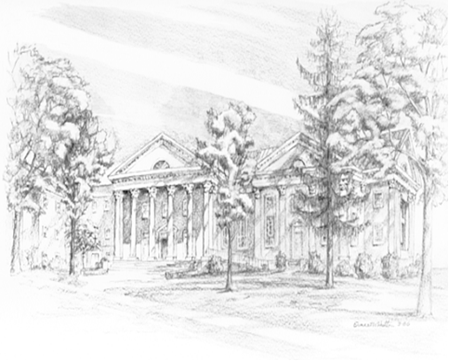

P.O. Box 877
249 South Wayne Avenue
Waynesboro, Virginia
(540) 949-8366
Church Website: www.firstpresway.org
Preschool Website: www.firstprespre.org
Email: church@firstpresway.com

P.O. Box 877
249 South Wayne Avenue
Waynesboro, Virginia
(540) 949-8366
Church Website: www.firstpresway.org
Preschool Website: www.firstprespre.org
Email: church@firstpresway.com

