Fifth Sunday of Lent April 3, 2022

PRELUDE How Blessed are They Whose Toil Is Ended, Op. 122, no. 6 Brahms
(1833-1896)
WELCOME & ANNOUNCEMENTS

INTROIT 576 Lord, Have Mercy Singapura
(Sung twice by the congregation)

CALL TO WORSHIP Sandi Henderson
Leader: If anyone is in Christ, they are a new creation:
People: Everything old has passed away. See, everything has become new!
Leader: We are ambassadors for Christ. God is making an appeal through us.
People: On behalf of Christ, let us all be reconciled to God.
Leader: Let us worship God.

MORNING PRAYER

*OPENING HYMN 367 Come, Ye Thankful People, Come St. George’s Windsor

CALL TO CONFESSION

PRAYER OF CONFESSION
Gracious Lord, our sin leads us astray. In our stubbornness, we go our own way,
and fail to stay near to you. We fail to remember how your righteous Son took on our sin,
that we might be reconciled to you. Forgive us, Lord, this and all our sin. Lead us back to
your path, and empower us to share the message of reconciliation entrusted to us, in the
name of Christ we pray.

SILENT PRAYER

ASSURANCE OF PARDON

*GLORIA PATRI #581 Greatorex

FIRST SCRIPTURE LESSON Psalm 126 p. 499

ANTHEM I Want Jesus To Walk With Me Spiritual
sung by Paul Jones

SECOND SCRIPTURE LESSON Isaiah 43:16-25 p. 585

THE SERMON Looking for the new. Rev. Patrick Pettit

*AFFIRMATION OF FAITH The Apostles’ Creed Hymnal p. 35

THE LORD’S SUPPER
Invitation
Great Thanksgiving
Communion of the People

PASTORAL PRAYER

*CLOSING HYMN 634 To God Be The Glory To God Be The Glory

*CHARGE & BENEDICTION

POSTLUDE Prelude in g, BWV 535 Bach (1685-1750)
*PLEASE STAND IF ABLE.

The flowers in the church are in honor of all who uplift us with music.

Audio aids are available for your convenience.
Please be aware that they do not function until after the service begins.

The Legacy: Mary June Cook

Shenandoah Nursing Home: Rubye Schwab

Summit Square: Lillian Hryshkanych

Home: Dick Huff, Nancy Garber, Mary Ultee, Edie Lawrence, Mary Ann Maupin

Friends and Family: Erwin Berry (Joan), Shae Blackwell and Family (Preschool), Bill Bromley, Tom Brown, Jerry Hughes, Sally McNeel, Bill Metzel (Joyce Tipton), George Morris Jr., Col. Stuart Roberts (Mark Henderson), Andy Robeson (Cunninghams), Jennifer & Charlotte Sergeant (Kathy Brown), Danny Smith (Nancy Hypes), Alissa Voils (Pam Leech), Ida Waddy, Paul Watts (Colleen Cash).

Military: Carson Craig, Jeremiah Henderson.

Missionaries: Elmarie & Scott Parker, PC (USA) Regional Liaisons to Iraq, Syria & Lebanon

Today’s link is : https://youtu.be/3nJNz0e3bI0

Easter Lily orders are due $12.00

BOOK STUDY LENT 2022
Lunch provided
Wednesday at Noon in the Barksdale Room
April 6

Our sympathies to former member Marian Burch of Redding, CA, whose son passed
March 20, 2022.

P.O. Box 877
249 South Wayne Avenue
Waynesboro, Virginia
(540) 949-8366
Church Website: www.firstpresway.org
Preschool Website: www.firstprespre.org
Email: church@firstpresway.com

FIRST PRESBYTERIAN CHURCH
WAYNESBORO, VIRGINIA

A community-minded congregation living out the love of Christ as we serve one another with humility, gentleness, and patience through God’s grace.

April 3, 2022 11:00 AM

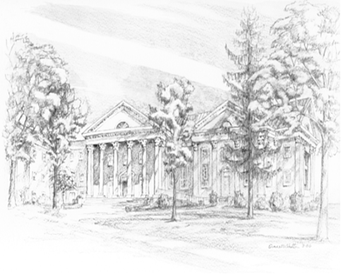

249 South Wayne Avenue
Waynesboro, Virginia
(540) 949-8366
Church Website: www.firstpresway.org
Preschool Website: www.firstprespre.org
Email: church@firstpresway.com

