Fourth Sunday in Lent March 27, 2022

PRELUDE Prelude in A, BWV 536 Bach (1685-1750)
WELCOME & ANNOUNCEMENTS
INTROIT 576 Lord, Have Mercy Singapura
(sung twice by the congregation)

CALL TO WORSHIP Anne Wood
Leader: If anyone is in Christ, they are a new creation:
People: Everything old has passed away.
Leader: We are ambassadors for Christ. God is making an appeal through us.
People: On behalf of Christ, let us all be reconciled to God.
Leader: Let us worship God.

MORNING PRAYER

*OPENING HYMN 336 We Gather Together Kremser

CALL TO CONFESSION

PRAYER OF CONFESSION
Merciful God, like the Prodigal Son, we have squandered our inheritance. You gave us the earth for our home, but we squander earth’s resources and hoard its bounty. You gave us neighbors to love, but we pursue selfish ambitions. You gave us the commandments that lead to human flourishing, but we break your law and forsake your love. Forgive us, Lord, this and all our sin. Draw our wandering hearts back to you, that we may find freedom in obedience to your love. Through Christ our Lord we pray.

SILENT PRAYER

ASSURANCE OF PARDON

*GLORIA PATRI 581 Greaterex

FIRST SCRIPTURE READING Psalm 32 p. 440

ANTHEM What is the World Like Morris (b. 1952)
(text can be found in hymn 771)

SECOND SCRIPTURE READING Luke 15: 1-3, 11-32 p. 850

SERMON Lost and Found. Rev. Patrick S. Pettit

*AFFIRMATION OF FAITH The Apostles' Creed Hymnal p. 35

PRAYERS OF THE PEOPLE & THE LORD’S PRAYER

*CLOSING HYMN 440 Jesus, Lover of My Soul Aberstwyth

*CHARGE and BENEDICTION

POSTLUDE Fugue on B-A-C-H, Op. 60, no. 6 Schumann (1810-1856)

Hearing devices are available for your convenience.
Please be aware that they do not function until after the service begins.

This week, FPC Director of Music/Organist Roger Daggy will resume his First Friday Organ Recital and Light Luncheon programs! Please join us in the Sanctuary on Friday, 1 April, at 12:15 for a concert of music ideal for FPC's 1893 Woodberry and Harris pipe organ. We are grateful to Susan Johnson for coordinating the light repast which will follow the program. We look forward to seeing you at Roger's 23rd First Friday program - no foolin'!

The Legacy: Mary June Cook

Shenandoah Nursing Home: Rubye Schwab

Summit Square: Lillian Hryshkanych

Home: Dick Huff, Nancy Garber, Mary Ultee, Edie Lawrence, Mary Ann Maupin

Friends and Family: Erwin Berry (Joan), Shae Blackwell and Family (Preschool), Bill Bromley, Tom Brown, Sally McNeel, Bill Metzel (Joyce Tipton), George Morris Jr., Col. Stuart Roberts (Mark Henderson), Andy Robeson (Cunninghams), Jennifer & Charlotte Sergeant (Kathy Brown), Danny Smith (Nancy Hypes), Alissa Voils (Pam Leech), Ida Waddy, Paul Watts (Colleen Cash).

Military: Carson Craig, Jeremiah Henderson.

Missionaries: Elmarie & Scott Parker, PC (USA) Regional Liaisons to Iraq, Syria & Lebanon

Today’s link is : https://youtu.be/HqxbxZ8iaW4

Easter Lily orders are due $12.00

BOOK STUDY LENT 2022
Lunch provided
Wednesdays at Noon in the Barksdale Room
March 30 and April 6

FIRST PRESBYTERIAN CHURCH
WAYNESBORO, VIRGINIA

A community-minded congregation living out the love of Christ as we serve one another with humility, gentleness, and patience through God’s grace.

March 27, 2022 11:00 AM

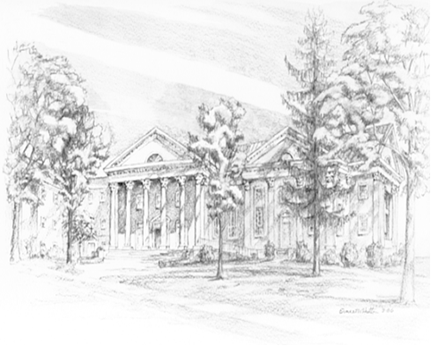

P.O. Box 877
249 South Wayne Avenue
Waynesboro, Virginia
(540) 949-8366
Church Website: www.firstpresway.org
Preschool Website: www.firstprespre.org
Email: church@firstpresway.com

P.O. Box 877
249 South Wayne Avenue
Waynesboro, Virginia
(540) 949-8366
Church Website: www.firstpresway.org
Preschool Website: www.firstprespre.org
Email: church@firstpresway.com

