FIFTH SUNDAY of EASTER May 15, 2022

PRELUDE Fugue in C, BuxWV 174 Buxtehude (1637-1707)

WELCOME & ANNOUNCEMENTS

INTROIT Now Enter In Hebble (1934-2020)

CALL TO WORSHIP Liturgist – Betsy Ruehl
Leader: Let everything that has being praise the name of the Lord!
People: Young men and women alike, old and young together shall praise the name of the Lord.
Leader: The Lord is risen!
People: He is risen indeed!
Leader: Let us worship God

MORNING PRAYER

*OPENING HYMN 667 When Morning Gilds the Skies Laudes Domine

CALL TO CONFESSION

PRAYER OF CONFESSION

Holy God, we long for you to make us whole, for sin has stained and scarred us. We worship you with our lips, but not with our hearts. We follow you with our words, but not with our lives. Our habits are those of convenience; they reinforce only our guilt. Forgive us, Lord, this and all our sin. Complete us, that we might go forward in the way of Jesus Christ.

SILENT PRAYER

ASSURANCE OF PARDON

*GLORIA PATRI 581 Greatorex

FIRST SCRIPTURE READING Psalm 148 p. 508

ANTHEM Come, Ye Sinners, Poor and Needy Walker (1809-1875)

SECOND SCRIPTURE READING Acts 11:1-18 p. 895

REFLECTIONS Jean Hashagen, Elder

HYMN OF MEDITATION 450 Be Thou my Vision Slane

*AFFIRMATION OF FAITH The Apostles' Creed Hymnal p. 35

PRAYERS OF THE PEOPLE & THE LORD’S PRAYER

*CLOSING HYMN 611 Joyful, Joyful, We Adore Thee Hymn to Joy

*CHARGE and BENEDICTION

POSTLUDE Concerto in G: Presto BWV 592 Ernst (1696-1715)
Bach (1685-1750)

Hearing devices are available for your convenience.
Please be aware that they do not function until after the service begins.

The Legacy: Mary June Cook

Shenandoah Nursing Home: Rubye Schwab

Summit Square: Lillian Hryshkanych

Home: Dick Huff, Nancy Garber, Mary Ultee, Edie Lawrence, Mary Ann Maupin

Friends and Family: Erwin Berry (Joan), Shae Blackwell and Family (Preschool), Bill Bromley, Tom Brown, Debbie Conner, Jerry Hughes, Sally McNeel, Bill Metzel (Joyce Tipton), George Morris Jr., Col. Stuart Roberts (Mark Henderson), Andy Robeson (Cunninghams), Jennifer & Charlotte Sergeant (Kathy Brown), Danny Smith (Nancy Hypes), Ida Waddy, Paul Watts (Colleen Cash), Rory Leap (Currys).

Military: Carson Craig, Jeremiah Henderson.

Missionaries: Elmarie & Scott Parker, PC (USA) Regional Liaisons to Iraq, Syria & Lebanon

Today’s link is : https://youtu.be/sDAzjPvR1YQ

Our Christian sympathies to the family of William (Bill) Kiser who passed on May 8, 2022.

Book Study, Being Presbyterian in the Bible Belt, to be rescheduled.

FIRST PRESBYTERIAN CHURCH
WAYNESBORO, VIRGINIA

A community-minded congregation living out the love of Christ as we serve one another with humility, gentleness, and patience through God’s grace.

May 15, 2022 11:00 AM

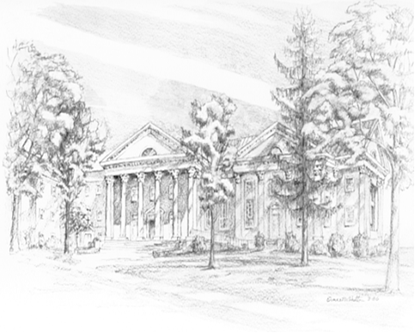

P.O. Box 877
249 South Wayne Avenue
Waynesboro, Virginia
(540) 949-8366
Church Website: www.firstpresway.org
Preschool Website: www.firstprespre.org
Email: church@firstpresway.com

P.O. Box 877
249 South Wayne Avenue
Waynesboro, Virginia
(540) 949-8366
Church Website: www.firstpresway.org
Preschool Website: www.firstprespre.org
Email: church@firstpresway.com

