SIXTH SUNDAY of EASTER May 22, 2022

PRELUDE My Heart Leaps With Joy Walcha (1907-1991)

WELCOME & ANNOUNCEMENTS

INTROIT What Does the Lord Require Routley (1917-1982)

CALL TO WORSHIP Warner Sandquist

Leader: Let the nations be glad and sing for joy.

People: For you judge the peoples with equity and guide the nations upon earth.

Leader: The Lord is risen!

People: He is risen indeed!

Leader: Let us worship God

MORNING PRAYER

*OPENING HYMN 265 Jesus Shall Reign Wher’er the Sun Duke Street

CALL TO CONFESSION

PRAYER OF CONFESSION

Almighty God, Jesus came to bring a peace that stills our hearts and calms our fears; but we struggle to receive what he offers. Peace is elusive in our world, but also in our homes, in our relationships – even within ourselves. We live with envy and dissatisfaction. Forgive us, Lord, this and all our sin. Release from these burdens, and open us to the peace of Christ, the peace that passes understanding.

SILENT PRAYER

ASSURANCE OF PARDON

*GLORIA PATRI 581 Greatorex

FIRST SCRIPTURE READING Psalm 67 p. 460

SPECIAL MUSIC Intermezzo in B-flat, Op. 76, no. 4 Brahms (1833-1897)
SECOND SCRIPTURE READING John 14:15-24 p. 877

REFLECTIONS Jean Hashagen, Elder

*AFFIRMATION OF FAITH The Apostles' Creed Hymnal p. 35

PRAYERS OF THE PEOPLE & THE LORD’S PRAYER

*CLOSING HYMN 366 Love Divine, All Loves Excelling Hyfrodol

*CHARGE and BENEDICTION

POSTLUDE Toccata Muffat (1653-1704)

The Madison Singers Return to First Presbyterian Church!

We are blessed, once again, to host The Madison Singers in concert at First Presbyterian Church this Saturday! The premiere choral ensemble at James Madison University previously performed at FPC in May 2019. This is the ensemble's first tour since the lifting of pandemic precautions. The free concert will be Saturday 28 May at 3pm. Bring your friends!

Hearing devices are available for your convenience.
Please be aware that they do not function until after the service begins.

The Legacy: Mary June Cook

Regency at Augusta: Edie Lawrence

Shenandoah Nursing Home: Rubye Schwab

Summit Square: Lillian Hryshkanych

Home: Dick Huff, Nancy Garber, Mary Ultee, Mary Ann Maupin, Mike Cunningham

Friends and Family: Erwin Berry (Joan), Shae Blackwell and Family (Preschool), Bill Bromley, Tom Brown, Debbie Conner, Jerry Hughes, Sally McNeel, Bill Metzel (Joyce Tipton), George Morris Jr., Col. Stuart Roberts (Mark Henderson), Andy Robeson (Cunninghams), Jennifer & Charlotte Sergeant (Kathy Brown), Danny Smith (Nancy Hypes), Ida Waddy, Paul Watts (Colleen Cash), Rory Leap (Currys).

Military: Carson Craig, Jeremiah Henderson.

Missionaries: Elmarie & Scott Parker, PC (USA) Regional Liaisons to Iraq, Syria & Lebanon

Today’s link is : https://youtu.be/ZM-_s7L8Fbk

Book Study, Being Presbyterian in the Bible Belt, to be rescheduled.

FIRST PRESBYTERIAN CHURCH
WAYNESBORO, VIRGINIA

A community-minded congregation living out the love of Christ as we serve one another with humility, gentleness, and patience through God’s grace.

May 22, 2022 11:00 AM

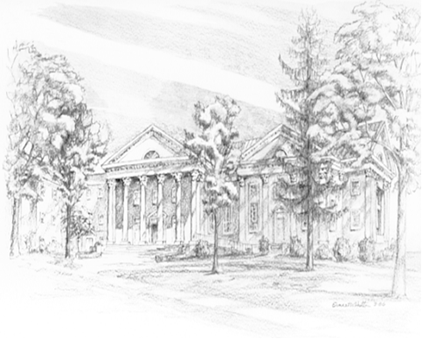

P.O. Box 877
249 South Wayne Avenue
Waynesboro, Virginia
(540) 949-8366
Church Website: www.firstpresway.org
Preschool Website: www.firstprespre.org
Email: church@firstpresway.com

P.O. Box 877
249 South Wayne Avenue
Waynesboro, Virginia
(540) 949-8366
Church Website: www.firstpresway.org
Preschool Website: www.firstprespre.org
Email: church@firstpresway.com

