FOURTH SUNDAY of EASTER May 8, 2022

PRELUDE Pastorale: I Bach (1685-1750)

WELCOME & ANNOUNCEMENTS

INTROIT Fanfare for Easter Season

CALL TO WORSHIP Liturgist – Cynthia Hoover

Leader: The Lamb that was slain has become our shepherd.

People: Christ will guide us to springs flowing with the water of life.

Leader: The Lord is risen!

People: He is risen indeed!

Leader: Let us worship God

MORNING PRAYER

*OPENING HYMN 803 My Shepherd Will Supply My Need Resignation

CALL TO CONFESSION

PRAYER OF CONFESSION

Lord of grace, in Jesus, you have shown us love that seeks, love that suffers, love that survives all things. You call us to show that love in our lives, yet we turn away. We confess the ways of love are not our ways. We deny and ignore, hurt and hate, despise and reject. Forgive us, Lord, this and all our sin. Help us to receive your love, and to share it with others; for the sake of our Risen Lord.

SILENT PRAYER

ASSURANCE OF PARDON

*GLORIA PATRI 581 Greatorex

FIRST SCRIPTURE READING Psalm 23 p. 435

ANTHEM The King of Love My Shepherd Is Traditional Irish
(Text can be found in hymn 802)

SECOND SCRIPTURE READING Acts 9:36-43 p. 894

SERMON Time of Meditation
Roger will play soothing hymn
*AFFIRMATION OF FAITH The Apostles' Creed Hymnal p. 35

PRAYERS OF THE PEOPLE & THE LORD’S PRAYER

*CLOSING HYMN 250 In the Bulb There is a Flower Promise

*CHARGE and BENEDICTION

POSTLUDE Pastorale: IV Bach

Flowers in the sanctuary are in honor of all mothers.

Hearing devices are available for your convenience.
Please be aware that they do not function until after the service begins.

The Legacy: Mary June Cook

Shenandoah Nursing Home: Rubye Schwab

Summit Square: Lillian Hryshkanych

Home: Dick Huff, Nancy Garber, Mary Ultee, Edie Lawrence, Mary Ann Maupin

Friends and Family: Erwin Berry (Joan), Shae Blackwell and Family (Preschool), Bill Bromley, Tom Brown, Debbie Conner, Jerry Hughes, Sally McNeel, Bill Metzel (Joyce Tipton), George Morris Jr., Col. Stuart Roberts (Mark Henderson), Andy Robeson (Cunninghams), Jennifer & Charlotte Sergeant (Kathy Brown), Danny Smith (Nancy Hypes), Ida Waddy, Paul Watts (Colleen Cash), Rory Leap (Currys).

Military: Carson Craig, Jeremiah Henderson.

Missionaries: Elmarie & Scott Parker, PC (USA) Regional Liaisons to Iraq, Syria & Lebanon

Today’s link is : https://youtu.be/Lsz_TGWCN-Q

Book Study, Being Presbyterian in the Bible Belt, continues Wednesday at noon.

FIRST PRESBYTERIAN CHURCH
WAYNESBORO, VIRGINIA

A community-minded congregation living out the love of Christ as we serve one another with humility, gentleness, and patience through God’s grace.

May 8, 2022 11:00 AM

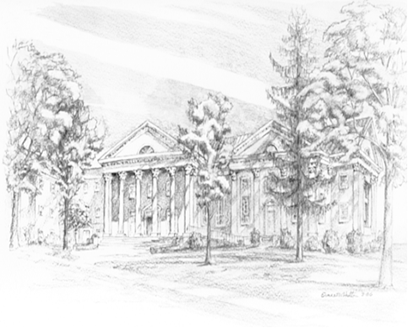

P.O. Box 877
249 South Wayne Avenue
Waynesboro, Virginia
(540) 949-8366
Church Website: www.firstpresway.org
Preschool Website: www.firstprespre.org
Email: church@firstpresway.com

P.O. Box 877
249 South Wayne Avenue
Waynesboro, Virginia
(540) 949-8366
Church Website: www.firstpresway.org
Preschool Website: www.firstprespre.org
Email: church@firstpresway.com

