Third Sunday of Easter May 1, 2022

PRELUDE Prelude, Op. 31, no. 5 Vierne (1770-1937)

WELCOME & ANNOUNCEMENTS

INTROIT Now Enter In Hebble (1934-2020)

CALL TO WORSHIP

Leader: Worthy is the Lamb that was slain!

People: He is worthy of honor and glory and blessing!

Leader: The Lord is risen!

People: He is risen indeed!

Leader: Let us worship God

MORNING PRAYER

*OPENING HYMN 246 Christ Is Alive! Truro

CALL TO CONFESSION

PRAYER OF CONFESSION

Loving God, you tend us gently and care for us completely, and yet we wander and stray, finding, to our shock, that our own way puts us in opposition to you. At the foot of the cross, you still call to us; at the empty tomb, you beckon to us. Forgive us, Lord; take away our sin. Transform our hearts, and fill us with goodness and mercy, we pray in the name of Jesus, our risen Lord.

SILENT PRAYER

ASSURANCE OF PARDON

*GLORIA PATRI #581 Gretorex

FIRST SCRIPTURE LESSON Psalm 30 p. 439
ANTHEM Alleluia! Alleluia, Give Thanks to the Risen Lord Fishel (b.1950)
(text can be found in hymn 240)

SECOND SCRIPTURE LESSON Acts 9:1-20 p. 893

THE SERMON The most important day we don’t celebrate. Rev. Patrick Pettit

*AFFIRMATION OF FAITH The Apostles’ Creed Hymnal p. 35

THE LORD’S SUPPER
Invitation
Great Thanksgiving
Communion of the People

PASTORAL PRAYER

*CLOSING HYMN 245 Christ the Lord is Risen Today Llanfair

*CHARGE & BENEDICTION

POSTLUDE Sonata in B-flat, Op. 65, no. 4: Allegro con brio
Mendelssohn (1809-1847)

*PLEASE STAND IF ABLE.

Audio aids are available for your convenience.
Please be aware that they do not function until after the service begins.

Shenandoah Nursing Home: Rubye Schwab

Legacy at North Augusta Mary June Cook

Summit Square: Lillian Hryshkanych

Home: Dick Huff, Nancy Garber, Mary Ultee, Edie Lawrence, Mary Ann Maupin

Friends and Family: Erwin Berry (Joan), Shae Blackwell and Family (Preschool),
Bill Bromley, Tom Brown, Debbie Conner, Jerry Hughes, Sally McNeel, Bill Metzel (Joyce Tipton), George Morris Jr., Col. Stuart Roberts (Mark Henderson),
Andy Robeson (Cunninghams), Jennifer & Charlotte Sergeant (Kathy Brown),
Danny Smith (Nancy Hypes), Ida Waddy, Paul Watts (Colleen Cash), Rory Leap (Currys).

Military: Carson Craig, Jeremiah Henderson.

Missionaries: Elmarie & Scott Parker, PC (USA) Regional Liaisons to Iraq,
Syria & Lebanon

Link for today's service: https://youtu.be/inG-lCT3o5k

FIRST PRESBYTERIAN CHURCH
WAYNESBORO, VIRGINIA

A community-minded congregation living out the love of Christ as we serve one another with humility, gentleness, and patience through God’s grace.

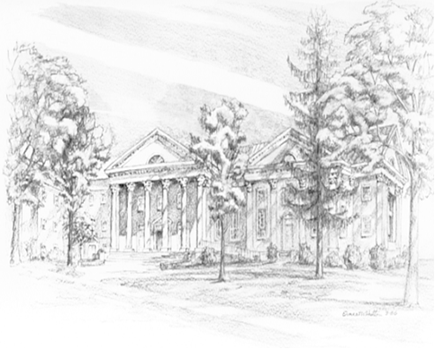
May 1, 2022 11:00 AM

P.O. Box 877
249 South Wayne Avenue
Waynesboro, Virginia
(540) 949-8366
Church Website: www.firstpresway.org
Preschool Website: www.firstprespre.org
Email: church@firstpresway.com

