Fourth Sunday after Pentecost July 3, 2022

PRELUDE Prelude, Op. 50, no. 5 Foote (1853-1937)

WELCOME & ANNOUNCEMENTS

INTROIT Lift Every Voice and Sing Johnson (1873-1954)

CALL TO WORSHIP
Leader: Sing to the Lord, you faithful servants.
People: Give thanks to God’s holy name.
Leader: God’s wrath lasts but the twinkling of an eye,
People: But God’s favor endures for a lifetime.
Leader: Weeping may spend the night,
People: But joy comes in the morning.
Leader: Let us worship God.

MORNING PRAYER

*OPENING HYMN 662 Christ, Whose Glory Fills the Skies Ratisbon

CALL TO CONFESSION

PRAYER OF CONFESSION
God of perfect love, who transforms death to life; we look to you to change our hearts. Take away the sin that burdens us and make of us the people you would have us be. We are weak, but you are strong. Our ways are flawed, but your ways are true. We are seldom right, but you are never wrong. Forgive us, redeem us, transform us, for the sake of Jesus Christ our Savior. Amen.

SILENT PRAYER

ASSURANCE OF PARDON

*GLORIA PATRI #581 Gretorex

FIRST SCRIPTURE LESSON Luke 10:1-11 p. 844

ANTHEM Studio in g minor Scarlatti (1685-1757)

SECOND SCRIPTURE LESSON Luke 10:16-20 p. 844

SERMON Notes on God’s power. Rev Patrick Pettit

*AFFIRMATION OF FAITH The Apostles’ Creed Hymnal p. 35

THE LORD’S SUPPER
Invitation
Great Thanksgiving
Communion of the People

PASTORAL PRAYER

*CLOSING HYMN 337 My Country, ‘Tis of Thee America

*CHARGE & BENEDICTION

POSTLUDE Introduction and Anthem Smith (1750-1836)
arr. Daggy

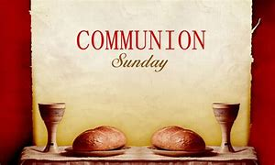

*PLEASE STAND IF ABLE.

Link for this week’s service is: https://youtu.be/bwsAK8xZ4TM

Audio aids are available for your convenience.
Please be aware that they do not function until after the service begins.

P.O. Box 877
249 South Wayne Avenue
Waynesboro, Virginia
(540) 949-8366
Church Website: www.firstpresway.org
Preschool Website: www.firstprespre.org
Email: church@firstpresway.com

The Legacy: Mary June Cook

Regency at Augusta: Edie Lawrence

Shenandoah Nursing Home: Rubye Schwab

Summit Square: Lillian Hryshkanych

Home: Dick Huff, Nancy Garber, Mary Ultee, Mary Ann Maupin, Walt Flora, Warner & Linda Sandquist.

Friends and Family: Erwin Berry (Joan), Shae Blackwell and Family (Preschool), Bill Bromley, Tom Brown, Debbie Conner, Jerry Hughes, Sally McNeel, Bill Metzel (Joyce Tipton), George Morris Jr., Col. Stuart Roberts (Mark Henderson), Andy Robeson (Cunninghams), Jennifer & Charlotte Sergeant (Kathy Brown), Danny Smith (Nancy Hypes), Ida Waddy, Paul Watts (Colleen Cash).

Military: Carson Craig, Jeremiah Henderson.

Missionaries: Elmarie & Scott Parker, PC (USA) Regional Liaisons to Iraq, Syria & Lebanon

Elder Terry Crickenberger is beginning his seminary career with an intensive course in Hebrew. Please pray for guidance and forbearance as he engages with this material over the summer.

Church office will be closed Monday- Happy Independence Day !

FIRST PRESBYTERIAN CHURCH
WAYNESBORO, VIRGINIA

A community-minded congregation living out the love of Christ as we serve one another with humility, gentleness, and patience through God’s grace.

July 3, 2022 11:00 AM

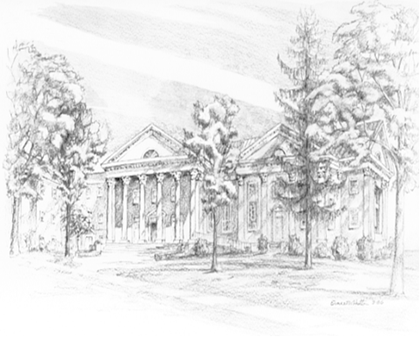

P O Box 877
249 South Wayne Avenue
Waynesboro, Virginia
(540) 949-8366
Church Website: www.firstpresway.org
Preschool Website: www.firstprespre.org
Email: church@firstpresway.com

