Trinity Sunday June 12, 2022

PRELUDE Sonata no. 3 in d, BWV 527: II Bach (1685-1750)

WELCOME & ANNOUNCEMENTS

INTROIT Let All The World Routley (1917-1982)

CALL TO WORSHIP Jen Jones

Leader: In You, O Lord, we take refuge.

People: Let us never be put to shame.

Leader: In Your righteousness deliver us.

People: For You are our rock and our fortress.

Leader: Let us worship God.

MORNING PRAYER

OPENING HYMN 1 Holy, Holy, Holy Nicaea

CALL TO CONFESSION

PRAYER OF CONFESSION

Holy God, you alone live in perfect relationship, one God in three persons, mutual and loving. You call us to live as one, always seeking reconciliation; yet we confess our relationships are imperfect and incomplete. We are selfish and greedy, anxious and resentful. We allow stubborn weakness to drive us apart from one another, and from you. Forgive us Lord, this and all our sin. Bind us together by the working power of your Spirit, that we might live together in gratitude and grace, for the sake of your son, Jesus.

SILENT PRAYER

ASSURANCE OF PARDON

*GLORIA PATRI 581 Greatorex

FIRST SCRIPTURE READING Proverbs 8:1- 4, 22- 31 p.515

SPECIAL MUSIC Sonata in A-flat: I Bach, CPE (1714-1788)

SECOND SCRIPTURE READING John 16:12-15 p.879

SERMON Bearing It. Rev. Patrick Pettit

*AFFIRMATION OF FAITH The Apostles' Creed Hymnal p. 35

PRAYERS OF THE PEOPLE & THE LORD’S PRAYER

*CLOSING HYMN 4 Holy God, We Praise Your Name Grosser Gott, Wir Loben Dich

*CHARGE and BENEDICTION

POSTLUDE Sonata in B-flat, Op. 65, no. 4: IV Mendelssohn (1809-1847)

Today’s link is : https://youtu.be/zYHOEnSkHw0

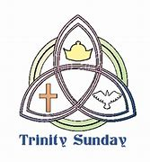

Hearing devices are available for your convenience.
Please be aware that they do not function until after the service begins.

The Legacy: Mary June Cook

Regency at Augusta: Edie Lawrence

Shenandoah Nursing Home: Rubye Schwab

Summit Square: Lillian Hryshkanych

Home: Dick Huff, Nancy Garber, Mary Ultee, Mary Ann Maupin, Mike Cunningham, Walt Flora.

Friends and Family: Erwin Berry (Joan), Shae Blackwell and Family (Preschool), Bill Bromley, Tom Brown, Debbie Conner, Jerry Hughes, Sally McNeel, Bill Metzel (Joyce Tipton), George Morris Jr., Col. Stuart Roberts (Mark Henderson), Andy Robeson (Cunninghams), Jennifer & Charlotte Sergeant (Kathy Brown), Danny Smith (Nancy Hypes), Ida Waddy, Paul Watts (Colleen Cash), Rory Leap (Currys), Josh Slonaker (Bennett).

Military: Carson Craig, Jeremiah Henderson.

Missionaries: Elmarie & Scott Parker, PC (USA) Regional Liaisons to Iraq, Syria & Lebanon

Book Study, Being Presbyterian in the Bible Belt, to be rescheduled.

Congratulations to Sean and Katherine Thomas Lucier on the birth of their son, Arthur Tavish Lucier on May 20. Proud grandparents are Richard and Jeannie Curry.

FIRST PRESBYTERIAN CHURCH
WAYNESBORO, VIRGINIA

A community-minded congregation living out the love of Christ as we serve one another with humility, gentleness, and patience through God’s grace.

June 12, 2022 11:00 AM

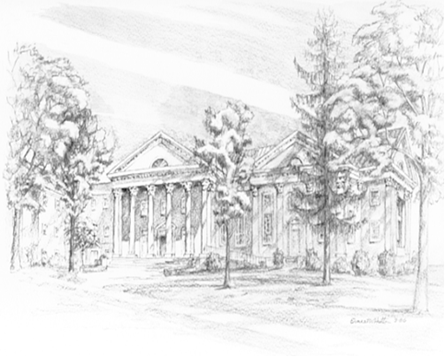

P.O. Box 877
249 South Wayne Avenue
Waynesboro, Virginia
(540) 949-8366
Church Website: www.firstpresway.org
Preschool Website: www.firstprespre.org
Email: church@firstpresway.com

P.O. Box 877
249 South Wayne Avenue
Waynesboro, Virginia
(540) 949-8366
Church Website: www.firstpresway.org
Preschool Website: www.firstprespre.org
Email: church@firstpresway.com

