Second Sunday after Pentecost June 19, 2022

PRELUDE Caprice Muffat, Gottlieb (1690-1770)

WELCOME & ANNOUNCEMENTS

INTROIT Faith of our Fathers Henry (1818-1888)

CALL TO WORSHIP Joan Berry
Leader: Our souls long for you, O God;
People: We have sought you in raging wind.
Leader: We have scoured the trembling earth for you.
People: We have gazed into the flame, looking for you.
Leader: God of grace, meet us in the stillness of this moment;
People: Open our ears to your voice.
Leader: Let us worship God.

MORNING PRAYER

OPENING HYMN 370 This is My Father’s World Terra Beata

CALL TO CONFESSION

PRAYER OF CONFESSION
O God, you promise us refuge and strength, and yet too often, we fail to recognize you in our midst. We are distracted by the noises of this world, by the light and fury surrounding us. Afraid of the quiet, we seek out confusion. Forgive us, Lord, this and all our sin. May we hear by the power of Your Spirit, and respond with quiet trust, in the name of Jesus Christ. Amen.

SILENT PRAYER

ASSURANCE OF PARDON

*GLORIA PATRI 581 Greatorex

FIRST SCRIPTURE READING Psalm 22:19-28 p.435

ANTHEM Sanctus, Gloria Mathias (1934-1992)
Maximilian Daggy, baritone

SECOND SCRIPTURE READING Luke 8:26-39 p.841

SERMON Evil on the hoof. Rev. Patrick Pettit

*AFFIRMATION OF FAITH The Apostles' Creed Hymnal p. 35

PRAYERS OF THE PEOPLE & THE LORD’S PRAYER

*CLOSING HYMN 169 Dear Lord and Father of Mankind Rest

*CHARGE and BENEDICTION

POSTLUDE Toccata no. 2 Muffat, Georg (1653-1704)

Today’s link is : https://youtu.be/KvSihmRCxfg

Hearing devices are available for your convenience.
Please be aware that they do not function until after the service begins.

The Legacy: Mary June Cook

Regency at Augusta: Edie Lawrence

Shenandoah Nursing Home: Rubye Schwab

Summit Square: Lillian Hryshkanych

Home: Dick Huff, Nancy Garber, Mary Ultee, Mary Ann Maupin, Mike Cunningham, Walt Flora.

Friends and Family: Erwin Berry (Joan), Shae Blackwell and Family (Preschool), Bill Bromley, Tom Brown, Debbie Conner, Jerry Hughes, Sally McNeel, Bill Metzel (Joyce Tipton), George Morris Jr., Col. Stuart Roberts (Mark Henderson), Andy Robeson (Cunninghams), Jennifer & Charlotte Sergeant (Kathy Brown), Danny Smith (Nancy Hypes), Ida Waddy, Paul Watts (Colleen Cash), Rory Leap (Currys), Josh Slonaker (Bennett).

Military: Carson Craig, Jeremiah Henderson.

Missionaries: Elmarie & Scott Parker, PC (USA) Regional Liaisons to Iraq, Syria & Lebanon

Book Study, Being Presbyterian in the Bible Belt, will not resume.
Look for a new study in the Fall of 2022.

FIRST PRESBYTERIAN CHURCH
WAYNESBORO, VIRGINIA

A community-minded congregation living out the love of Christ as we serve one another with humility, gentleness, and patience through God’s grace.

June 19, 2022 11:00 AM

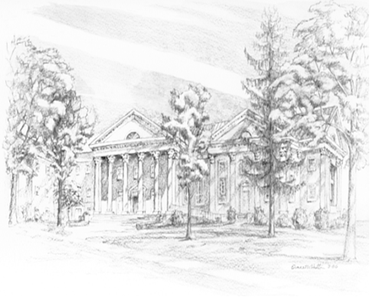

P.O. Box 877
249 South Wayne Avenue
Waynesboro, Virginia
(540) 949-8366
Church Website: www.firstpresway.org
Preschool Website: www.firstprespre.org
Email: church@firstpresway.com

P.O. Box 877
249 South Wayne Avenue
Waynesboro, Virginia
(540) 949-8366
Church Website: www.firstpresway.org
Preschool Website: www.firstprespre.org
Email: church@firstpresway.com

