

THE COLUMNS

June 2022, Volume 60, Issue 6

First Presbyterian Church, Waynesboro, VA

*First Presbyterian Church of Waynesboro is a community-minded congregation living out the love of Christ as we serve one another with humility, gentleness, and patience through God’s grace.*

**NEW LEAVES AND OLD FEARS**

***Reading spring with the help of Ezekiel***

When is it time to plant corn? When oak leaves are the size of a squirrel’s ear. I remembered this bit of Iowa folk wisdom on my walk this morning, so I gave the burr oak a closer look. No leaves to measure. Nor squirrels, for that matter. Just a scattering of acorn caps on the ground below.

But new leaves are coming, if not yet for the oaks, already for some of the other woody plants along the trail. Leaves pop from arching blackberry canes. Wands of willow dance in yellow-green boas. And dogwood stems hold rolls of leaf aloft like tiny torches.

Spring weather is coming in fits and starts this year. Warmer stretches get chased off by loud barking cold fronts. We even had snow on Easter Day.

With all that thawing and freezing, all that now-and-not-yet, I find it hard to fault the leaves for being slow to emerge. Is it safe to come out now? Or is another frost in the offing?

I’ve been slow to embrace spring myself this year. The first blush of green on brown woods invariably brightens my spirits. But this time around, I’m hesitant. What blast of bad news is about to break? Another blizzard? Another rending of the body politic? Another resurgence of the virus?

I suppose my worries are part of the hangover from all that has happened over the past several years. I feel like a cartoon character after something big has just flown by. I’m still spinning around in the jet wash, blitzed and dizzy. Maybe you’re feeling something like that, too.

But the sight of new leaves gives me a boost. Bushes and trees are deciding that it’s time. They are placing their bets on warmer days and soon.

When the prophet Ezekiel looked into God’s future and saw restoration, he spoke of a life-giving river lined with trees. And of the trees he prophesied, “Their fruit will be for food and their leaves for healing.” (Ezekiel 47:12 NRSV).

Leaves for healing – I like the sound of that. Seems like the world could use some healing. I could use some, too.

What if I could see Ezekiel’s hopeful vision in the new leaves around me?

Then a bit of green on a blackberry cane might show me God’s hand reaching out to heal. Then a leafing willow might remind me that God is working for restoration even now. Then a greening dogwood might speak to me of God’s desire for all of life to be made whole.

I think I’ll bring Ezekiel’s field glasses along with me the next time I’m on the trail and see what the leaves have to show me.

And who knows? Maybe I can convince a squirrel to sit still long enough for a measurement.

*(Ken Rummer, a retired pastor in the Presbytery of Des Moines,*

*writes about life and faith from the middle of Iowa by the High Trestle Trail.)*

 **JUNE MUSIC NOTES**

This month, we welcome the lovely season of summer, complete with cookouts, swimming, lazy afternoons in the sun and time with loved ones. It’s the season of endings and beginnings as well, and we delight in the splendor of God’s creation.

We are grateful to The Madison Singers, the premiere vocal ensemble from James Madison University, for the program they presented on Saturday 28 May, concluding the ensemble’s Spring tour. Dr. Jo-Anne van der Vat-Chromy, the director of choral music at JMU, was delighted to return to the acoustically excellent space of FPC’s Sanctuary!

Another *First Friday* is upon us! Roger will play his 25th program on Friday 3 June at 12:15, followed by a light luncheon generously provided by Susan Johnson. All are welcome! The series will be on hiatus for the rest of the summer and will resume 2 September.

Throughout the summer, as in years past, various musicians will provide music for the Introit and Anthem/Special Music on Sunday mornings.

The first Sunday of June brings fiddle music to the Sanctuary! Isabelle Gorman is a Charlottesville resident who studies at the New England Conservatory of Music in Boston. She has won several competitions for Appalachian Old-Time and Bluegrass fiddle music in Virginia, West Virginia, and North Carolina. Ms. Gorman played at FPC last year, and we are delighted that she will return!

Later this month, on Father’s Day, Roger will play music by one of the most famous fathers in classical music, Johann Sebastian Bach. The “Master of Masters” had 22 children, and many followed in their father’s footsteps. Four in particular earned their living as musicians (as had generations of Bachs before them): Wilhelm Friedemann was organist at St. Sophia in Dresden, Carl Philip served as Court Musician for Frederick the Great, Johann Christoph Friedrich played harpsichord in Lower Saxony and Johann Christian served Queen Charlotte in London.

In other news, the Daggy family experienced a number of transitions in the month of May.

Maximilian Reid Daggy graduated cum laude from James Madison University on 14 May with a Bachelor of Arts in Psychology. Max was also inducted into the Psi Chi Honor Society. He hopes to work in with special needs elementary school children in Harrisonburg for the upcoming school year.

Celia Grace Daggy won the position of Principal Viola with the Virginia Symphony. She begins playing with the orchestra in the end of August. The Virginia Symphony is based in Norfolk and plays concerts in Norfolk, Newport News and Virginia Beach each weekend. We are exploring a road trip for interested parties sometime in the future to hear and see her play!

And, finally, Frances Eloise Duvall (1935-2022), Roger’s mother, transitioned from our earthly realm on 14 May. She was a force of nature for her family and her country and will be deeply missed by all who knew and loved her.

We remain thankful to FPC for the consistent support of the music program.

Roger and Kimberlea Daggy

**SESSION HIGHLIGHTS**

The Stated Session Meeting, scheduled for May 10, 2022, was cancelled.

The next Stated Meeting is scheduled for June 14, 2022.

-Betsy Ruehl

**225th General Assembly (2022) June 18 – July 9, 2022**

**Hybrid – Committee Sessions in Louisville, KY – Plenary Sessions Online**

WHAT IS IT AND WHAT DOES IT DO?

The General Assembly consists of commissioners elected by presbyteries. Half of the commissioners will be ruling elders, half will be teaching elders. Few will ever have been commissioners to the General Assembly before, but most will have served in one of the other governing bodies of our church: the session, which provides care and oversight of a local congregation; the presbytery, which provides care and oversight of a group of congregations; or the synod which provide care and oversight of several presbyteries.

It reviews the work of synods, resolves controversies in the church, is responsible for matters of common concern for the whole church, and serves as a symbol of unity for the church.

The General Assembly has several specific responsibilities outlined in Chapter 3 of the Book of Order. The assembly seeks to protect our church from errors in faith and practice and is responsible for assuring that the expression of our theology remains true to the biblical standards in our historic confessions. The General Assembly presents a witness for truth and justice in our community and in the world community. It sets priorities for the church and establishes relationships with other churches or ecumenical bodies.

HOW DOES IT WORK?

First, reports and recommendations come from the various arms of the Presbyterian Mission Agency and the Office of the General Assembly.

The Office of the General Assembly, headed by the Stated Clerk, is the ecclesiastical arm of the church. The Stated Clerk and his staff work to ensure that the Presbyterian Church maintains itself as a church. The Office of the General Assembly carries out all constitutional, and most ecumenical, functions at the General Assembly.

Overtures from synods and presbyteries are the second source of General Assembly business. These governing bodies use Overtures to bring recommendations and matters of concern before the whole church.

Commissioners Resolutions are a third source of General Assembly business. As a commissioner one is entitled to sign two resolutions which will come before the whole assembly.

The meeting begins with an orientation on Saturday afternoon and that evening the plenary, or whole General Assembly, meets together to elect a Moderator from among the commissioners assembled.

The moderator presides over the plenary meetings for the rest of the week.

Once a moderator is elected, the assembly breaks up into assembly committees to consider particular kinds of business. Each committee is responsible for considering a number of items and reporting back to the General Assembly on completed actions or their recommendations.

The combined insights of all those on assembly committees become the recommendations to the whole assembly. If they are approved, they guide the church in the years to come.

**DAY OF PENTECOST**

**June 5, 2022**

On the day of Pentecost we celebrate the gift of the Holy spirit descending in a mighty rush of wind and fame to inspire the church’s proclamation of Christ’s rising and to empower its mission an ministry to the world.

The notion of Easter as a season of 50 days ending at Pentecost is patterned after the ancient Jewish festival of seven weeks that extended from the beginning of the barley harvest (on the second day after the beginning of Passover) to the end of the wheat harvest at the Festival of Weeks or *Shavuot* (see Deuteronomy 16:9-12). The Festival of Weeks later came to be called Pentecost (“50th day”) by Greek speaking Jews.

**Pentecost is new creation**

An excerpt from the *Companion to the Book of Common Worship*

(Geneva Press, 2003, 117-119):

According to the Day of Pentecost story in Acts 2:1-13, God gave the gift of the Holy Spirit to empower witnesses to the resurrection. Sounds from heaven, cosmic language, the rush of a mighty *ruach* (wind, spirit, breath) invaded the house in which the apostles gathered and appeared to them as a burning fire. Tongues of fire touched their nerve centers. A power – the unseen power of God – moved among them and gripped them. The Holy spirit is unseen, like the wind, which is why the Old Testament calls it *ruach YHWH,* the wind, or breath, of God (cf. John 3:8)

According to Joel (2:28-29) the *ruach* is to open everybody to God’s future. People young and old will dream and will have visions of hope they will be able to loose themselves from the way things are now, because God is establishing a whole new economy of creation. The Holy Spirit breaks us out of our preoccupation with ourselves and frees us to serve neighbors, loosens our grasp on possessions, and sets us to loving people. New Creation is what Joel is talking about. Pentecost is new creation.

The book of Acts tells the story of the outcome of Pentecost’s new creation. People witness in word and in deed to the risen Christ. At the onset, the newborn church immediately tumbled out into the streets to witness to God’s mighty works in the languages of people all over the world. By the end of the story, a tiny, Spirit-filled community of faith that broke from its present order has spread across the continents with incredible power to bring new things into being. With the gift of the spirit, all things are possible….

Therefore, on the Day of Pentecost, we celebrate God’s gift of Holy Spirit which draws us together as one people, helps us to comprehend what God is doing in the world, and empowers us to proclaim, in word and in deed, God’s plan of reconciling all people in the name of Christ (Ephesians 1:10).

Without the gift of the Spirit, Christ’s church dries up and withers away, and we are left with only our broken selves. With the gift of the spirit, all things are possible. A spirit-filled community of faith opens eyes to needs in the world and sees its mission as God’s new people. The Day of Pentecost is the climax of the Great Fifty Days of Easter, celebrating as it does the gift of the Spirit to the body of Christ – the church.

**TRINITY SUNDAY**

**June 12, 2022 – First Sunday after Pentecost**

On Trinity Sunday we proclaim the mystery of our faith in the triune God: Father, Son and Holy Spirit, One-in-Three and Three-in-One.

**Unfathomable mystery**

An excerpt from the *Companion to the Book of Common Worship*

(Geneva Press, 2003, 149-150

Unlike other festivals in the church’s liturgical calendar, Trinity Sunday centers on a *doctrine* of the church, rather than an *event.*

Trinity Sunday, in a sense, synthesizes all we have celebrated over the past months which have centered on God’s mighty acts. Christmas Epiphany celebrating God’s taking flesh and dwelling among us in Jesus Christ; Easter celebrating Christ’s death and resurrection for us; Pentecost celebrating God the Holy Spirit becoming our Sanctifier, guide, and Teacher.

The triune God is the basis of all we are and do as Christians. In the name of this triune God we are baptized. As the baptized ones we bear the name of the triune God in our being. We are the family of the triune God, which we affirm when, in reciting the creeds, we say what we believe. The triune God is the basis of all our prayers – we pray to God the Father, *through Jesus Christ, by* the Holy Spirit.

In celebrating Trinity Sunday, remember that every Lord’s Day is consecrated to the triune God. On the first day of the week, God began creation. On the first day of the week, God raised Jesus from the grave. On the first day of the week, the Holy Spirit descended on the newly born church. Every Sunday is special. Every Sunday is a day of the Holy Trinity.

[Editor’s note: The reflection by Rev. Rummer and the articles on the General Assembly, Pentecost Sunday and Trinity Sunday are all materials provided by the PC(USA) website.]

**SHENENDOAH PRESBYTERY MEETING**

A regularly scheduled quarterly Shenandoah Presbytery Meeting was held at Massanutten Presbyterian Church in Penn Laird on May 24, 2022. This was the first in-person meeting in two years; meetings have been held Zoom. Jean Hashagen, commissioned elder from FPC, attended.

The second reading of the revised Sexual Misconduct Policy and the Policy on Background Check and Mandatory Boundary Training passed unanimously.

There was an update on the situation in Ethopia. Our presbytery has had a partnership with Illubabor Bethel Synod since 1989. Although there are some real differences between the holistic ministry of the Ethiopian Evangelical Church Mekane and ours, the partnership is still alive. Ethnic fighting in the country is nearby.

Progress is being made in Martinsburg on new congregational development – an actual place, “Community Cup” (coffee shop), for non-traditional worshippers to meet.

The 185 Afghan refugees are no longer at Massanetta Springs, opening up the facility for regular conferences and camp.

Deed restrictions, which the city is addressing and clarifying, have delayed the sale of the Presbytery building in Harrisonburg. The Presbytery Office has not yet moved to Massanetta Springs.

Membership in Shenandoah Presbytery declined from 10,268 to 9,702 by the end of 2021. -Betsy Ruehl

**REPORT OF CALLED SHENANDOAH PRESBYTERY MEETING ON APRIL 26 VIA ZOOM**

The meeting was called for the purpose of concurring with an overture from the Presbytery of Western Reserve to the General Assembly. In essence, the overture “commends the Stated Clerk’s ‘Call to Prayer for the People of Ethiopia’….encourage engagement in self-directed study, prayer, and action related to the origins of the conflict, ongoing acute suffering, and prospects for peace in the Horn of Africa.” The motion passed. Doug Sensabaugh will be the Presbytery’s advocate at General Assembly this summer.

**First Friday Organ Recital**

**12:15 pm June 3 in the Sanctuary**

**Followed with a light lunch**

**FLAG DAY TIMELINE**

**1776–1777**

**First American Flag Created**

**Continental Congressman Francis Hopkinson designs a United States flag and a flag for the U.S. Navy, however, Hopkinson's naval flag becomes the preferred National flag and the Continental Marine Committee sponsors the U.S. Flag Resolution on June 14, 1777.**

**1916**

**President Woodrow Wilson Recognizes Flag Day**

**Celebrating the selection of the first American flag back in 1777,**

**President Wilson signs off on establishing June 14 of each year as Flag Day.**

**July 4, 1960**

**The Current U.S. Flag is Completed**

**The 50th star, representing Hawaii (not Alaska),**

**completes the flag flown in the U.S. today.**

**July 20, 1969**

**The U.S. Flag Sees the Moon**

**There are now six U.S. flags present on the moon,**

**but the first was placed by Neil Armstrong in 1969.**

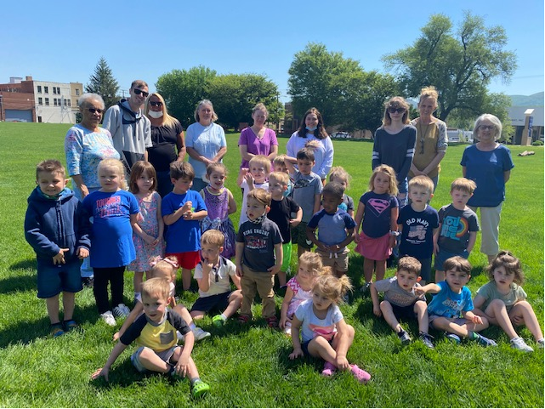

**2022 First Presbyterian**

**Church Preschool**

**Butterfly Release**

**And Graduation**

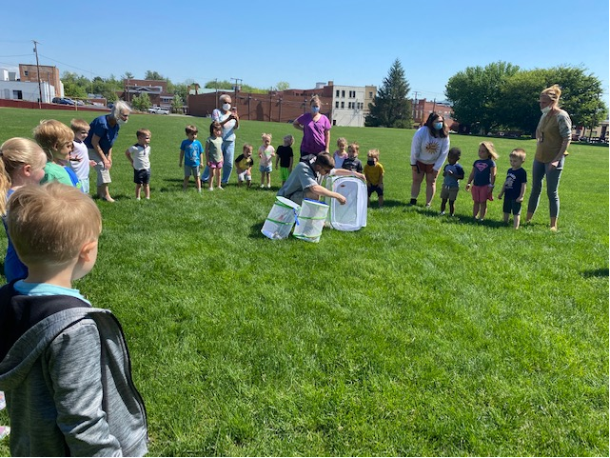

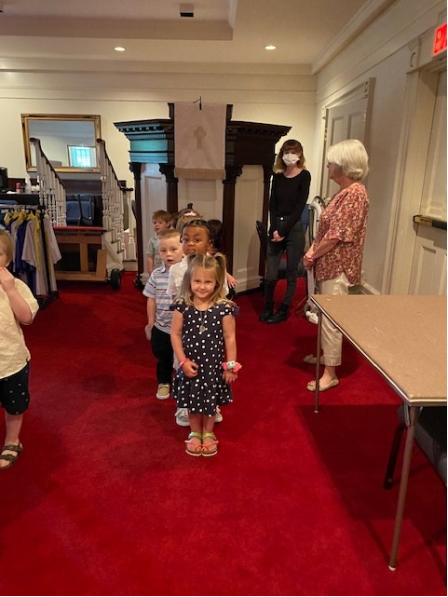

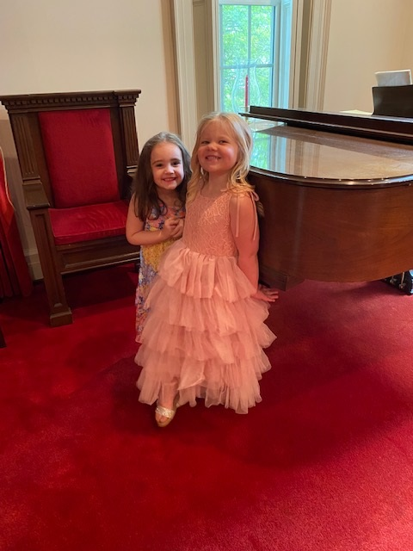

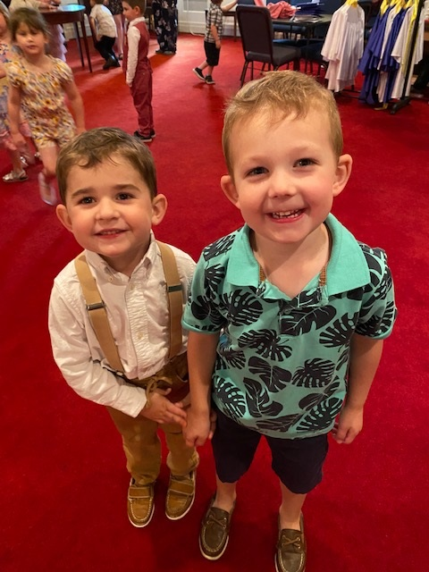



**June 5 Jean Droughman**

**June 9 Pam Leech**

**June 14 Betsy Ruehl**

**June 14 Colleen Cash**

**June 16 Warner Sandquist**

**June 24 Carol Powers**

**June 29 Phyllis Hanna**

**June 29 Bill Pannill**



**June 1 Roger & Ann Bryant**

**June 6 Tom & Sandy Bellamy**

**June 6 Steve & Sara Doherty**

**June 9 Erwin & Joan Berry**

**June 13 Bruce Bosselman & Kevin Henkel**

**June 14 Bob & Mary Scott Miller**

**June 16 Arnett & Judy Tomey**

**June 19 Paul & Jen Jones**

**June 23 Bill & Joann Pannill**

**June 25 Art & Anne Johnson**

**June 28 Mark & Sandi Henderson**

**June 30 Bob & Colleen Cash**

**William “Bill” Robinette Kiser**

**July 31, 1925 – May 8, 2022**

**Dr. Gilmer Cornelius Ayers**

**May 30, 1936 – May 24,2022**

**Mailing Address**

P. O. Box 877

Waynesboro, VA 22980

**Phone**

540.949.8366

**Fax**

540.949.5750

**E-mail**

church@firstpresway.com

**Website**

www.firstpresway.org

**Church Office Hours**

Monday-Wednesday

8 a.m. – 2:30 p.m.

Thursday

8 a.m. – 4:30 p.m.

**Interim Pastor**

Rev. Patrick S. Pettit

pspettit@gmail.com

**Administrative Assistant**

Mrs. Colleen Cash

ccash@firstpresway.com

**Preschool Director**

Mr. Nate Rudin

preschool@firstpresway.com

**Director of Music**

Mr. Roger Daggy

[firstpreswaymusic@gmail.com](mailto:firstpreswaymusic@gmail.com)

**Music Associate**

Mrs. Kimberlea Daggy

[firstpreswaymusic@gmail.com](mailto:firstpreswaymusic@gmail.com)

**Audio/Visual Technician**

Mr. Craig Cavanaugh

**Maintenance Technician**

Mr. Michael Griffith

**LITURGISTS SCHEDULE**

**June 5 Jen Jones**

**June 12 Jo Pannill**

**June 19 Joan Berry**

**June 26 Anne Wood**



**Friday, June 3**

**12:15** PM First Friday Concert with light lunch

**Sunday, June 5**

11:00 AM Worship Service

**Thursday, June 9**

2 - 4 PM Food Bank

**Sunday, June 12**

11:00 AM Worship Service

**Tuesday, June 14**

2:30 PM Session Meeting Room

**Thursday, June 16**

6 - 8 PM Food Bank

**Sunday, June 19 Father’s Day**

11:00 AM Worship Service

**Thursday, June 23**

2- 4 PM Food Bank

**Sunday, June 26**

11:00 AM Worship Service