Third Sunday after Pentecost June 26, 2022

PRELUDE Préambule, Op. 31, no. 1 Vierne (1870-1937)

WELCOME & ANNOUNCEMENTS

INTROIT Amazing Grace arr. Line (b. 1958)

CALL TO WORSHIP
Leader: We gather to worship the God of wonder.
People: We come to meditate on God’s works and deeds.
Leader: Our God is great and mighty.
People: With outstretched arms., God welcomes us into the fold.
Leader: Let us worship God.

MORNING PRAYER

OPENING HYMN 336 We Gather Together Kremser

CALL TO CONFESSION

PRAYER OF CONFESSION
Spirit of Truth, you know what lurks deep within us. Forsaking your gifts of love and service, we are quick to find fault and spread gossip. Forsaking our unity in Christ, we undermine the fellowship of believers, leaving strangers and seekers feeling like outsiders. Forgive us, Lord, this and all our sin. Renew a right spirit within us, that we may carry Christ's love and mercy from this place to our community and to the world beyond; in the name of Christ, we pray.

SILENT PRAYER

ASSURANCE OF PARDON

*GLORIA PATRI 581 Greatorex

FIRST SCRIPTURE READING Psalm 16 p. 430

SPECIAL MUSIC Nocturne in c, Op. 48, no. 1 Chopin (1810-1849)
Sarah Braverman, piano

SECOND SCRIPTURE READING Galatians 5:1, 13–25 p. 948

SERMON Free to be...better Rev. Patrick Pettit

*AFFIRMATION OF FAITH The Apostles' Creed Hymnal p. 35

PRAYERS OF THE PEOPLE & THE LORD’S PRAYER

*CLOSING HYMN 279 Come, Holy Spirit, Heavenly Dove St. Agnes

*CHARGE and BENEDICTION

POSTLUDE Fugue in C, BuxWV 174 Buxtehude (1637-1707)

Today’s link is : https://youtu.be/F4H6EjMUyA4

We welcome Sarah Braverman to today’s service. She received degrees in piano performance from Illinois Wesleyan University and the University of North Carolina at Greensboro. Ms. Braverman teaches piano in Fishersville and held two recitals for her students this month here at FPC. We are grateful to her for sharing her musical gifts with us this morning!

Hearing devices are available for your convenience.
Please be aware that they do not function until after the service begins.

The Legacy: Mary June Cook

Regency at Augusta: Edie Lawrence

Shenandoah Nursing Home: Rubye Schwab

Summit Square: Lillian Hryshkanych

Home: Dick Huff, Nancy Garber, Mary Ultee, Mary Ann Maupin, Mike Cunningham, Walt Flora.

Friends and Family: Erwin Berry (Joan), Shae Blackwell and Family (Preschool), Bill Bromley, Tom Brown, Debbie Conner, Sally McNeel, Bill Metzel (Joyce Tipton), George Morris Jr., Col. Stuart Roberts (Mark Henderson), Andy Robeson (Cunninghams), Jennifer & Charlotte Sergeant (Kathy Brown), Danny Smith (Nancy Hypes), Ida Waddy, Paul Watts (Colleen Cash), Josh Slonaker (Bennett).

Military: Carson Craig, Jeremiah Henderson.

Missionaries: Elmarie & Scott Parker, PC (USA) Regional Liaisons to Iraq, Syria & Lebanon

Book Study, Being Presbyterian in the Bible Belt, will not resume.
Look for a new study in the Fall of 2022.

FIRST PRESBYTERIAN CHURCH
WAYNESBORO, VIRGINIA

A community-minded congregation living out the love of Christ as we serve one another with humility, gentleness, and patience through God’s grace.

June 26, 2022 11:00 AM

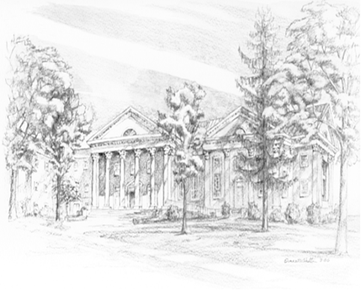

P.O. Box 877
249 South Wayne Avenue
Waynesboro, Virginia
(540) 949-8366
Church Website: www.firstpresway.org
Preschool Website: www.firstprespre.org
Email: church@firstpresway.com

P.O. Box 877
249 South Wayne Avenue
Waynesboro, Virginia
(540) 949-8366
Church Website: www.firstpresway.org
Preschool Website: www.firstprespre.org
Email: church@firstpresway.com

