DAY OF PENTECOST June 5, 2022

THE PROCLAMATION OF THE PENTECOST Acts 2:1-11

PRELUDE Come, Holy Spirit BuxWV 199 Buxtehude (1637-1707)

WELCOME & ANNOUNCEMENTS

INTROIT Farewell Appalachian Tune

CALL TO WORSHIP Jo Pannill

Leader: How many and great are your works, O Lord!

People: In wisdom you have made them all.

Leader: You send forth your Spirit, and they are created.

People: And so you renew the face of the earth. Leader: Bless the Lord! People: The Lord’s name be praised! Leader: Let us worship God

MORNING PRAYER

*OPENING HYMN 289 On Pentecost They Gathered Munich

CALL TO CONFESSION

PRAYER OF CONFESSION

God of fire and wind, we are drawn by your Spirit to this place, aware of how unworthy we are to be in your presence. Ignoring the truth of Pentecost, we squander your gifts on ourselves, afraid of those who are different from us. Forgive us, Lord, this and all our sin. Let your Spirit fill us with faith and courage to live into the promise of this day and receive the fullness of what you have prepared for us all, through the risen Christ.

SILENT PRAYER

ASSURANCE OF PARDON

*GLORIA PATRI #581 Gretorex

FIRST SCRIPTURE LESSON Psalm 104: 24-35 p. 483

SPECIAL MUSIC Appalachian Fiddle Medley Various
Isabella Gorman, fiddle

SECOND SCRIPTURE LESSON Acts 2:14-21 p. 885

THE SERMON Heritage. Rev. Patrick Pettit

*AFFIRMATION OF FAITH The Apostles’ Creed Hymnal p. 35

THE LORD’S SUPPER
Invitation
Great Thanksgiving
Communion of the People

PASTORAL PRAYER

*CLOSING HYMN 282 Come Down, O Love Divine Down Ampney

*CHARGE & BENEDICTION

POSTLUDE Come, Holy Spirit BWV 651 Bach (1685-1750)

*PLEASE STAND IF ABLE.

We welcome Isabella Gorman to our Sanctuary today. Ms. Gorman resides in Charlottesville and studies violin at the New England Conservatory of Music in Boston. She is also co-director of the Heifetz Hootenanny programs for Heifetz International Music Institute Summer Festival in Staunton. We thank her for sharing her gifts with us this morning!

Audio aids are available for your convenience.
Please be aware that they do not function until after the service begins.

P.O. Box 877
249 South Wayne Avenue
Waynesboro, Virginia
(540) 949-8366
Church Website: www.firstpresway.org
Preschool Website: www.firstprespre.org
Email: church@firstpresway.com

The Legacy: Mary June Cook

Regency at Augusta: Edie Lawrence

Shenandoah Nursing Home: Rubye Schwab

Summit Square: Lillian Hryshkanych

Home: Dick Huff, Nancy Garber, Mary Ultee, Mary Ann Maupin, Mike Cunningham, Walt Flora

Friends and Family: Erwin Berry (Joan), Shae Blackwell and Family (Preschool), Bill Bromley, Tom Brown, Debbie Conner, Jerry Hughes, Sally McNeel, Bill Metzel (Joyce Tipton), George Morris Jr., Col. Stuart Roberts (Mark Henderson), Andy Robeson (Cunninghams), Jennifer & Charlotte Sergeant (Kathy Brown), Danny Smith (Nancy Hypes), Ida Waddy, Paul Watts (Colleen Cash), Rory Leap (Currys).

Military: Carson Craig, Jeremiah Henderson.

Missionaries: Elmarie & Scott Parker, PC (USA) Regional Liaisons to Iraq, Syria & Lebanon

Book Study, Being Presbyterian in the Bible Belt, to be rescheduled.

FIRST PRESBYTERIAN CHURCH
WAYNESBORO, VIRGINIA

A community-minded congregation living out the love of Christ as we serve one another with humility, gentleness, and patience through God’s grace.

June 5, 2022 11:00 AM

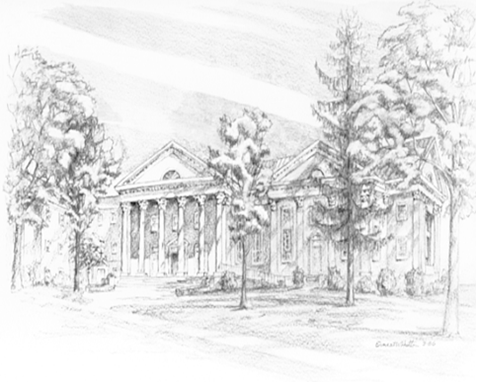

249 South Wayne Avenue
Waynesboro, Virginia
(540) 949-8366
Church Website: www.firstpresway.org
Preschool Website: www.firstprespre.org
Email: church@firstpresway.com

