SEVENTH SUNDAY of EASTER May 29, 2022

PRELUDE How Fair and Pleasant Thou Art, Op. 18, no. 5 Dupré (1886-1971)

WELCOME & ANNOUNCEMENTS

INTROIT Deo Gracias Agincourt Hymn

CALL TO WORSHIP Bill Pannill
The Lord is king! Let the earth rejoice.
We praise God, for righteousness and justice are the foundations
of his throne.
For you, O Lord, are most high over all the earth. You are exalted far above
all gods.
The heavens proclaim his righteousness, and all the peoples behold
his glory.
Light dawns for the righteous, and joy for the upright in heart.
Rejoice in the Lord, O you righteous, and give thanks to
God’s holy name! Let us worship the one true God.

MORNING PRAYER

OPENING HYMN 267 Come, Christians, Join to Sing Madrid

CALL TO CONFESSION

PRAYER OF CONFESSION
Loving God, you create us to be one family, one flock, one people. But we focus on the differences and diversity among us instead of heeding your call to unity. You call us to care for all creation, all children, and all people. But we prefer to stay comfortable, only caring for those who are familiar and look and act like us. Forgive us, we pray. Remind us of our belovedness, and inspire us to share your hospitality with full inclusion. Soften our hearts to speak up against division and injustice. Grant us courage to show up on behalf of our neighbors near and far who are suffering. Lead us to love and live like your son, our Shepherd, Jesus. We begin by meeting you in the silence now. …

SILENT PRAYER

ASSURANCE OF PARDON

*GLORIA PATRI 581 Greatorex

FIRST SCRIPTURE READING Acts 16:25-34 p. 901

SPECIAL MUSIC Meditation
Charles Fitch, Jr., harmonica

SECOND SCRIPTURE READING John 17:20-26 p. 879

SERMON God in me and I in you Terry Crickenberger

*AFFIRMATION OF FAITH The Apostles' Creed Hymnal p. 35

PRAYERS OF THE PEOPLE & THE LORD’S PRAYER

*CLOSING HYMN 263 All Hail the Power of Jesus’ Name Coronation

*CHARGE and BENEDICTION

POSTLUDE The King Sitteth At His Table, Op. 18, no. 1 Dupré

You are cordially invited to this week's First Friday program! Roger Daggy will present his 25th recital on Friday 3 June at 12:15pm, followed by a light luncheon, generously provided by Susan Johnson. (First Fridays will be on hiatus for the summer and will resume Friday 2 September.) All are welcome!

Today’s link is : https://youtu.be/xpB1SDm4Ls4

Hearing devices are available for your convenience.
Please be aware that they do not function until after the service begins.

The Legacy: Mary June Cook

Regency at Augusta: Edie Lawrence

Shenandoah Nursing Home: Rubye Schwab

Summit Square: Lillian Hryshkanych

Home: Dick Huff, Nancy Garber, Mary Ultee, Mary Ann Maupin, Mike Cunningham

Friends and Family: Erwin Berry (Joan), Shae Blackwell and Family (Preschool), Bill Bromley, Tom Brown, Debbie Conner, Jerry Hughes, Sally McNeel, Bill Metzel (Joyce Tipton), George Morris Jr., Col. Stuart Roberts (Mark Henderson), Andy Robeson (Cunninghams), Jennifer & Charlotte Sergeant (Kathy Brown), Danny Smith (Nancy Hypes), Ida Waddy, Paul Watts (Colleen Cash), Rory Leap (Currys).

Military: Carson Craig, Jeremiah Henderson.

Missionaries: Elmarie & Scott Parker, PC (USA) Regional Liaisons to Iraq, Syria & Lebanon

Book Study, Being Presbyterian in the Bible Belt, to be rescheduled.

Our Christian sympathies to the family of Dr. Gil Ayers, passed on May 24, 2022. Reynold’s Hamrick Funeral Home are entrusted with arrangements.
Today we welcome Kate Fiedler, Associate Pastor of 2nd Presbyterian Church in Downtown Richmond. Kate grew up Presbyterian and is the offspring of mother and father Presbyterian Pastors who have led churches in Roanoke and elsewhere. She is a graduate of Davidson College and Union Presbyterian Seminary. Kate arrived at 2nd Presbyterian Church during the height of the pandemic in August 2020. She has served as Director of Admissions at Union Presbyterian Seminary and as Associate Pastor at University Presbyterian Church in Chapel Hill, North Carolina. Kate loves the church and dreams of how the Spirit leads us to build up the beloved community through advocacy, justice, and truth-telling. During her leisure time, Kate enjoys road trips, live music, reading poetry and mysteries, exploring new restaurants, swimming, and cheering on her favorite sports teams: the Cubs, the Warriors, and the Tar Heels. We thank Kate for her gifts of worship leadership and for taking this road trip to be one in Spirit with us this morning.

FIRST PRESBYTERIAN CHURCH
WAYNESBORO, VIRGINIA

A community-minded congregation living out the love of Christ as we serve one another with humility, gentleness, and patience through God’s grace.

May 29, 2022 11:00 AM

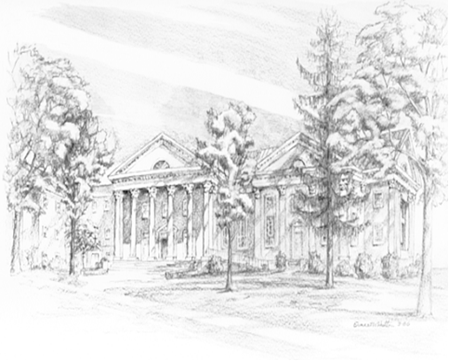

P.O. Box 877
249 South Wayne Avenue
Waynesboro, Virginia
(540) 949-8366
Church Website: www.firstpresway.org
Preschool Website: www.firstprespre.org
Email: church@firstpresway.com

P.O. Box 877
249 South Wayne Avenue
Waynesboro, Virginia
(540) 949-8366
Church Website: www.firstpresway.org
Preschool Website: www.firstprespre.org
Email: church@firstpresway.com

