FIFTH SUNDAY AFTER PENTECOST July 10, 2022

PRELUDE Variations on Onder een Linde Groen Sweelinck (1562-1621)

WELCOME & ANNOUNCEMENTS

INTROIT played by a string quartet from the Heifetz Institute

CALL TO WORSHIP
Leader: Sing, dance, and rejoice in the Lord,
People: for God is among us.
Leader: Give thanks and praise to the Holy One.
People: for in Christ our salvation has come.
Leader: Let us Worship God.

MORNING PRAYER

OPENING HYMN 634 To God Be the Glory God Be the Glory

CALL TO CONFESSION

PRAYER OF CONFESSION
Gracious God, Jesus tells us that our lives are enriched by loving you and loving our neighbors. We confess that kind of love is hard for us. You welcome them with open arms; we segregate or reject them. You provide for them; we demonize them; You heal them; and we hurt them. We are selfish and pessimistic, tired and hardened. Forgive us, Lord, this and all our sin. Teach us to welcome all of your children, until our hospitality is as wide as your mercy. Guide us to love one another as you love us, in the name of Christ.

SILENT PRAYER

ASSURANCE OF PARDON

*GLORIA PATRI 581 Greatorex

FIRST SCRIPTURE READING Colossians 1:1-9 p. 956

SPECIAL MUSIC played by a string quartet from the Heifetz Institute

SECOND SCRIPTURE READING Colossians 1:10-20 p. 956

SERMON Paul Prays. Rev. Patrick Pettit

*AFFIRMATION OF FAITH The Apostles' Creed Hymnal p. 35

PRAYERS OF THE PEOPLE & THE LORD’S PRAYER

*CLOSING HYMN 321 The Church’s One Foundation Aurelia

*CHARGE and BENEDICTION

POSTLUDE Postlude in C Foote (1853-1937)

*Please stand if able

Today’s link is : https://youtu.be/Yu1VrU_ZWec

Today, we welcome musicians from the Heifetz International Music Institute in Staunton. For the last few years, young musicians have shared their craft with FPC, and we are grateful to them for being here this morning! This year, FPC is pleased to welcome violinists Noelle Naito of Eldridge, MD and Emily Lin of Cary, NC; violist Aidan Garrison of San Diego, CA and cellist Rachel Taylor of Herndon, VA.

Hearing devices are available for your convenience.
Please be aware that they do not function until after the service begins.

The Legacy: Mary June Cook

Regency at Augusta: Edie Lawrence

Shenandoah Nursing Home: Rubye Schwab

Summit Square: Lillian Hryshkanych

Home: Dick Huff, Nancy Garber, Mary Ultee, Mary Ann Maupin, Walt Flora, Warner & Linda Sandquist.

Friends and Family: Erwin Berry (Joan), Shae Blackwell and Family (Preschool), Bill Bromley, Tom Brown, Debbie Conner, Jerry Hughes, Sally McNeel, Bill Metzel (Joyce Tipton), George Morris Jr., Col. Stuart Roberts (Mark Henderson), Andy Robeson (Cunninghams), Jennifer & Charlotte Sergeant (Kathy Brown), Danny Smith (Nancy Hypes), Ida Waddy, Paul Watts (Colleen Cash).

Military: Carson Craig, Jeremiah Henderson.

Missionaries: Elmarie & Scott Parker, PC (USA) Regional Liaisons to Iraq, Syria & Lebanon

Elder Terry Crickenberger is beginning his seminary career with an intensive course in Hebrew. Please pray for guidance and forbearance as he engages with this material over the summer.

It is with deep sadness that we announce the death of Dr. Mark Hammock.
Mark passed Thursday arrangements will be forthcoming.
Please keep Pam and their loved ones in your thoughts and prayers.

FIRST PRESBYTERIAN CHURCH
WAYNESBORO, VIRGINIA

A community-minded congregation living out the love of Christ as we serve one another with humility, gentleness, and patience through God’s grace.

July 10, 2022 11:00 AM

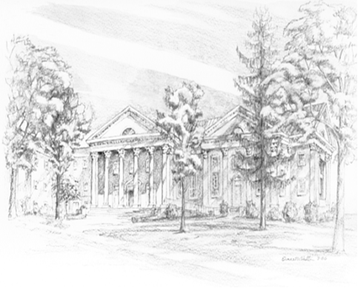

P.O. Box 877
249 South Wayne Avenue
Waynesboro, Virginia
(540) 949-8366
Church Website: www.firstpresway.org
Preschool Website: www.firstprespre.org
Email: church@firstpresway.com

P.O. Box 877
249 South Wayne Avenue
Waynesboro, Virginia
(540) 949-8366
Church Website: www.firstpresway.org
Preschool Website: www.firstprespre.org
Email: church@firstpresway.com

