SIXTH SUNDAY AFTER PENTECOST July 17, 2022

PRELUDE Air and Variations William Inglot (1554-1621)

WELCOME & ANNOUNCEMENTS

INTROIT Fanfare! Gilbert M. Martin (b.1941)

CALL TO WORSHIP
Leader: I am like a green olive tree in the house of God.
People: Trust in the steadfast love of God forever and ever.
Leader: I will thank you, God, forever, because of what you have done.
People: In the presence of the faithful proclaim God’s name, for it is good.
Leader: Let us worship God.

MORNING PRAYER

OPENING HYMN #65 Guide Me O, Thou Great Jehovah CWM Rhondda

CALL TO CONFESSION

PRAYER OF CONFESSION
Merciful Savior, you stand beside us, yet we prefer to stand on our own. You choose us, yet we choose worry. You attend to us, yet we attend to our work. Forgive us, Lord, this and all our sin. Call us by name and visit us once more that we might find at your feet our joy, our purpose, and our hope.

SILENT PRAYER

ASSURANCE OF PARDON

*GLORIA PATRI 581 Greatorex

FIRST SCRIPTURE READING Psalm 15 p. 430

SPECIAL MUSIC Sarabande from Second English Suite J.S. Bach (1685-1750)

SECOND SCRIPTURE READING Luke 10:38-42 p. 845

SERMON What really matters. Rev. Patrick Pettit

*AFFIRMATION OF FAITH The Apostles' Creed Hymnal p. 35

PRAYERS OF THE PEOPLE & THE LORD’S PRAYER

*CLOSING HYMN #41 O Worship the King, All Glorious Above Lyons

*CHARGE and BENEDICTION

POSTLUDE My Heart Rejoices David Paxton (1934-2015)

*Please stand if able

Today’s link is : https://youtu.be/-xJJOuf2Z2Q

We welcome guest organist Diane Kingsbury this morning, as Roger and Kimberlea are away celebrating their 34th wedding anniversary. Diane has helped us on numerous occasions over the years, and we are most grateful to her for providing music for our worship service this morning.

Hearing devices are available for your convenience.
Please be aware that they do not function until after the service begins.

The Legacy: Mary June Cook

Regency at Augusta: Edie Lawrence

Shenandoah Nursing Home: Rubye Schwab

Summit Square: Lillian Hryshkanych

Home: Dick Huff, Nancy Garber, Mary Ultee, Mary Ann Maupin, Walt Flora, Warner & Linda Sandquist.

Friends and Family: Erwin Berry (Joan), Shae Blackwell and Family (Preschool), Bill Bromley, Tom Brown, Jean Custen, Jerry Hughes, Sally McNeel, Bill Metzel (Joyce Tipton), Col. Stuart Roberts (Mark Henderson), Andy Robeson (Cunninghams), Jennifer & Charlotte Sergeant (Kathy Brown), Danny Smith (Nancy Hypes), Paul Watts (Colleen Cash).

Military: Carson Craig, Jeremiah Henderson.

Missionaries: Elmarie & Scott Parker, PC (USA) Regional Liaisons to Iraq, Syria & Lebanon

Elder Terry Crickenberger is beginning his seminary career with an intensive course in Hebrew. Please pray for guidance and forbearance as he engages with this material over the summer.

A Memorial Service was held Saturday, July16 for Dr. Mark Hammock in the Sanctuary.
Please continue to keep Mark’s loved ones in your prayers.

There will be a congregational meeting Sunday, July 24 immediately following worship. The purpose of this meeting will be to hear a report from the Session and to elect the Class of 2023, 2024,2025 slate of officers.

FIRST PRESBYTERIAN CHURCH
WAYNESBORO, VIRGINIA

A community-minded congregation living out the love of Christ as we serve one another with humility, gentleness, and patience through God’s grace.

July 17, 2022 11:00 AM

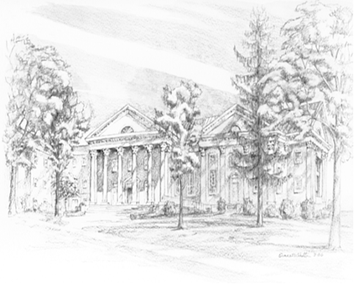

P.O. Box 877
249 South Wayne Avenue
Waynesboro, Virginia
(540) 949-8366
Church Website: www.firstpresway.org
Preschool Website: www.firstprespre.org
Email: church@firstpresway.com

P.O. Box 877
249 South Wayne Avenue
Waynesboro, Virginia
(540) 949-8366
Church Website: www.firstpresway.org
Preschool Website: www.firstprespre.org
Email: church@firstpresway.com

