THE COLUMNS

July 2022, Volume 60, Issue 7
First Presbyterian Church, Waynesboro, VA

First Presbyterian Church of Waynesboro is a community-minded congregation living out the love of Christ as we serve one another with humility, gentleness, and patience through God’s grace.

JULY MUSIC NOTES

Happy birthday, America! This month opens with a celebration of our nation’s 246th birthday. Much of the music will reflect our nation’s annual commemoration of our independence.
The prelude was composed by Arthur Foote (1853-1937), a Massachusetts native who studied at the New England Conservatory of Music and what was then Harvard College. Foote also received a Master of Arts degree in music from Harvard, the first such degree conferred in America. He was the first noteworthy American composer to be trained entirely in the United States. Foote was one of the founders of the American Guild of Organists, which he served as president for three years.
The Introit, Lift Every Voice and Sing, was composed by two brothers. James Weldon Johnson wrote the text in 1900. Five years later, his brother, John Rosamond Johnson, composed the music for the anniversary of Abraham Lincoln’s birth. The other hymn celebrating Independence Day will be America (My Country, ‘Tis of Thee.)
For many years, FPC has loaned its harpsichord to the Virginia Baroque Academy. The workshop, held in conjunction with the Shenandoah Valley Bach Festival, “is designed to give participants hands-on experience in Baroque technique and interpretation through master classes and coached ensembles with internationally acclaimed faculty.” The harpsichord is back in the Sanctuary, and Roger will play a Studio in g, one of 550 keyboard pieces by Domenico Scarlatti (1685-1757.)
Young musicians from the Heifetz International Music Institute in Staunton will join us for the service on July 10. FPC has been fortunate over these past few years to work with the Institute, which brings talented high school and college musicians to Staunton for the summer to hone their skills.

July 17 marks our (Roger and Kimberlea’s) 34th wedding anniversary. As many of you know, we were married at FPC in 1988. We feel extremely fortunate to make music in the place where our union was blessed! The wonderfully capable and kind Diane Kingsbury will play our historic 1893 Woodberry and Harris organ that day.

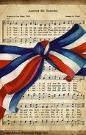
We continue to be grateful to FPC for the support of the music program.

Blessings –

Roger and Kimberlea Daggy

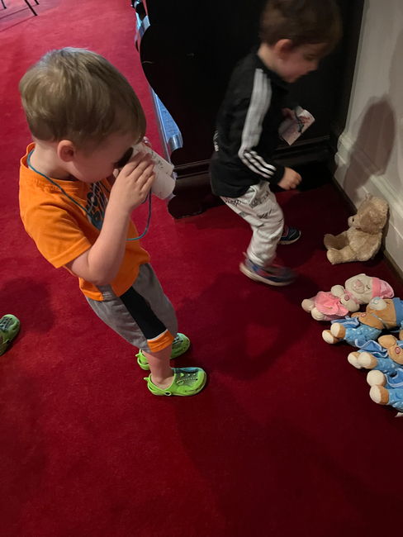
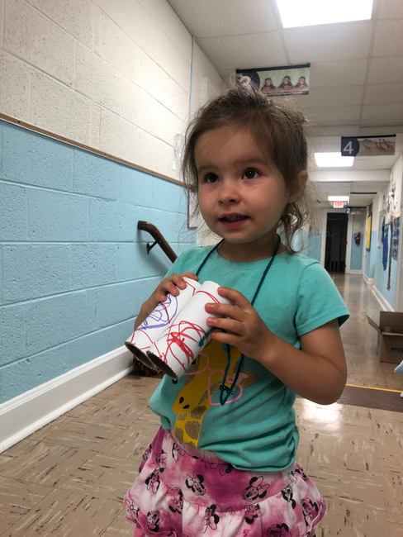
SUMMER CAMP

Summer camp is in full swing,
We have been studying all types
of animals. This past week the children went on a Safari hunt through the church where they used handmade binoculars to locate various animals.

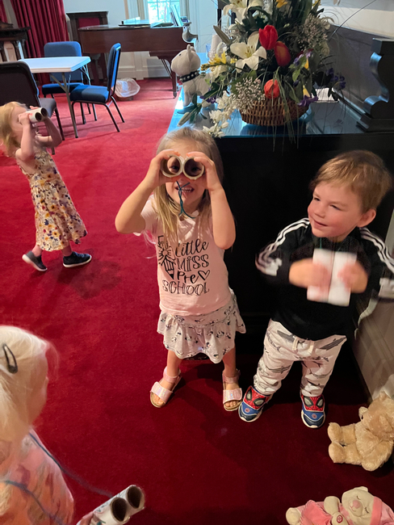
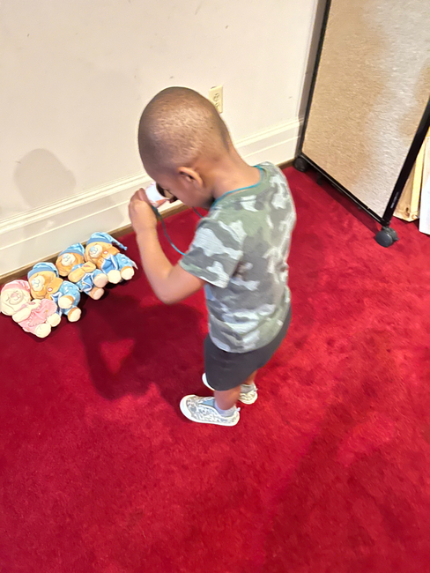

On July 1st, the children will enjoy their first water day in two years. They are all extremely excited as are the staff.

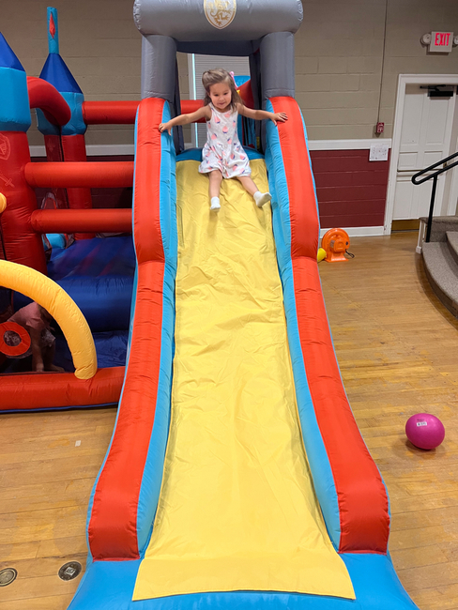
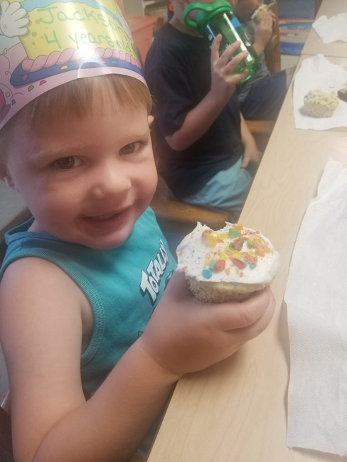

Bruce Bosselman and Kevin Henkel’s Grandson celebrated his birthday in June

SESSION HIGHLIGHTS

Session held a Stated Session meeting on June 14, 2022. Minutes of the last meeting, April 22, 2022 were
approved.
- Reports of the Called Presbytery Meeting on April 26 and the regular Presbytery Meeting on May 24 were given. The latter is the first in-person meeting since COVID-19.
- Preschool: Summer Camp began June 6 at full capacity of 26 children in 2 rooms. 9 students graduated the end of May. Two newly vacant positions have been filled: 2- and 3-year-old aides. Mandatory masking for staff has been lifted.
- Christian Education – A Bible Study is being considered for the fall.
- Personnel – Session approved a pay raise for Craig Cavanaugh, A/V Technician, and Michael Griffith, Maintenance Technician.
- Property & Maintenance: The recently hired cleaning crew quit; Colleen and Nate are sharing duties for now. Grounds are looking good but need some weeding. The building has been used for two piano recitals and a watercolor workshop. The church van has been sold.
- As the Church Nominating Committee, Session discussed which active members of the congregation might be willing and able candidates for elders. One elder is needed for Class of 2023, one for Class of 2024 and two for Class of 2025.
- All Session meetings are opened and closed with prayer. The next meeting is scheduled for July 12.
--Betsy Ruehl, Clerk of Session

RESHUFFLING AT DISCIPLES’ KITCHEN

First Presbyterian Church members have been serving for about twelve years at Disciples' Kitchen at Second Presbyterian Church. During the past few years, due to the threat of COVID, the usual Monday, Tuesday, and Thursday lunches have continued, but with several adaptations. Meals are picked up between 11 and 12 in the church parking lot instead of being eaten at tables inside. This change has necessitated simpler menus (pizza in Styrofoam containers. drinks in cups plus chips, fruit, a p-b-&-j sandwich and dessert in lunch bags). Fewer workers are needed (four usually). Masks are required for workers and visitors. The upcoming dates so far assigned to First Pres are Tuesday, July 12, and Tuesday, September 13, both days still in the parking lot.
Earlene Templeman and Betty Dixon have worked with this mission since its beginning, with Earlene serving as chairman for most of those years and many of our church members helping in various capacities. After working on July 12, Earlene and Betty will pass the torch to Jean Hashagen, Mission Chair, and other willing volunteers. New workers can decide on desired menus and change from Tuesdays to a different day if they wish.
A list of monitors from Second Pres and their phone numbers will be provided soon. We will be available to help as needed. Blessings, Earlene and Betty

You will hear of wars and rumors of wars,
but see to it that you are not alarmed.
Such things must happen, but the end is still to come.
Matthew 24:6 (ESV)

The report of my death was an exaggeration.
Mark Twain, in the New York Journal, 2 June, 1892

It's no secret I have been distracted over the past several weeks. The death of our son Connall was devastating; it was wholly unexpected, and the cause is still not known, which in many ways compounds our sense of grief and loss. We have theories, but without a solid foundation of fact, they remain just that: theories - some of which are more likely than others to prove true. We await the report of the medical examiner, which we hope will shed light on which theory, if any, proves to be true.

Of course, my grief has not stopped the march of time, nor did it bring pause to the speculation surrounding the future of First Presbyterian. Rumors of our imminent demise as a congregation have flourished in the Waynesboro community; Colleen and I have been forced to respond to queries about the disposition of the building, and speculation runs rampant, even among members, about what comes next. What's the session hiding? many are asking; why don't they just tell us what's going on? Allow me to attempt an explanation.

After reviewing the report of the Church Assessment Tool and the congregation’s discussions that followed, a few things were clear: the congregation, while small in number and unable to take on the more strenuous aspects of church life, retains an affection for, and devotion to, the worship and fellowship FPC provides. The session found itself with the task of prioritizing our mission and ministry opportunities, and looking for ways to create a legacy to last beyond the life of the congregation, no matter how long it continues to exist. One of the crucial elements in this process of discernment turned out to be the cost of maintenance and upkeep for the church facility. To that end, session has been exploring ways to address those costs, while maintaining the character of our common life. This work is not secret, but it is confidential - it is not being held back for reasons of power or influence, but because the parties involved deserve the chance to freely deliberate and negotiate without undue influence that might stifle or drown out the voice of the Spirit. But that is only the first part of the discernment; what's crucial is how the Spirit moves through you, the congregation, as you hear and respond to the plan session will outline. Far from being cut out of the process, you are an integral part of the process, and you will have the opportunity to hear and be heard - as soon as the session has a plan to share.

The church may die; human institutions live for a season, then pass into history.
But it will not die, today, or tomorrow - unless we kill it with rumors.
Anxiety and distrust can be fatal; let us choose the way of patience, and live.

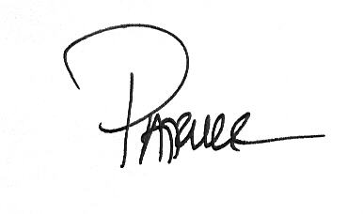

SCHOLARSHIP REPORT
2022-2023
The Memorial Fund Committee - Holly Bennett, Chair; Mary Ann Maupin and Connie Sachlis - met on May 6, 2022, to examine scholarship applications for the 2022-23 academic year.
Scholarships were awarded to:
Faye Griffith- Mary Baldwin (daughter of Michael Griffith, FPC Maintenance Technician)
Nate Rudin – Blue Ridge Community College (FPC Preschool Director)
Isai Zamudio – Piedmont Virginia Community College (Isai and his father, Duke, have done landscaping at FPC)
I want to personally thank the committee members for their time and effort. I am especially grateful to Colleen Cash for all her administrative assistance throughout the academic year.
Holly Bennett

THE FIRST FOURTH OF JULY CELEBRATION AT THE PRESIDENT’S HOUSE

Although John Adams was the first president to occupy the Executive Mansion in November 1800, it was Thomas Jefferson who first celebrated the Fourth of July at the White House in 1801. Jefferson opened the house and greeted diplomats, civil and miliary officers, citizens, and Cherokee chiefs in the center of the oval saloon (today’s Blue Room). The Marine Band played in the Entrance Hall while on the north grounds a festival took place – complete with horse races, parades, and food and drink. The tradition of an annual reception at the White House continued for much of the nineteenth century.
The north grounds of the President’s Park – the “common” – came alive at daybreak with the raising of tents and booths, soon followed by crowds of people. A festival took place just for the day. Food and drink and cottage goods of all types were sold. There were horse races and cockfights and parades of the Washington Militia and other military companies. A bare headed Jefferson with his “grey locks waving in the air” watched from the steps of the White House. Then he invited everyone in to partake of his hospitality and his thanksgiving for the preservation of independence
(From the White House Historical Association)

HOPE LIKE A GREEN SHOOT
What I noticed preaching for presbytery
Rev. Ken Rummer

“Like a green shoot pushing up through scorched earth.”
I had just spoken these words when I noticed the listening. Heads tilted for a better view. Silence pooled in the pause. They were listening, really listening.
I was preaching for presbytery at the time, and Lamentations 3:19-24 was my text.
In the sermon I pointed to what we’d been through over the past two years. I spoke of how scary and hard it’s been, and how, despite all the lemonade we’ve made from all the lemons, there have been losses and we are grieving.
Then I turned to the alphabetic poem of Lamentations. Here were outpourings of anger and grief and shaken faith, written out of the rubble of Jerusalem destroyed.
But then, I noted, right in the middle of the woe and alas, the poet finds something unexpected. “But this I call to mind, and therefore I have hope. The steadfast love of the Lord never ceases. [God’s] mercies never come to an end.” (Lamentations 3:21-22 NRSV alt.)
Trying to find an image to convey this surprising hope, I said it was “like a green shoot pushing up through scorched earth.” And that’s when I noticed everyone was listening.
There’s a story about the not-yet-famous Giuseppe Verdi. At the first rehearsal of his opera, Nobucco, when the company began to sing the chorus, “Va pensiero” (Go, thought), the stagehands stopped their work to listen. And that’s when Verdi knew he was on to something with his music.
The all-ears moment after my green shoot line was something like that. I realized that it was happening. The bush was on fire. We had turned aside to see. And we were waiting, shoes off, to hear what the Holy One might say. The sermon was working.
Now I know that God is not limited to using only goosebump sermons. Like a skilled woodworker who can craft a dovetail joint with a hacksaw and a sharpened screwdriver, God can use even our hesitant and healing efforts.
Still, the rare sermon like this one, when it all come together, the peaking and the hearing, the moment and the message, the life in the room and the life that is found in God – it gives me hope for all the other sermons, and for the next one. I remind me that God is still bringing blessing through the speaking and the hearing of preaching.
Isn’t that what keeps us digging in the commentaries and typing late on Saturday night? Isn’t that what keeps us returning to our chairs and favorite pew on a Sunday morning?
This could be the day when the sermon speaks for our hearts, and to our souls. This could be the day when our words and God’s word swirl together on gusts of the Spirit and take us to an unexpected place. This could be the day when hope breaks through, like a green shoot out of scorched earth.
(Ken Rummer, Teaching Elder PCUSA, Honorably Retired, writes about
life and faith from the middle of Iowa by the Trestle Trail.)

MEETING OF THE 225TH GENERAL ASSEMBLY

A meeting of the PC(USA) General Assembly has been taking place June 18-July 9 in Louisville, KY. Rev. Pettit has been reporting highlights in his weekly online Columns. A brief summary of events is planned for the August Columns.

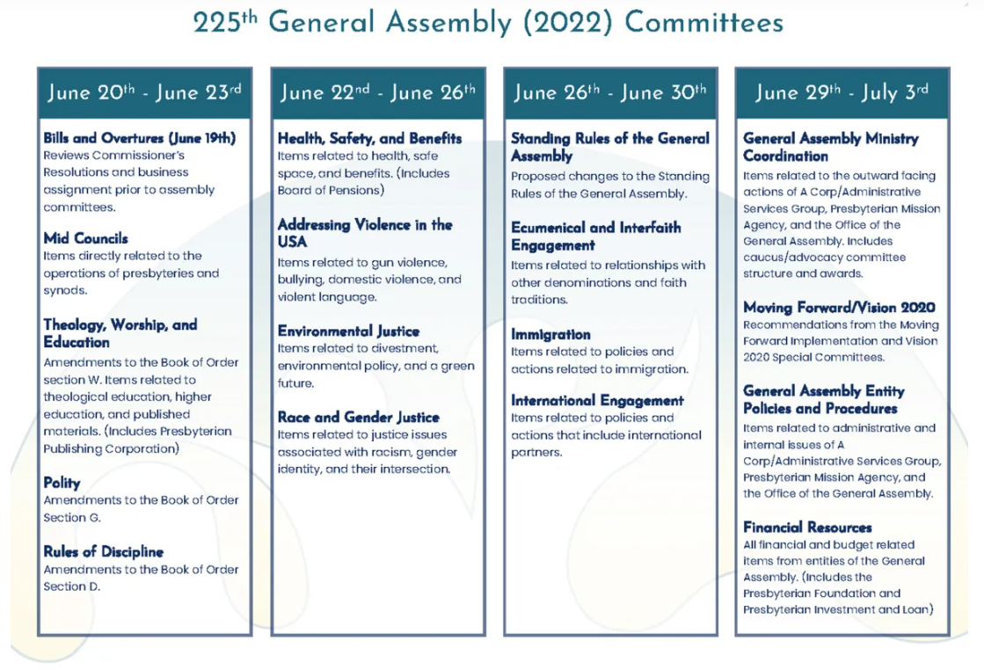

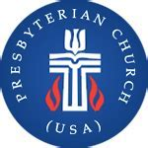

BIRTHDAYS
July 2 Mary June Cook
July 4 Mike Cunningham
July 9 Mary Ultee
July 10 Edie Lawrence
July 18 Earlene Templeman
July 21 Ruth Quillen

July 7 Don & Jeanne Hashagen
July 7 Randy & Nancy Hypes
July 17 Roger & Kimberlea Daggy

Office will be closed

Mailing Address
P. O. Box 877
Waynesboro, VA 22980
Phone
540.949.8366
Fax
540.949.5750
E-mail
church@firstpresway.com
Website
www.firstpresway.org

Church Office Hours
Monday-Wednesday
8 a.m. – 2:30 p.m.
Thursday
8 a.m. – 4:30 p.m.

Interim Pastor
Rev. Patrick S. Pettit
pspettit@gmail.com

Administrative Assistant
Mrs. Colleen Cash
ccash@firstpresway.com

Preschool Director
Mr. Nate Rudin
preschool@firstpresway.com

Director of Music
Mr. Roger Daggy
firstpreswaymusic@gmail.com

Music Associate
Mrs. Kimberlea Daggy
firstpreswaymusic@gmail.com

Audio/Visual Technician
Mr. Craig Cavanaugh

Maintenance Technician
Mr. Michael Griffith

LITURGISTS SCHEDULE
For July

3 Linda Sandquist
10 Sandi Henderson
17 Betty Dixon
24 Danny Leech
31 Jean Hashagen

Sunday, July 3
11:00 AM Worship Service
Monday, July 4 Office Closed
Independence Day
Thursday, July 7
6-8 PM Food Bank
Sunday, July 10
11:00 AM Worship Service
Tuesday, July 12
2:30 PM Session Meeting Room 212
Thursday, July 14
2-4 PM Food Bank
Sunday, July 17
11:00 AM Worship Service
Thursday, July 21
6-8 PM Food Bank
Sunday, July 24
11:00 AM Worship Service
Thursday, July 28
2-4 PM Food Bank

