SEVENTH SUNDAY AFTER PENTECOST July 24, 2022

PRELUDE Prelude and Fugue, BuxWV 137 Buxtehude (1637-1707)

WELCOME & ANNOUNCEMENTS

INTROIT Let All the World in Every Corner Sing Routley (1917-82)

CALL TO WORSHIP
Leader: You have been gracious to your land, O Lord,
People: you have restored the good fortune of Jacob.
Leader: You have forgiven the iniquity of your people;
People: You have blotted out all our sins.
Leader: Righteousness shall go before you;
People: Peace shall be a pathway for your feet.
Leader: Let us worship God.

MORNING PRAYER

OPENING HYMN #494 Jesus, Thou Joy of Loving Hearts Quebec

CALL TO CONFESSION

PRAYER OF CONFESSION
Compassionate God, you invite us to open our hearts to you, but we close ourselves off, instead seeking other paths. Again and again, you draw near, but we keep turning away. Our sinfulness has led to our undoing. Forgive us, Lord, this and all our sin. Teach us to pray, that, in your light we might see our darkness; in your truth, we might know our lies. Grant us your grace and mercy, that we may live the abundant life you have prepared for us in Jesus Christ.

SILENT PRAYER

ASSURANCE OF PARDON

*GLORIA PATRI 581 Greatorex

FIRST SCRIPTURE READING Psalm 138 p. 503

ANTHEM Seek Ye First the Kingdom of God Lafferty (b. 1948)
(text can be found in hymn 175)

SECOND SCRIPTURE READING Luke 11:1-13 p. 845

SERMON We Pray. Rev. Patrick Pettit

*AFFIRMATION OF FAITH The Apostles' Creed Hymnal p. 35

PRAYERS OF THE PEOPLE & THE LORD’S PRAYER

*CLOSING HYMN #629 Jesus, the Very Thought of Thee St. Agnes

*CHARGE and BENEDICTION

POSTLUDE Chaconne, BuxWV 137 Buxtehude

*Please stand if able

Today’s link is : https://youtu.be/TzaDFnI94mo

Hearing devices are available for your convenience.
Please be aware that they do not function until after the service begins.

The Legacy: Mary June Cook

Regency at Augusta: Edie Lawrence

Shenandoah Nursing Home: Rubye Schwab

Summit Square: Lillian Hryshkanych

Home: Dick Huff, Nancy Garber, Mary Ultee, Mary Ann Maupin, Walt Flora, Warner & Linda Sandquist.

Friends and Family: Erwin Berry (Joan), Shae Blackwell and Family (Preschool), Bill Bromley, Ron Buckalew, Jean Custen, Jerry Hughes, Sally McNeel, Bill Metzel (Joyce Tipton), Col. Stuart Roberts (Mark Henderson), Andy Robeson (Cunninghams), Jennifer & Charlotte Sergeant (Kathy Brown), Danny Smith (Nancy Hypes), Paul Watts (Colleen Cash).

Military: Carson Craig, Jeremiah Henderson.

Missionaries: Elmarie & Scott Parker, PC (USA) Regional Liaisons to Iraq, Syria & Lebanon

Elder Terry Crickenberger is beginning his seminary career with an intensive course in Hebrew. Please pray for guidance and forbearance as he engages with this material over the summer.

There will be a congregational meeting immediately following worship. The purpose of this meeting will be to hear a report from the Session and to elect the Class of 2023, 2024, 2025 slate of officers.

FIRST PRESBYTERIAN CHURCH
WAYNESBORO, VIRGINIA

A community-minded congregation living out the love of Christ as we serve one another with humility, gentleness, and patience through God’s grace.

July 24, 2022 11:00 AM

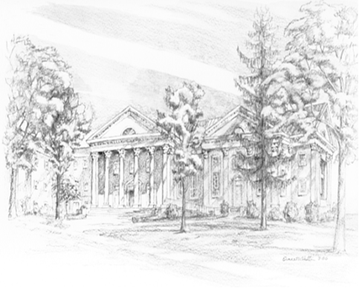

P.O. Box 877
249 South Wayne Avenue
Waynesboro, Virginia
(540) 949-8366
Church Website: www.firstpresway.org
Preschool Website: www.firstprespre.org
Email: church@firstpresway.com

P.O. Box 877
249 South Wayne Avenue
Waynesboro, Virginia
(540) 949-8366
Church Website: www.firstpresway.org
Preschool Website: www.firstprespre.org
Email: church@firstpresway.com

