EIGHTH SUNDAY AFTER PENTECOST July 31, 2022

PRELUDE Melodia, Op. 129, no. 4 Reger (1873-1916)

WELCOME & ANNOUNCEMENTS

INTROIT Now Enter In Hebble (1934-2020)

CALL TO WORSHIP
Leader: O Lord, send out Your light and Your truth, that they may lead us to your holy hill.
People: Then we shall go to the altar of God, to the God of our joy and gladness.
Leader: Let us worship God.

MORNING PRAYER

OPENING HYMN #351 All Who Love and Serve Your City Charlestown

CALL TO CONFESSION

PRAYER OF CONFESSION
Faithful God, we confess our faithlessness. We are called to seek the higher things, but instead our eyes wander, and we trick ourselves into serving false gods. We are called to put aside the things that separate us from You, but we find ourselves entangled in our own wants and desires and estranged from You. Forgive us, Lord, this and all our sin. May your faithfulness embolden our trust in You, and may Your call stir our souls.

SILENT PRAYER

ASSURANCE OF PARDON

*GLORIA PATRI 581 Greatorex

FIRST SCRIPTURE READING Psalm 49:1-12 p. 451

ANTHEM God Whose Giving Knows No Ending White (1800-1879)
(text can be found in hymn 716)

SECOND SCRIPTURE READING Luke 12:13-21 p. 847

SERMON Rich Fools. Rev. Patrick Pettit

*AFFIRMATION OF FAITH The Apostles' Creed Hymnal p. 35

PRAYERS OF THE PEOPLE & THE LORD’S PRAYER

*CLOSING HYMN 317 In Christ There Is No East Or West McKee

*CHARGE and BENEDICTION

POSTLUDE Intermezzo, Op. 59, no. 3 Reger

*Please stand if able

Today’s link is : https://youtu.be/65qiQ9U-830

Hearing devices are available for your convenience.
Please be aware that they do not function until after the service begins.

The Legacy: Mary June Cook

Regency at Augusta: Edie Lawrence

Shenandoah Nursing Home: Rubye Schwab

Summit Square: Lillian Hryshkanych

Home: Dick Huff, Nancy Garber, Mary Ultee, Mary Ann Maupin, Walt Flora, Warner & Linda Sandquist. Mike Cunningham, Ruth and Lewis Kelley.

Friends and Family: Erwin Berry (Joan), Bill Bromley, Ron Buckalew, Jean Custen, Jerry Hughes, Sally McNeel, Bill Metzel (Joyce Tipton), Col. Stuart Roberts (Mark Henderson), Danny Smith (Nancy Hypes), Paul Watts (Colleen Cash).

Military: Carson Craig, Jeremiah Henderson.

Missionaries: Elmarie & Scott Parker, PC (USA) Regional Liaisons to Iraq, Syria & Lebanon

Elder Terry Crickenberger is beginning his seminary career with an intensive course in Hebrew. Please pray for guidance and forbearance as he engages with this material over the summer.

Mike and Cathy Cunningham on the death of her Father, Andy Robeson, on July 10.

Anne Epes on the death of her significant other, Freddie Phillips, on July 22. A memorial service will be held August 13, 2 PM at Rockfish Valley Baptist Church, Nellysford, VA.

FIRST PRESBYTERIAN CHURCH
WAYNESBORO, VIRGINIA

A community-minded congregation living out the love of Christ as we serve one another with humility, gentleness, and patience through God’s grace.

July 31, 2022 11:00 AM

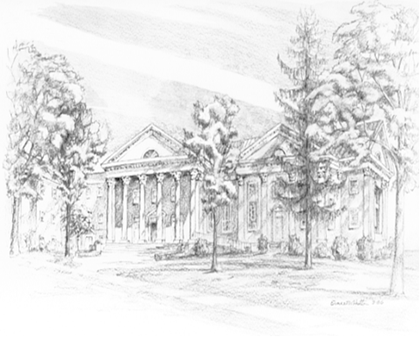

P.O. Box 877
249 South Wayne Avenue
Waynesboro, Virginia
(540) 949-8366
Church Website: www.firstpresway.org
Preschool Website: www.firstprespre.org
Email: church@firstpresway.com

P.O. Box 877
249 South Wayne Avenue
Waynesboro, Virginia
(540) 949-8366
Church Website: www.firstpresway.org
Preschool Website: www.firstprespre.org
Email: church@firstpresway.com

