TENTH SUNDAY AFTER PENTECOST August 14, 2022

PRELUDE Allemande Mattheson (1681-1764)

WELCOME & ANNOUNCEMENTS

INTROIT Alleluia Milburn (b. 1963)

CALL TO WORSHIP Mark Henderson
Leader: Behold, the gathering of God's own:
People: Disciples and apostles, believers and doubters, shepherds and saints!
Leader: Since we are surrounded by this great cloud of witnesses,
People: May we run with perseverance the race before us,
looking to Jesus the pioneer and perfecter of our faith.
Leader: Let us worship God.

MORNING PRAYER

OPENING HYMN 393 O Day of Rest and Gladness Es flog ein kleins Waldvögelein

CALL TO CONFESSION

PRAYER OF CONFESSION
Loving Creator, with a gardener’s tender touch, you planted us to bear good fruit; but our harvest is bitter grapes. With a welder’s fire, you fashioned us to glorify you, but we are brittle with impurities. Forgive us, Lord, this and all our sin. In your generous mercy, regard the vine you planted: reform the vessel you crafted: cleanse and refine us. Give us life, O God, that with our whole being, we may worship you rightly.

SILENT PRAYER

ASSURANCE OF PARDON

*GLORIA PATRI 581 Greatorex

FIRST SCRIPTURE READING Psalm 82 p. 472

SPECIAL MUSIC Courante Mattheson

SECOND SCRIPTURE READING Romans 5:1-5 p. 917

SERMON Where Faith Ends Up. Rev. Rachel Hamburger

*AFFIRMATION OF FAITH The Apostles' Creed Hymnal p. 35

PRAYERS OF THE PEOPLE & THE LORD’S PRAYER

*CLOSING HYMN 838 Standing on the Promises Promises
(stanzas 1 and 4)
*CHARGE and BENEDICTION

POSTLUDE Gigue Mattheson

*Please stand if able

Today’s link is : https://youtu.be/4dzfQEyGlyE

Hearing devices are available for your convenience.
Please be aware that they do not function until after the service begins.

The Legacy: Mary June Cook

Regency at Augusta: Edie Lawrence

Shenandoah Nursing Home: Rubye Schwab

Summit Square: Lillian Hryshkanych

Home: Dick Huff, Nancy Garber, Mary Ultee, Mary Ann Maupin, Walt Flora, Warner & Linda Sandquist.

Friends and Family: Erwin Berry (Joan), Shae Blackwell and Family (Preschool), Bill Bromley, Ron Buckalew, Jean Custen, Jerry Hughes, Sally McNeel, Bill Metzel (Joyce Tipton), Col. Stuart Roberts (Mark Henderson), Danny Smith (Nancy Hypes), Paul Watts (Colleen Cash), Vince Costello (Cunninghams).

Military: Carson Craig, Jeremiah Henderson.

Missionaries: Elmarie & Scott Parker, PC (USA) Regional Liaisons to Iraq, Syria & Lebanon

Elder Terry Crickenberger is beginning his seminary career with an intensive course in Hebrew. Please pray for guidance and forbearance as he engages with this material over the summer.

We welcome Rev. Rachael Hamburger to our pulpit this morning.

Rachel has served as Associate Pastor in five wonderful churches, the first one being at First Presbyterian Church of Harrisonburg, beginning in 1992 and the most recent being Sequoyah Hills Presbyterian Church in Knoxville, Tennessee, finishing at the end of February this year. In between she served 3 different churches in California, where her family spent most of their years. She is happy to take a bit of a "break" in this season of life, and so glad to be back in the Shenandoah Valley!

Thankful for a lifetime of gifts from God, Rachel is grateful to share in worship with us this morning!

FIRST PRESBYTERIAN CHURCH
WAYNESBORO, VIRGINIA

A community-minded congregation living out the love of Christ as we serve one another with humility, gentleness, and patience through God’s grace.

August 14, 2022 11:00 AM

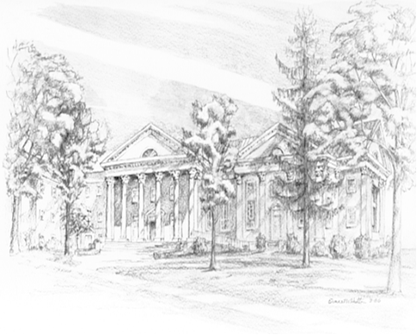

P.O. Box 877
249 South Wayne Avenue
Waynesboro, Virginia
(540) 949-8366
Church Website: www.firstpresway.org
Preschool Website: www.firstprespre.org
Email: church@firstpresway.com

P.O. Box 877
249 South Wayne Avenue
Waynesboro, Virginia
(540) 949-8366
Church Website: www.firstpresway.org
Preschool Website: www.firstprespre.org
Email: church@firstpresway.com

