ELEVENTH SUNDAY AFTER PENTECOST August 21, 2022

PRELUDE Moderato from Sonata 36 in C Sharp Minor Haydn

WELCOME & ANNOUNCEMENTS

INTROIT O Day of Rest and Gladness

CALL TO WORSHIP Cynthia Hoover
Leader: God is our rock and refuge, a strong and mighty fortress.
People: Beloved, people of light, come.
Leader: The Lord is our hope.
People: Let us never be put to shame.
Leader: In Your righteousness deliver us,
People: For You are our rock and our fortress.
Leader: Let us worship God.

MORNING PRAYER

OPENING HYMN 620 Praise My Soul the King of Heaven Lauda Anima

CALL TO CONFESSION

PRAYER OF CONFESSION

God our Solid Rock, our wavering spirits keep us from following you. Our grudges weigh us down until we cannot walk straight in your way. Our anger becomes a fire which scorches our friends and loved ones. Our fears blind us to the goodness in those we believe to be different. Forgive us, Lord, this and all our sin. Set us free from our wrongdoings and failures, that we may we offer your love to the world, in the name of Christ

SILENT PRAYER

ASSURANCE OF PARDON

*GLORIA PATRI 581 Greatorex

FIRST SCRIPTURE READING Psalm 103:1-8 p. 482

SPECIAL MUSIC Prelude No. 4 in D Major BWV936 J.S. Bach
SECOND SCRIPTURE READING Jeremiah 1:4-10 p. 609

SERMON The Mouth piece. Rev. Patrick Pettit

*AFFIRMATION OF FAITH The Apostles' Creed Hymnal p. 35

PRAYERS OF THE PEOPLE & THE LORD’S PRAYER

*CLOSING HYMN 545 Lord, Bid Your Servant Go in Peace Land of Rest

*CHARGE and BENEDICTION

POSTLUDE Presto Assai from Sonata in G Major Johann Christian Bach

*Please stand if able

Today’s link is : https://youtu.be/mYfeKkwtzss

Hearing devices are available for your convenience.
Please be aware that they do not function until after the service begins.

The Legacy: Mary June Cook

Regency at Augusta: Edie Lawrence

Shenandoah Nursing Home: Rubye Schwab

Summit Square: Lillian Hryshkanych

Home: Dick Huff, Nancy Garber, Mary Ultee, Mary Ann Maupin, Walt Flora, Warner & Linda Sandquist.

Friends and Family: Erwin Berry (Joan), Shae Blackwell and Family (Preschool), Bill Bromley, Ron Buckalew, Jean Custen, Jerry Hughes, Sally McNeel, Bill Metzel (Joyce Tipton), Col. Stuart Roberts (Mark Henderson), Danny Smith (Nancy Hypes), Paul Watts (Colleen Cash), Vince Costello (Cunninghams).

Military: Carson Craig.

Missionaries: Elmarie & Scott Parker, PC (USA) Regional Liaisons to Iraq, Syria & Lebanon

Thank you to Charles Simpkins for sharing his talents today. Roger and Kimberlea are away helping their daughter, Celia, move to Norfolk to begin her new position as principal viola of the Virginia Symphony.

FIRST PRESBYTERIAN CHURCH
WAYNESBORO, VIRGINIA

A community-minded congregation living out the love of Christ as we serve one another with humility, gentleness, and patience through God’s grace.

August 21, 2022 11:00 AM

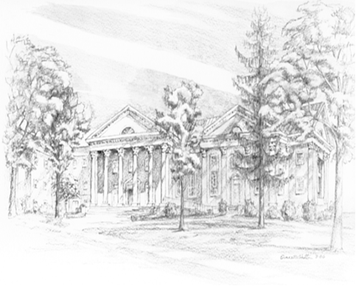

P.O. Box 877
249 South Wayne Avenue
Waynesboro, Virginia
(540) 949-8366
Church Website: www.firstpresway.org
Preschool Website: www.firstprespre.org
Email: church@firstpresway.com

P.O. Box 877
249 South Wayne Avenue
Waynesboro, Virginia
(540) 949-8366
Church Website: www.firstpresway.org
Preschool Website: www.firstprespre.org
Email: church@firstpresway.com

