TWELFTH SUNDAY AFTER PENTECOST August 28, 2022

PRELUDE Plein Jeu Clérambault (1676-1749)

WELCOME & ANNOUNCEMENTS

INTROIT Alleluia Milburn (b. 1963)

CALL TO WORSHIP Betsy Ruehl
Leader: Sing with joy to God our strength!
People: Raise a loud shout to the God of Jacob!
Leader: For the Lord is our God, who has delivered us from captivity.
People: God has opened wide our mouths, and filled us with good things.
Leader: Let us worship God.

MORNING PRAYER

OPENING HYMN 667 When Morning Gilds the Skies Laudes Domine

CALL TO CONFESSION

PRAYER OF CONFESSION
Merciful God, in Jesus, you have shown us a way that is humble and seeks the good of others; we confess that our way is often selfish. Our attention and resources are focused on about pleasing ourselves, while we ignore the needs of others. Forgive us, Lord, this and all our sin. Help us to live in harmony with one another, sharing Your world for the sake of our Lord Jesus Christ.

SILENT PRAYER

ASSURANCE OF PARDON

*GLORIA PATRI 581 Greatorex

FIRST SCRIPTURE READING Proverbs 25:6-7 p. 530
.

SPECIAL MUSIC Duo, Trio Clérambault

SECOND SCRIPTURE READING Luke 14:1, 7-12 p. 849

SERMON The best seat in the house. Rev. Patrick Pettit

*AFFIRMATION OF FAITH The Apostles' Creed Hymnal p. 35

PRAYERS OF THE PEOPLE & THE LORD’S PRAYER

*CLOSING HYMN 772 Lord, Speak to Me That I May Speak Canonbury

*CHARGE and BENEDICTION

POSTLUDE Basse de Trompette, Grand Jeu Clérambault

*Please stand if able

Today’s link is : https://youtu.be/qfhiOk4jbyk

First Fridays return next month! After a summer hiatus, the First Friday Organ Recitals and Light Luncheons resume on Friday 2 September. You (and your friends, colleagues, etc.) are invited to this free program at 12:15, followed by a light repast, generously provided by Susan Johnson. All are welcome!

Hearing devices are available for your convenience.
Please be aware that they do not function until after the service begins.

The Legacy: Mary June Cook

Regency at Augusta: Edie Lawrence

Shenandoah Nursing Home: Rubye Schwab

Summit Square: Lillian Hryshkanych

Home: Dick Huff, Nancy Garber, Mary Ultee, Mary Ann Maupin, Walt Flora, Warner & Linda Sandquist.

Friends and Family: Erwin Berry (Joan), Shae Blackwell and Family (Preschool), Bill Bromley, Ron Buckalew, Jean Custen, Jerry Hughes, Sally McNeel, Bill Metzel (Joyce Tipton), Col. Stuart Roberts (Mark Henderson), Danny Smith (Nancy Hypes), Paul Watts (Colleen Cash), Vince Costello (Cunninghams).

Military: Carson Craig.

Missionaries: Elmarie & Scott Parker, PC (USA) Regional Liaisons to Iraq, Syria & Lebanon

FIRST PRESBYTERIAN CHURCH
WAYNESBORO, VIRGINIA

A community-minded congregation living out the love of Christ as we serve one another with humility, gentleness, and patience through God’s grace.

August 28, 2022 11:00 AM

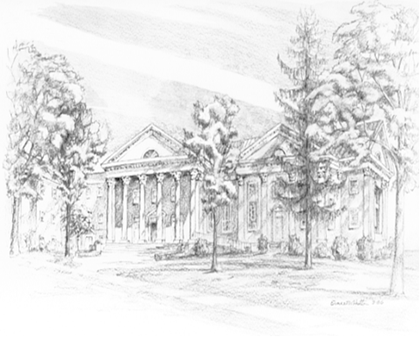

P.O. Box 877
249 South Wayne Avenue
Waynesboro, Virginia
(540) 949-8366
Church Website: www.firstpresway.org
Preschool Website: www.firstprespre.org
Email: church@firstpresway.com

P.O. Box 877
249 South Wayne Avenue
Waynesboro, Virginia
(540) 949-8366
Church Website: www.firstpresway.org
Preschool Website: www.firstprespre.org
Email: church@firstpresway.com

