Ninth Sunday after Pentecost August 7, 2022

PRELUDE Aria Pastoralis Variata Murschhauser (1670-1733)
WELCOME & ANNOUNCEMENTS

INTROIT Alleluia Milburn (b. 1963)

CALL TO WORSHIP
Leader: As was Moses in the wilderness, we are called by God;
People: May we be equipped to respond this day.
Leader: Like Abram and Sarai, we are called by God
People: May we follow in faith, wherever God leads.
Leader: Let us worship God.

MORNING PRAYER

*OPENING HYMN 49 The God of Abraham Praise Leoni

CALL TO CONFESSION

PRAYER OF CONFESSION
God of perfect love, you transform sadness to joy, despair to hope, death to life.
We look to you to change our hearts, to take away the sin that burdens us, and to
restore us to the people you would have us be. We are weak, but you are strong.
Our ways are flawed, but your ways are true. We are seldom right, but you are never
wrong. Forgive us, redeem us, transform us, for the sake of Jesus Christ our Savior.

SILENT PRAYER

ASSURANCE OF PARDON

*GLORIA PATRI #581 Gretorex

FIRST SCRIPTURE LESSON Genesis 15:1-6 p.10

ANTHEM The Disciples Knew the Lord Jesus Milburn

SECOND SCRIPTURE LESSON Hebrews 11:1-3, 8-16 p. 977

SERMON Faith IS action. Rev. Patrick Pettit

INSTALLATION OF OFFICERS

*AFFIRMATION OF FAITH The Apostles’ Creed Hymnal p. 35

THE LORD’S SUPPER
Invitation
Great Thanksgiving
Communion of the People

PASTORAL PRAYER

*CLOSING HYMN 39 Great Is Thy Faithfulness Faithfulness
(Stanzas 1 and 3)

*CHARGE & BENEDICTION

POSTLUDE Prelude in F, BWV 928 Bach (1685-1750)

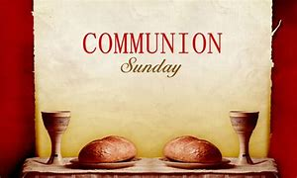

*PLEASE STAND IF ABLE.

Link for this week’s service is: https://youtu.be/_3o8S4HI5Jk

Audio aids are available for your convenience.
Please be aware that they do not function until after the service begins.

The Legacy: Mary June Cook

Regency at Augusta: Edie Lawrence

Shenandoah Nursing Home: Rubye Schwab

Summit Square: Lillian Hryshkanych

Home: Dick Huff, Nancy Garber, Mary Ultee, Mary Ann Maupin, Walt Flora, Warner & Linda Sandquist. Mike Cunningham, Ruth and Lewis Kelley.

Friends and Family: Erwin Berry (Joan), Bill Bromley, Ron Buckalew, Jean Custen, Jerry Hughes, Sally McNeel, Bill Metzel (Joyce Tipton), Col. Stuart Roberts (Mark Henderson), Danny Smith (Nancy Hypes), Paul Watts (Colleen Cash).

Military: Carson Craig, Jeremiah Henderson.

Missionaries: Elmarie & Scott Parker, PC (USA) Regional Liaisons to Iraq, Syria & Lebanon

New Elders will be installed at today’s service.

Our sympathies to George and Myra Chapman. George’s mother Mary died last week; a memorial service will be in the Fall.

Food Bank is now collecting school supplies. Items needed:

Pencils Glue Sticks
Pens Crayons
Notebooks (spiral) Notebook paper

FIRST PRESBYTERIAN CHURCH
WAYNESBORO, VIRGINIA
August 7, 2022

A community-minded congregation living out the love of Christ as we serve one another with humility, gentleness, and patience through God’s grace.

August 7, 2022 11:00 AM

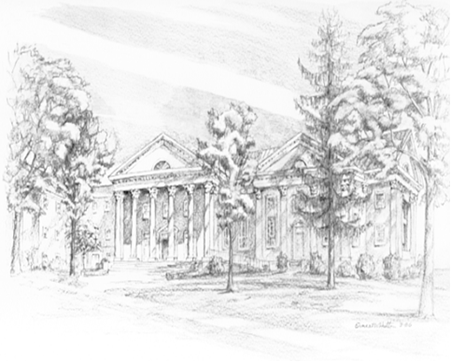

P O Box 877
249 South Wayne Avenue
Waynesboro, Virginia
(540) 949-8366
Church Website: www.firstpresway.org
Preschool Website: www.firstprespre.org
Email: church@firstpresway.com

