Thirteenth Sunday after Pentecost September 4, 2022

PRELUDE Campanile Mulet (1878-1967)

WELCOME & ANNOUNCEMENTS

INTROIT Now Enter In Hebble (1934-2020)

CALL TO WORSHIP Warner Sandquist
Leader: With endless creativity, God forms and shapes our lives.
People: Each of us bears the image of our maker; each of us is made in love.
Leader: Let us worship God.

MORNING PRAYER

*OPENING HYMN 457 How Happy Are the Saints of God Wareham

CALL TO CONFESSION

PRAYER OF CONFESSION

O God, you have given us a firm foundation in Jesus Christ, yet we choose to build weak and unstable lives. We think we are free, but we are enslaved to sin, powerless to save ourselves from ourselves. We seek security in the works of our hands, but our creations are fleeting and imperfect. Forgive us Lord, this and all our sin. Create within us hearts that seek your purposes, so that what we build may give you glory.

SILENT PRAYER

ASSURANCE OF PARDON

*GLORIA PATRI #581 Greatorex

FIRST SCRIPTURE LESSON Psalm 1 p. 424

SPECIAL MUSIC Let Us Break Bread Together Spiritual

SECOND SCRIPTURE LESSON Luke 14: 25-33 p. 850

SERMON Half- built faith. Rev. Patrick Pettit

*AFFIRMATION OF FAITH The Apostles’ Creed Hymnal p. 35

THE LORD’S SUPPER
Invitation
Great Thanksgiving
Communion of the People

PASTORAL PRAYER

*CLOSING HYMN 718 Take Up Your Cross, The Savior Said Bourbon

*CHARGE & BENEDICTION

POSTLUDE Concerto in a BWV 593: III Vivaldi (1678-1741)
Bach (1685-1750)

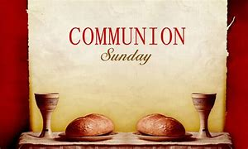

*PLEASE STAND IF ABLE.

Link for this week’s service is: https://youtu.be/QeONAj5ESEw

Audio aids are available for your convenience.
Please be aware that they do not function until after the service begins.

Choice Rehab (Avante) Tom Bellamy, Room 110

The Legacy: Mary June Cook

Regency at Augusta: Edie Lawrence

Shenandoah Nursing Home: Rubye Schwab

Summit Square: Lillian Hryshkanych

Home: Dick Huff, Nancy Garber, Mary Ultee, Mary Ann Maupin, Walt Flora, Warner & Linda Sandquist. Mike Cunningham, Ruth and Lewis Kelley.

Friends and Family: Erwin Berry (Joan), Bill Bromley, Ron Buckalew, Jean Custen, Jerry Hughes, Sally McNeel, Bill Metzel (Joyce Tipton), Col. Stuart Roberts (Mark Henderson), Danny Smith (Nancy Hypes), Paul Watts (Colleen Cash).

Military: Carson Craig

Missionaries: Elmarie & Scott Parker, PC (USA) Regional Liaisons to Iraq, Syria & Lebanon

FIRST PRESBYTERIAN CHURCH
WAYNESBORO, VIRGINIA
September 4, 2022

A community-minded congregation living out the love of Christ as we serve one another with humility, gentleness, and patience through God’s grace.

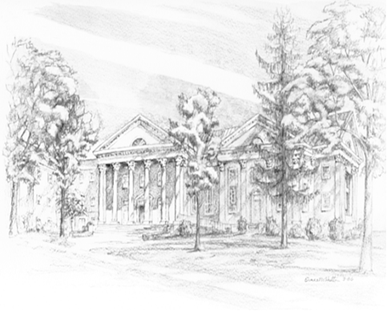

P O Box 877
249 South Wayne Avenue
Waynesboro, Virginia
(540) 949-8366
Church Website: www.firstpresway.org
Preschool Website: www.firstprespre.org
Email: church@firstpresway.com

