FOURTEENTH SUNDAY AFTER PENTECOST September 11, 2022

PRELUDE Meditation, Op. 31, no. 7 Vierne (1870-1937)

WELCOME & ANNOUNCEMENTS

INTROIT What Does the Lord Require Routley (1917-1982)

CALL TO WORSHIP Jim Leech
Leader: In You, O Lord, we take refuge.
People: Let us never be put to shame.
Leader: In Your righteousness deliver us.
People: For You are our rock and our fortress.
Leader: Let us worship God.

MORNING PRAYER

OPENING HYMN 340 This Is My Song Finlandia

CALL TO CONFESSION

PRAYER OF CONFESSION
Searching God, you come for us like a shepherd searching for lost sheep. We hide and we run, sometimes knowing we have strayed, other times completely unaware we are on the wrong path. Regardless, you come after us. We make this our confession with the hope you will find us again, wipe away our sin, and return us to your fold. We pray in the name of the Good Shepherd, Jesus Christ.

SILENT PRAYER

ASSURANCE OF PARDON

*GLORIA PATRI 581 Greatorex

FIRST SCRIPTURE READING Psalm 14:1-7 p. 430
.

SPECIAL MUSIC The Foolish in Their Hearts Deny Van Oss (b. 1953)
(text can be found in hymn 335)

SECOND SCRIPTURE READING Luke 15:1-10 p. 850

SERMON Where’s the fun in that? Patrick Pettit, Interim Pastor

*AFFIRMATION OF FAITH The Apostles' Creed Hymnal p. 35

PRAYERS OF THE PEOPLE & THE LORD’S PRAYER

*CLOSING HYMN 649 Amazing Grace, How Sweet the Sound Amazing Grace

*CHARGE and BENEDICTION

POSTLUDE Sortie, Op. 31, no. 2 Vierne

*Please stand if able

Today’s link is : https://youtu.be/-Rb0PRPnLnc

Hearing devices are available for your convenience.
Please be aware that they do not function until after the service begins.

Choice Rehab (Avante) Tom Bellamy, Room 110

The Legacy: Mary June Cook

Regency at Augusta: Edie Lawrence

Shenandoah Nursing Home: Rubye Schwab

Summit Square: Lillian Hryshkanych

Home: Dick Huff, Nancy Garber, Mary Ultee, Mary Ann Maupin, Walt Flora, Warner & Linda Sandquist. Mike Cunningham, Ruth and Lewis Kelley.

Friends and Family: Erwin Berry (Joan), Bill Bromley, Ron Buckalew, Jean Custen, Jerry Hughes, Sally McNeel, Bill Metzel (Joyce Tipton), Col. Stuart Roberts (Mark Henderson), Danny Smith (Nancy Hypes), Paul Watts (Colleen Cash).

Military: Carson Craig

Missionaries: Elmarie & Scott Parker, PC (USA) Regional Liaisons to Iraq, Syria & Lebanon

FIRST PRESBYTERIAN CHURCH
WAYNESBORO, VIRGINIA

A community-minded congregation living out the love of Christ as we serve one another with humility, gentleness, and patience through God’s grace.

September 11, 2022 11:00 AM

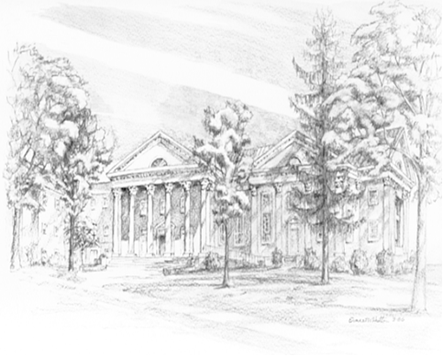

P.O. Box 877
249 South Wayne Avenue
Waynesboro, Virginia
(540) 949-8366
Church Website: www.firstpresway.org
Preschool Website: www.firstprespre.org
Email: church@firstpresway.com

P.O. Box 877
249 South Wayne Avenue
Waynesboro, Virginia
(540) 949-8366
Church Website: www.firstpresway.org
Preschool Website: www.firstprespre.org
Email: church@firstpresway.com

