FIFTEENTH SUNDAY AFTER PENTECOST September 18, 2022

PRELUDE Prelude in F, BuxWV 145 Buxtehude (1637-1707)

WELCOME & ANNOUNCEMENTS

INTROIT Now Enter In Routley (1917-1982)

CALL TO WORSHIP
Leader: Beloved children of God, in prayer and thanksgiving,
People: we come to worship God.
Leader: In hope and in humility, with joy and with concerns,
People: we come to worship God.
Leader: In faith and in uncertainty, with questions and with conviction,
People: let us worship God.

MORNING PRAYER

OPENING HYMN 35 Praise to the Lord Lobe den Herrn

CALL TO CONFESSION

PRAYER OF CONFESSION
Holy God, we confess our preoccupation with our own peace. We seek the comfort of silence and ignore the cries of the oppressed. We focus inward, missing your call to serve the world in justice and love. Forgive us, Lord, this and all our sin. Equip us to fulfill your will for a world in which all know dignity and are treated as your beloved children.

SILENT PRAYER

ASSURANCE OF PARDON

*GLORIA PATRI 581 Greatorex

FIRST SCRIPTURE READING Psalm 113 p. 491
.

ANTHEM God, Reveal Your Presence Neander (1650-1680)
(text can be found in hymn 412)

SECOND SCRIPTURE READING Luke 16:1-13 p. 851

SERMON Shrewd Living. Patrick Pettit, Interim Pastor

*AFFIRMATION OF FAITH The Apostles' Creed Hymnal p. 35

PRAYERS OF THE PEOPLE & THE LORD’S PRAYER

*CLOSING HYMN 708 We Give Thee But Thine Own Schumann

*CHARGE and BENEDICTION

POSTLUDE Fugue in F, BuxWV 145 Buxtehude

*Please stand if able

Today’s link is : https://youtu.be/BkYrElGd968

Hearing devices are available for your convenience.
Please be aware that they do not function until after the service begins.

Choice Rehab (Avante) Tom Bellamy, Room 110

The Legacy: Mary June Cook

Regency at Augusta: Edie Lawrence

Shenandoah Nursing Home: Rubye Schwab

Summit Square: Lillian Hryshkanych

Home: Dick Huff, Nancy Garber, Mary Ultee, Mary Ann Maupin, Walt Flora, Warner & Linda Sandquist. Mike Cunningham, Ruth and Lewis Kelley.

Friends and Family: Erwin Berry (Joan), Bill Bromley, Ron Buckalew, Jean Custen, Jerry Hughes, Sally McNeel, Bill Metzel (Joyce Tipton), Col. Stuart Roberts (Mark Henderson), Danny Smith (Nancy Hypes), Paul Watts (Colleen Cash).

Military: Carson Craig

Missionaries: Elmarie & Scott Parker, PC (USA) Regional Liaisons to Iraq, Syria & Lebanon

MARK YOUR CALENDARS: There will be a Covered Dish Luncheon Sunday, October 9, immediately following worship. Details will follow.

The Augusta Regional Clinic will hold a free dental clinic day – Dentalpalooza – for eligible uninsured residents of Augusta County ages 18+. A third of Augusta County residents do not have dental insurance, and the clinic is the only dental office that offers affordable dental care options within a 30-40 miles radius. More than 15 volunteers from local dental practices will reinforce the Clinic’s staff to provide general dentistry services (consultations, fillings, extractions and cleanings) for 70 patients at the event. The generosity of a dozen sponsors, including the Central Blue Ridge Community Foundation and the Virginia Association of Free and Charitable Clinics helps keep these appointments free of charge. This outreach was important to Dr. Mark Hammock, and in his memory, FPC will make a donation to Dentalpalooza.
The Session has set a goal of $500.00; checks can be made out to the church, with 'Dental' on the memo line. For more information, visit augustafreeclinic.org. or call the office.

FIRST PRESBYTERIAN CHURCH
WAYNESBORO, VIRGINIA

A community-minded congregation living out the love of Christ as we serve one another with humility, gentleness, and patience through God’s grace.

September 18, 2022 11:00 AM

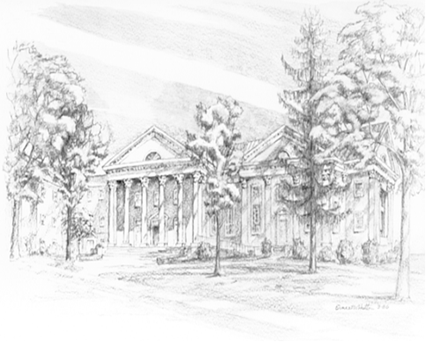

P.O. Box 877
249 South Wayne Avenue
Waynesboro, Virginia
(540) 949-8366
Church Website: www.firstpresway.org
Preschool Website: www.firstprespre.org
Email: church@firstpresway.com

P.O. Box 877
249 South Wayne Avenue
Waynesboro, Virginia
(540) 949-8366
Church Website: www.firstpresway.org
Preschool Website: www.firstprespre.org
Email: church@firstpresway.com

